

## 2022-2023 Gender and Ethnic Pay Gap Action Plan for the Ministry of Education

## Introduction

Our Gender and Ethnic Pay Gap Action Plan for 2022-23 sets out information about gender and ethnic pay comparisons and describes the actions we will take over the coming year to ensure we are addressing any potential pay gaps. This represents a continuation of previous work to reduce pay gaps and is part of our broader Diversity and Inclusion work programme. The plan aligns to Public Service guidance on pay gap action planning.

## Summary – our areas of focus for 2022/23

**We will focus on:**

* Enabling career progression for diverse communities within our workforce
* Increasing representation through recruitment practices.
* Progressing Pay Equity claims

**Whilst continuing to:**

* Embed flexible work
* Review remuneration for potential gender or ethnic pay gaps at an individual level and fix them.
* Capture data and provide reporting on pay.

## Gender Pay Gap Measurements

This section details our 31 December 2021 Gender Pay Gap (GPG) measures for permanent and fixed term employees. We have used the Public Service Commission | Te Kawa Mataaho template as a guideline. We have used our ongoing measurement of like for like work which provides us a much stronger and clearer picture of pay gaps across our workforce.

We have considered how we analyse pay gaps for diverse genders. Whilst we have the functionality to record this in our systems the numbers recorded as other genders and transgender are low and we are not able to include meaningfully in our analysis.

### Agency-Wide GPG

Our agency-wide GPG figures are as follows:

GPG Average is **17.8%** where ${GPG}_{Average}=\frac{(Male Avg Basic Pay-Female Avg Basic Pay)}{Male Avg Basic Pay}$

GPG Medianis**15.8%** where ${GPG}_{Median}=\frac{(Male Median Basic Pay-Female Median Basic Pay)}{Male Median Basic Pay}$

### 

### Breakdown of GPG Average

In January 2023 we will be updating this plan with by publishing full analysis of our GPG.

### Gender and Ethnic Pay Gaps

The chart below shows the Ministry’s gender and ethnic pay gaps at 31 December 2021. These pay gaps are monitored on a monthly and quarterly basis.

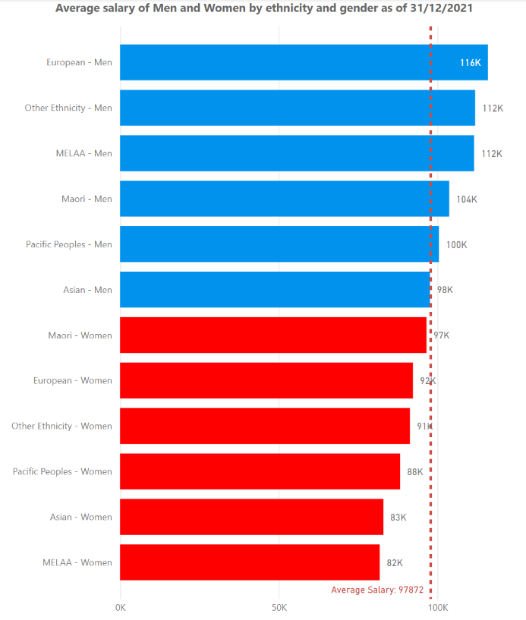

### Gender and Ethnicity Breakdown

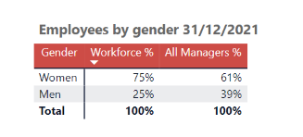

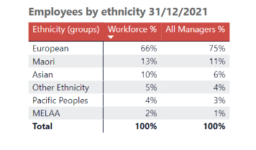

**Our planned actions for 2022/23**

**Career Progression**

* We will design a career planning and progression service with diversity at the centre of it and promote this as a key service that all staff can access. Costs of establishing a service will be considered and access may be met from existing professional development budgets.
* Promote existing career development tools and raise awareness of these with Managers and staff.
* Promote our leadership development offerings through employee networks.
* Pilot and assess a Māori leadership programme and participate in cross agency pacific leadership opportunities.
* Clearly communicate our leadership vacancies through our employee networks.
* Provide skills to Managers through unconscious bias and inclusive leadership training.

**Sourcing and Selection**

* Review our sourcing and selection guidance and practices to ensure they are inclusive and have a focus on increasing representation in leadership and other senior roles.
* Upskill hiring managers on key aspects of attracting and valuing diversity when they recruit
* Ensure our gender pay remuneration calculator is used when considering offers to new hires.
* Start publishing remuneration ranges on job advertisements.

**Progressing Pay Equity Claims**

* In 2020/21 we received pay equity claims for some parts of our workforce, some of which have an interface with the Education Workforce. This includes learning support roles such as Special Education Advisors, Advisors on Deaf Children, Therapists, Psychologists and Service Managers, Early Intervention Teachers. We also have part of our workforce covered by a pay equity claim for clerical and administrative staff across the Public Service.
* Work will continue through 2022/23 to progress these claims, we are running on track to the agreed timelines with our union partners.

**Equal Pay**

* Run regular reporting to measure pay gaps and have processes in place to rectify any pay gaps.
* Start to assess how we can measure whether there are pay gaps in our contractor workforce.

**Embedding flexible work**

* We have policies, guidance and processes in place to enable and monitor flexible work practices. In 2022/23 we will continue to promote flexible working.

**Data and Reporting**

* Report regularly to our Leadership Team on gender and ethnic pay information.
* Monitor data, on those returning from career breaks and those that have had internal promotions or secondments. Analyse the data based on gender and ethnicity to inform our career progression initiatives outlined above.
* Report regularly on new hire information for both pay gaps and diversity information.
* Monitor and report on gender and diversity in our talent identification and talent development investments.

## Agency, Union and Employee Involvement

This plan was developed building on our Gender Pay Gap plan for 2021/22. Wider consultation with our Unions, our Employee Networks and our Māori Education Group will move into the 2022/23 year.