How to print The E19/1 Manual Attendance Register:
- Open up the attendance register pdf file
- Click File
- Click Print
- Click Properties
- Select the Detailed Settings tab
- Ensure the document is printing on both sides of the paper as per the image below. *Please note the options may vary depending on the settings of your computer/printer

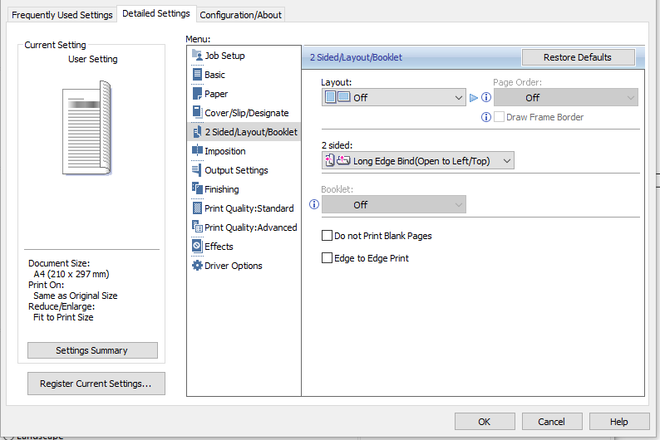

- Click OK
- Click Print
- Once the document has printed, please ensure it is double sided
- Staple the printed document together like a book
- Some of the centre pages in this booklet are half blank. Cut the blank ends off lengthways.
- Once completed, all the half pages should line up with the student’s name

