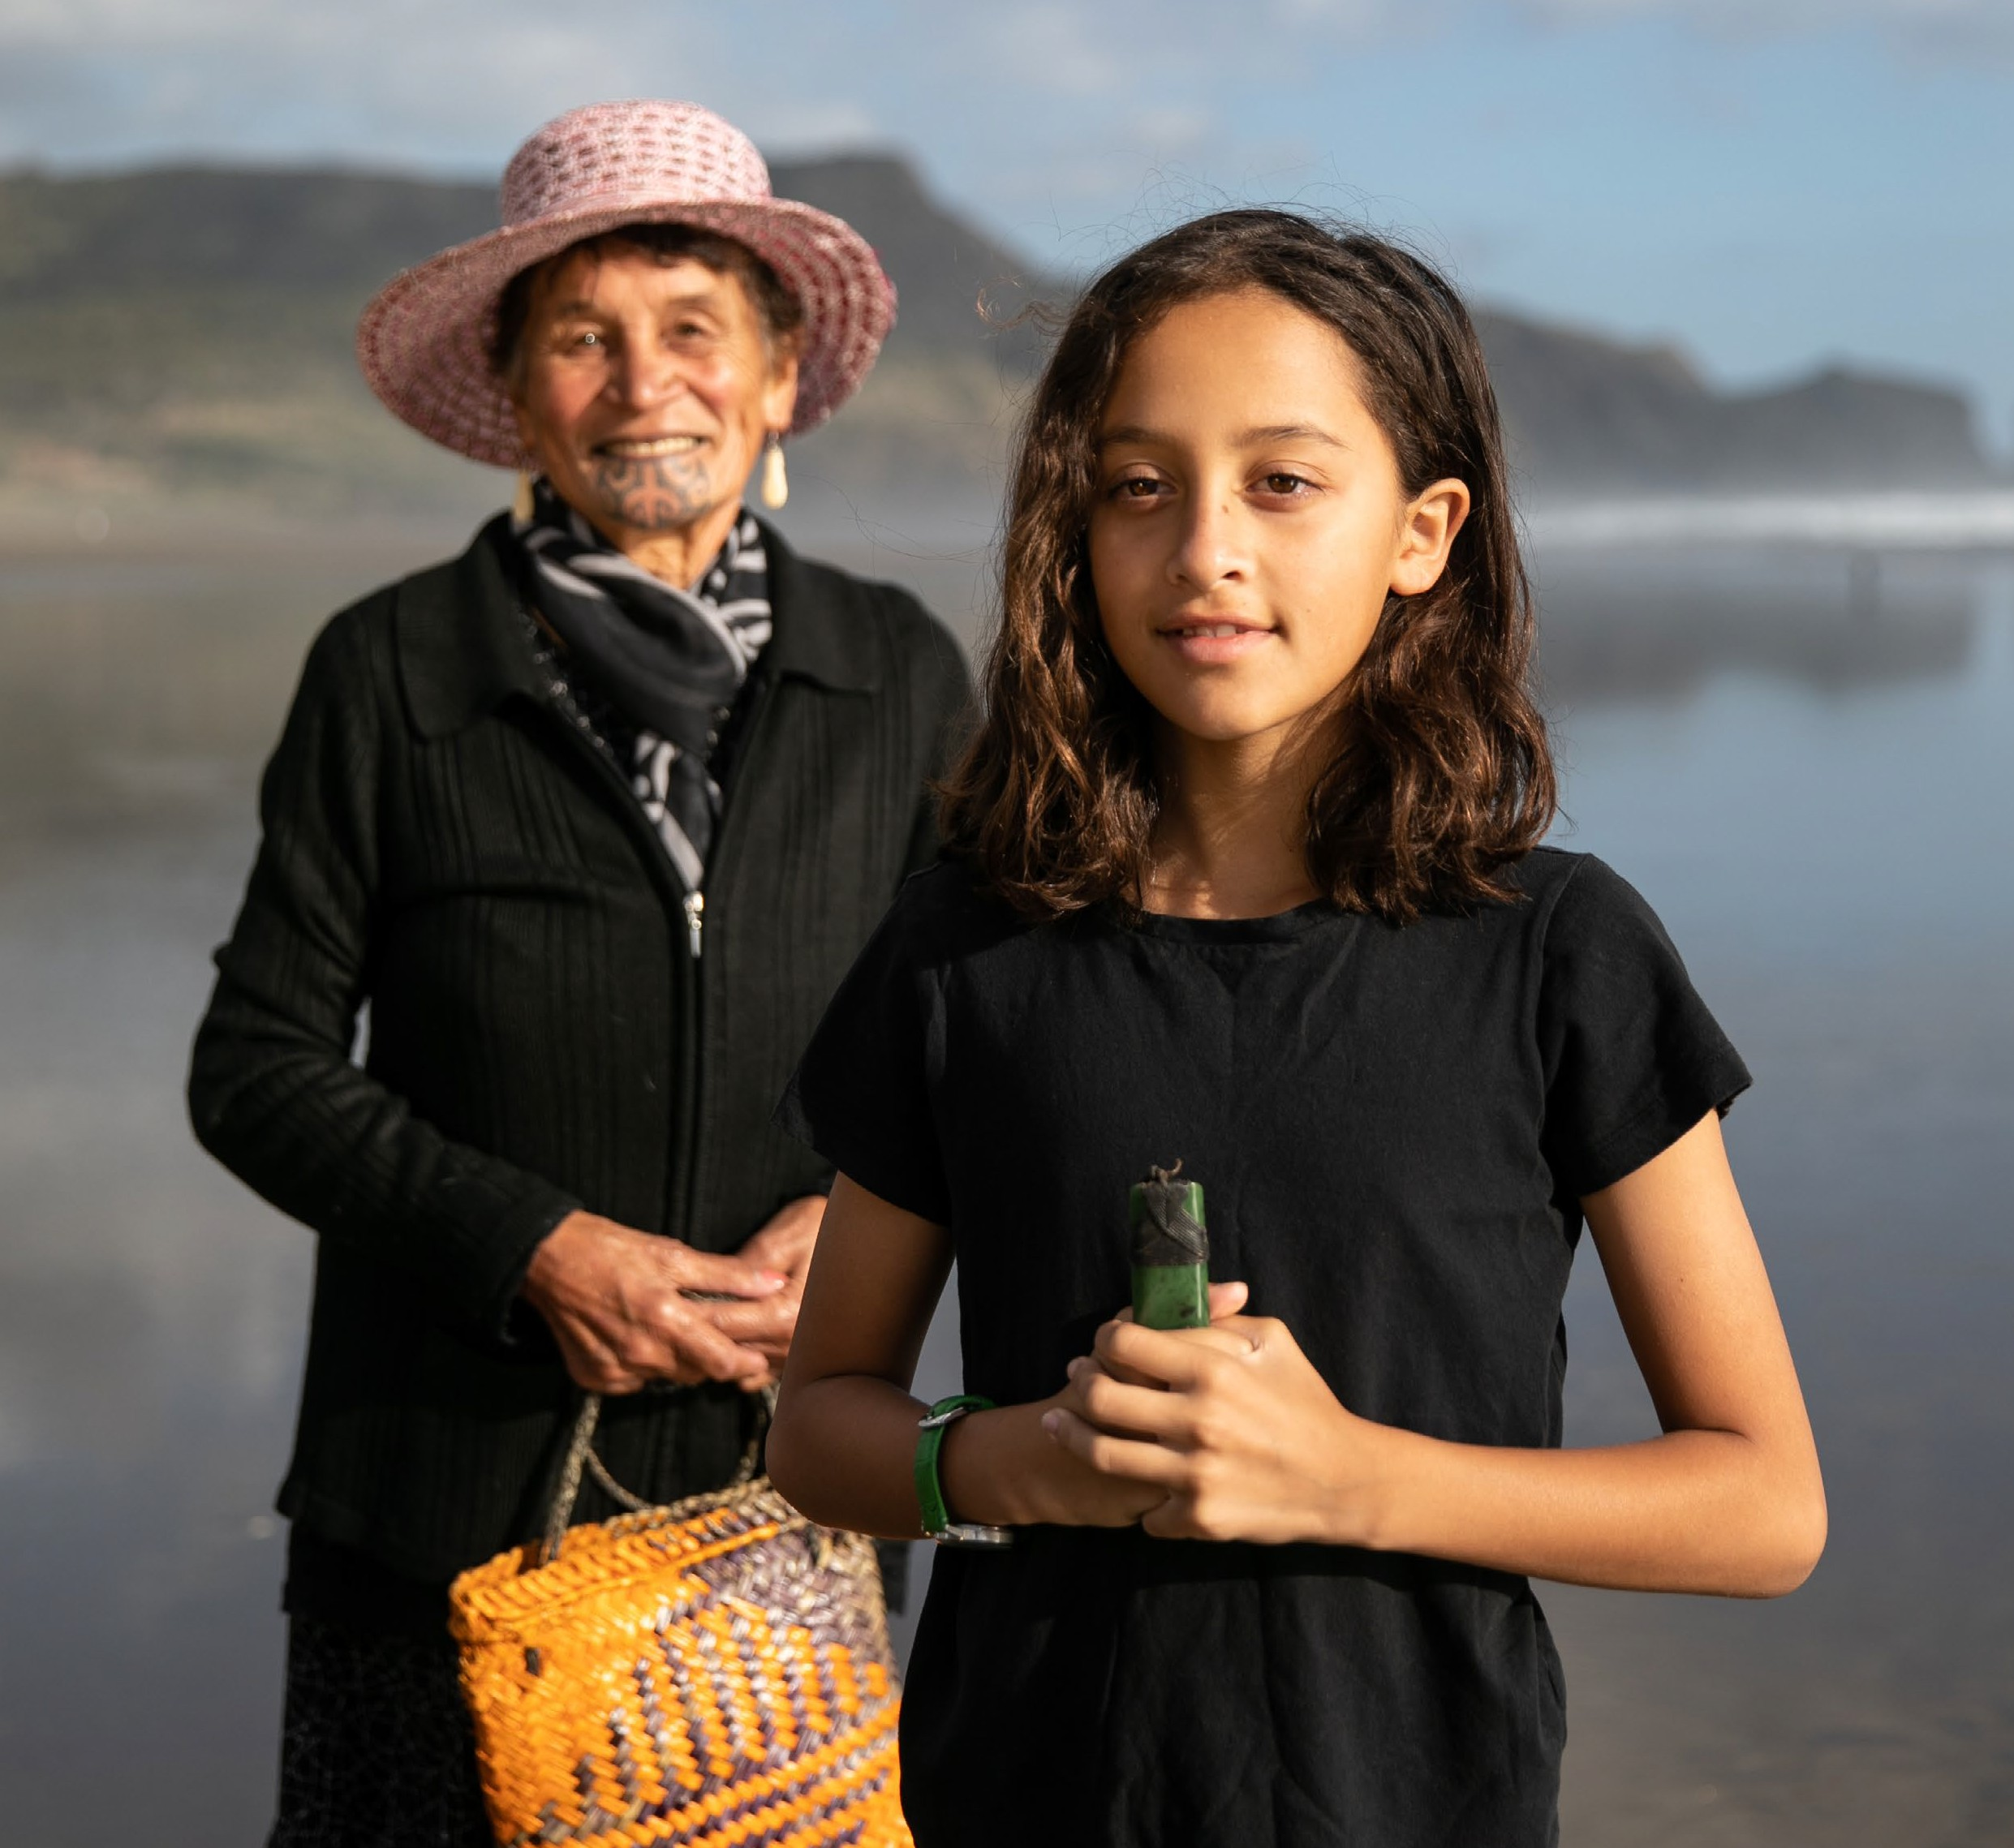
Aotearoa New Zealand’s histories:
What you told us and how we’re responding

Published by Te Tāhuhu o te Mātauranga | the New Zealand Ministry of Education. www.education.govt.nz

All text and images copyright © Crown 2021, except for the photograph on page 17 copyright © Nao Takabayashi – Unsplash.
All rights reserved. Enquiries should be made to the publisher. ISBN (online) 978-1-77690-258-3

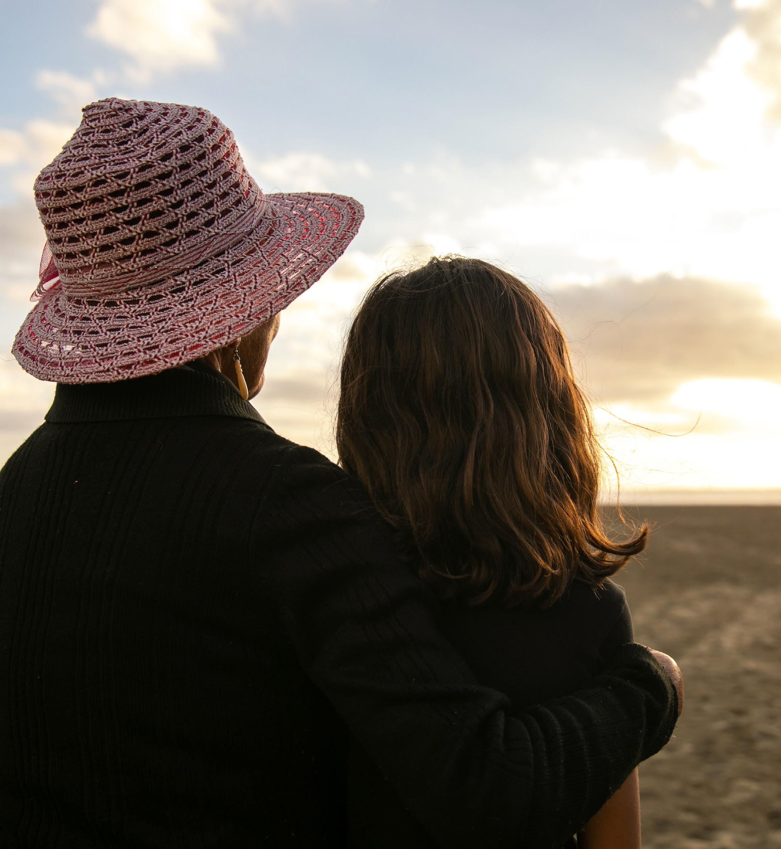
Page 3
Me tiro whakamuri, kia anga whakamua.
Look backwards to move forwards into the future.
If we want to shape Aotearoa New Zealand’s future, start with our past.

Contents

The way we teach and learn about our histories matters 5
What is the ‘curriculum’? 6
Marau ā-kura and local curriculum 6
How was the histories curriculum content developed? 7
Developing the drafts 7
Consultation with the education sector 7
Consultation with the wider public 8
Analysing and summarising feedback from the sector and public consultation 8
What did we hear and how are we responding? 9
What happens next? 16
Glossary 17

Purpose of this report
In early 2021, we asked the public and the education sector for feedback on the draft content of Te Takanga o Te Wā and Aotearoa New Zealand’s histories. This report summarises what we
heard, and the actions we are taking to respond to that feedback as we work on the final version of the content.

The way we teach and learn about our histories matters

We have heard a strong call for the history of Aotearoa New Zealand to be taught to all ākonga at all schools and kura. This has been requested for a number of years from different groups across the sector, as shown in Figure 1. The requests have included petitions from students and teachers proposing that the history of Aotearoa New Zealand should be an essential part of the national curriculum.

Long-term campaigns and discussions

Discussions through Kōrero Mātaurangi | The Education Conversation

Government decision that ākonga at all schools and kura should learn about
the history of Aotearoa New Zealand

2016 petition of Waimarama Anderson and Leah Bell to introduce the land wars into the national curriculum

2019 petition of NZ History Teachers’ Association to teaching NZ history a compulsory component of the nation curriculum

Figure 1: Background to the development of Te Takanga o Te Wā and Aotearoa New Zealand’s histories

Over the next five years, Te Tāhuhu o te Mātauranga
| the Ministry of Education is undertaking a refresh of the national curriculum for schooling, which includes Te Marautanga o Aotearoa and The New Zealand Curriculum. Te Takanga o Te Wā and Aotearoa New Zealand’s histories mark the first step towards the changes in these two curriculum frameworks. Te Takanga o Te Wā will be a new whenu (strand) under the tikanga ā-iwi wāhanga ako (learning area) of Te Marautanga o Aotearoa. Aotearoa New Zealand’s histories will be part of learning under the social sciences learning area of The New Zealand Curriculum.
The introduction of histories curriculum content will ensure that all ākonga who learn through our curriculum leave school or kura with an understanding of our history and how it has shaped our nation. Te Takanga o Te Wā and
Aotearoa New Zealand’s histories will provide extra clarity on learning that is too important to leave to chance. They will also support ākonga to be critical citizens, to understand our past in order to make sense of the present, and to learn about histories from a local and a national perspective.

The nature of history is subjective, contested, and in some cases deeply personal. We acknowledge that there will always be multiple perspectives on historical events and issues. Understanding this is important for young people, their communities, and society as a whole. Through Te Takanga o Te Wā and Aotearoa New Zealand’s histories, ākonga will broaden their understanding of the perspectives and experiences of a diverse range of New Zealanders and develop their critical thinking skills.

What is the ‘curriculum’?

The national curriculum is a description of what all ākonga across Aotearoa New Zealand will learn. The two frameworks, Te Marautanga o Aotearoa and The New Zealand Curriculum, are high-level policy statements that broadly describe the values, knowledge, attitudes, and skills that ākonga will develop.
The national curriculum does not describe the day-to-day learning that ākonga will experience. Instead, it identifies the national contexts and ideas that ākonga will explore and the knowledge and skills they will develop throughout their time at school.

Marau ā-kura and local curriculum
Marau ā-kura and local curriculum weave the national curriculum frameworks into community contexts, in order to provide rich learning opportunities for ākonga.
Tumuaki, school leaders, kaiako, and teachers use the national curriculum to plan the marau ā-kura or local curriculum for their school or kura. This gives them the scope and flexibility to design a curriculum that best meets the needs of ākonga and whānau and responds to their interests
and aspirations.
With support and input from whānau, schools decide what specific topics and events to teach their ākonga within the framework set out in the curriculum.

For Te Takanga o Te Wā and Aotearoa New Zealand’s histories, for example:
- learners with strong links to the Pacific community can learn about the history of Pacific peoples in Aotearoa New Zealand
- learners in rural parts of Aotearoa New Zealand can learn about farming and trade history
- learners in special character kura and schools can learn about the histories that are relevant to that character
- ākonga Māori can learn about significant events for Māori, such as Te Koroneihana or Ruapekapeka.

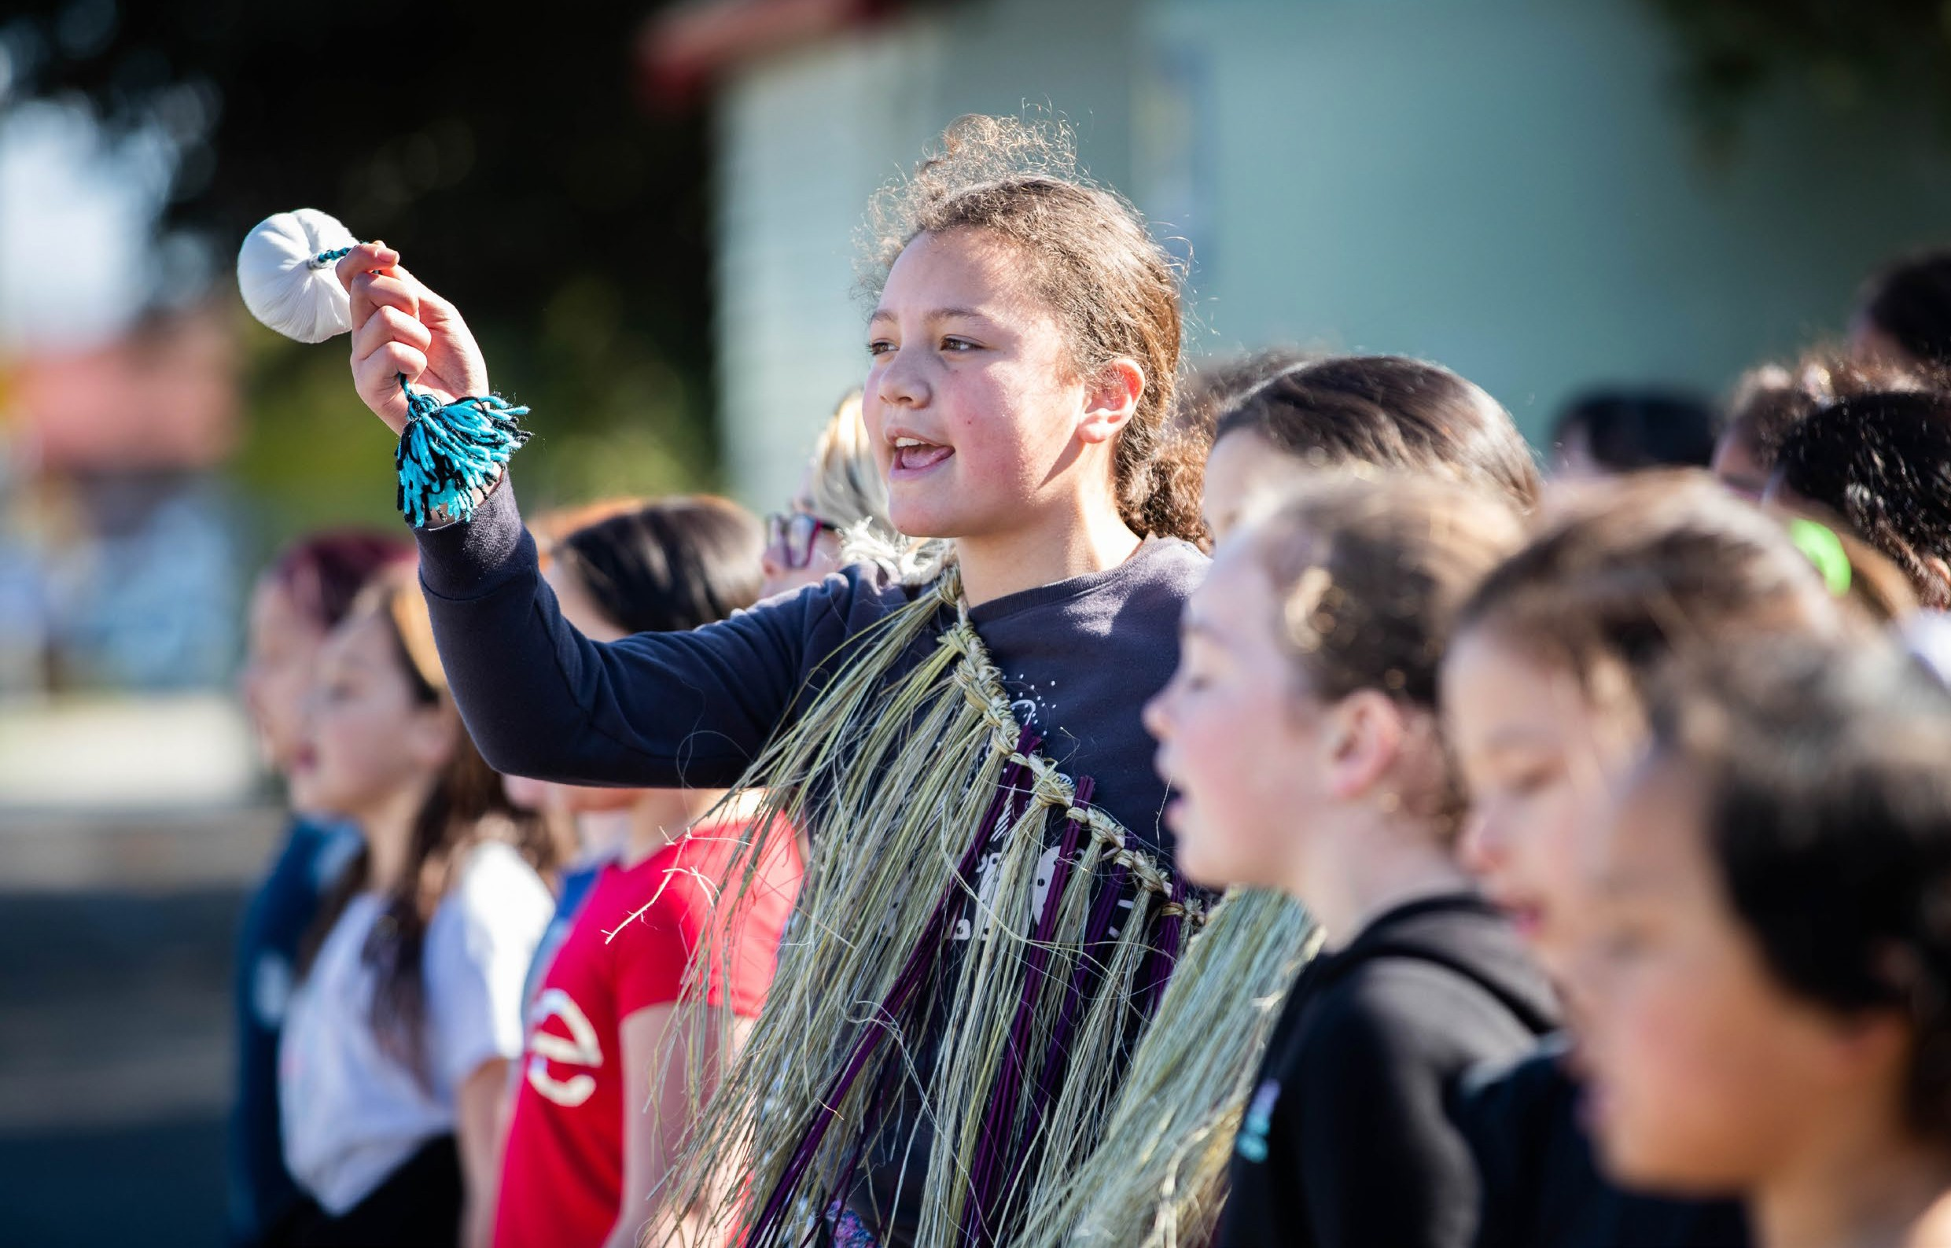
Page 6

How was the histories curriculum content developed?

Developing the drafts
During 2020, we worked with a wide range of people and groups to develop the draft curriculum content for Te Takanga o Te Wā and Aotearoa New Zealand’s histories, as shown in Figure 2.

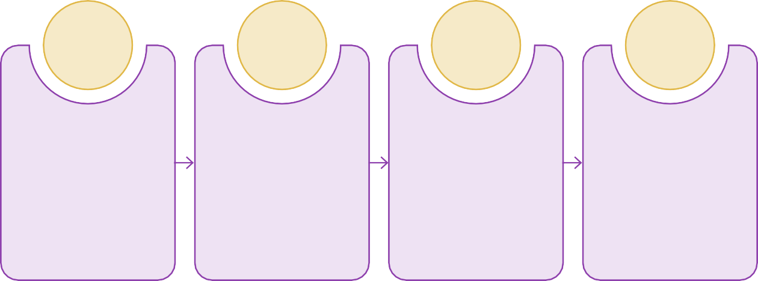
2020 2020 2021 2021

Content created by curriculum writers with help from our expert and reference groups
Feedback from an independent advisory panel with expertise in Aotearoa New
Zealand’s histories
Further feedback from testing with a small cohort of kura and schools
Feedback acted upon to produce draft for wider public testing

Figure 2: Developing the draft curriculum content

We then sent out the draft curriculum content¹ for education sector consultation and public consultation, which took place from 3 February 2021 to 31 May 2021.

Consultation with the education sector
We asked kaiako, teachers, tumuaki, and school leaders for detailed feedback on the draft curriculum content.
We supported tumuaki and school leaders to engage with the draft curriculum content and discuss it with their colleagues. Through an online survey and face-to-face wānanga, we also asked the education sector:
  - how they would use the content
  - whether it was clear and suitable for each year level group
  - whether it was easy to understand and use.
We received 354 survey responses on the draft curriculum content from 157 kura, schools,
or groups of kura and schools. Ten wānanga, attended by 98 people, were also held to provide

specific feedback on Te Takanga o Te Wā. This range of engagement gave us strong insights about the views of the education sector on the new curriculum content and allowed us to revise it with confidence.
We also supported more than 20 Māori-medium kura and 60 English-medium schools to trial the draft curriculum content in their akomanga and classrooms. Trialling in many kura and schools involved kaiako and teachers from different year levels, and some trialling was by a whole Kāhui Ako or local cluster. The trial groups reviewed the
content by exploring it together, testing it directly in classrooms, and providing comprehensive feedback on its usability. Accordingly, their comments were given greater emphasis in our responses.

1 Throughout this report, ‘draft curriculum content’ refers to the drafts of both Te Takanga o Te Wā and Aotearoa New Zealand’s histories, unless one or the other is specified.

Consultation with the wider public
Alongside our consultation with the education sector, we engaged with the public to find out what Aotearoa New Zealand thought about the draft curriculum content.
Feedback from the public consultation was received in three ways, as shown in Figure 3.

There were

488
submissions from individuals or groups who shared their thoughts.

Public consultation

There were

4,491
individuals or groups who completed the online public survey.

More than

90
workshops, fono, and
hui were held.

Figure 3: The ways of providing feedback during public consultation

The three overarching questions in the public engagement were:
  - Does the draft curriculum content reflect us as a nation?
  - What is most important to you?
  - What are the challenges in implementing this curriculum change?

Analysing and summarising feedback from the sector and public consultation
Each type of feedback was independently analysed and reported back to us by:
  - the New Zealand Council for Educational Research (NZCER), or
  - Te Paetawhiti Ltd & Associates.
We used these reports to identify key themes in the education sector’s and public’s responses to the draft curriculum content. The reports are available online.²
Taking account of these key themes, we planned actions for making changes to the draft curriculum content and for providing implementation supports and resources. We checked the validity and reliability of these planned actions with members of our expert and reference groups.

² This report includes links to resources on the Internet. If you are working with hard copy, you will need to access the online version at https://xxx in order to activate these links.

What did we hear and how are we responding?

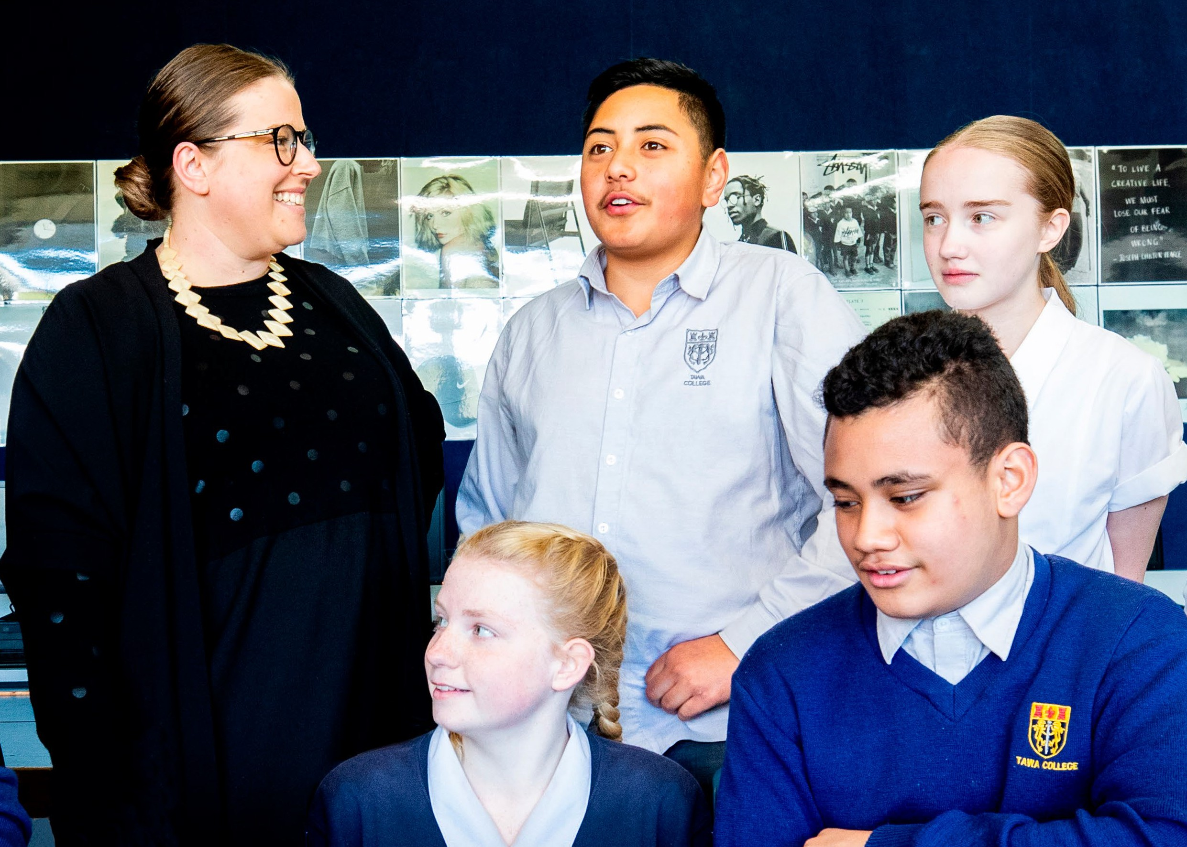
Given that we received a large number of responses from a wide range of individuals and groups, it is unsurprising that there were many different perspectives about the draft curriculum content and how it could be improved.
Despite this diverse feedback, similar key themes emerged in the responses from both the education sector and the public:

  - There was enthusiasm for the draft content, as well as suggested improvements
  - People had differing views about the nature of history
  - People saw strong links between the draft curriculum content and identity, culture, and citizenship
- People supported the focus on Māori histories and want to see more focus on our multicultural histories in the final content
- People were excited about greater partnership between kura/schools and hapū and iwi, but resourcing and support is needed
- People emphasised the large amount of support that kura and schools will need

Below is a description of each key theme and how we are responding to it. For detailed analysis of all of the feedback, see the reports available online.

There was enthusiasm for the draft content, as well as suggested improvements

There was a general sense of enthusiasm and support for the draft curriculum content from both the education sector and the public. Testing with kura, schools, kaiako, and teachers has been very positive, conveying high levels of satisfaction with the content and the new curriculum model.
Overall the public response to the new content was positive. There were negative responses, for example, some respondents did not believe that learning about history should be a curriculum priority, and others disagreed with the ideas introduced in the draft curriculum content regarding power, colonisation, and Māori history. At the extreme end were responses that opposed a focus on Māori history, language,
and culture.

This is essential learning for all New Zealanders, and I am excited to see it becoming a priority in our curriculum.
Survey, primary teacher

I don’t know much about New Zealand history, but I would like to learn more. Survey, ākonga

For Te Takanga o Te Wā, there was a call for key concepts such as manaakitanga, aroha, ukaipōtanga, and whakapono to be included, to add further richness to the discussions about our past and present.
For Aotearoa New Zealand’s histories, we heard calls for more diversity and wide-ranging topics, as well as the use of language that is easy for young people to understand.

How we are responding to this theme
The draft curriculum content has been developed to reflect the significance of Māori histories in New Zealand and to honour te Tiriti o Waitangi and the partnership between the Crown and tangata whenua. This content is inclusive and is about diversity – between groups and within
groups. Suggested changes that would contradict the aims of the New Zealand education system and the Crown’s obligations under Te Tiriti o Waitangi will not be acted upon.
As a result of the positive response to the content and its structure, particularly from the education sector, we will focus on enhancing the features people liked. There will not be any radical changes to the content and any additional content will be in line with what currently exists.
In Te Takanga o Te Wā, the writers will explore additional key concepts and how these could be authentically woven throughout the strand.
In Aotearoa New Zealand’s histories, we will widen the breadth of content and make the language clearer.

People had differing views about the nature of history

Some people believed that studying history should be about all young people learning a single ‘objective’ view of the past, while others thought it should involve learning about multiple sources and perspectives. The strongest message, however, was the importance of developing young people’s critical thinking skills.
In the draft for Te Takanga o Te Wā, critical thinking skills were seen as the underpinning capabilities our ākonga need in order to understand multiple perspectives and how these perspectives can affect and influence the transmission of histories over time.
In the Aotearoa New Zealand’s histories draft, many kaiako and teachers supported the ‘Understand, Know, Do’, framework, which gives young people opportunities to build their knowledge and develop their inquiry skills and appreciation of diverse perspectives.

The focus on critical thinking skills was considered vital to creating a generation who can weigh bias, look at and question where a source comes from, and theorise as to why this might be the case.
Analysis of school feedback

How we are responding to this theme
We understand that there are multiple perspectives on history, and we are working to ensure that
the new curriculum content develops the critical thinking skills of ākonga in relation to these.
Resources that will be created to support Te Takanga o Te Wā and Aotearoa New Zealand’s histories will help teachers and kaiako teach about the multiple perspectives that different people have about our nation’s history.

People saw strong links between the draft curriculum content and identity, culture, and citizenship
Many people believed that learning through Te Takanga o Te Wā and Aotearoa New Zealand’s histories
would be beneficial for ākonga wellbeing and confidence, and for shared whānau aspirations.

Strengthening Māori knowledge will enable our tamariki without Māori ancestry to explore their own culture and develop a cultural identity. This is vitally important for the wellbeing and identity of all New Zealanders.
Group survey response, ākonga

Teaching a wide range of stories provides more opportunities to spark young people’s passion for and interest in the past.
Survey, tertiary lecturer

How we are responding to this theme
Our implementation supports, resources, and guidance for kaiako and teachers will highlight opportunities to foster the identities, cultures, and citizenship of ākonga while keeping wellbeing at the centre.
Exploring the diverse perspectives of different iwi, communities, or groups on specific historical events will provide opportunities for ākonga to consider the identities, cultures, and languages of others. We will also ensure that such diverse perspectives are reflected in the curriculum content.

People supported the focus on Māori histories and want to see more focus on our multicultural histories in the final content
We heard that Te Takanga o Te Wā had an appropriate balance of tangata whenua perspectives and flexibility to include other cultures and histories.
Te Takanga o Te Wā acknowledged tangata whenua but was equally inclusive of all cultures and focused on what was most important from a Māori world-view – that is, Who are we?
Where do we come from? Where are we going?
Notes from wānanga

For the Aotearoa New Zealand’s histories content, some people thought there needed to be a better balance between Māori and European New Zealanders’ perspectives. Others asked that the content include historical narrative perspectives that reflect the multicultural, multi-ethnic communities of Aotearoa. We especially heard that people would like ākonga to learn more about Moriori, Pacific, and Asian New Zealanders’ histories.

Migration is not the sum total of Chinese New Zealand experience. And it should not be the only place where our community can see its history reflected.
Group submission

How we are responding to this theme
Te ao Māori will provide the tūāpapa (foundation) for Te Takanga o Te Wā. It will be the lens through which the histories of other cultures will be explored. Presenting the diverse perspectives of different iwi, hapū, and whānau about historical events, people, or places will be encouraged and strongly acknowledged through Te Takanga o Te Wā.
In Aotearoa New Zealand’s histories, we will show clearly how the histories of both Māori and diverse communities are to be covered within local curricula, so that learners of all ethnicities and cultural backgrounds can see themselves in their curriculum. Our implementation supports and resources for kaiako and teachers will provide guidance on how to design rich, relevant learning experiences that reflect all ākonga in their classrooms.

People were excited about greater partnership between kura/schools and hapū and iwi, but resourcing and support is needed
Kaiako, teachers, and ākonga were excited about learning more local hapū and iwi stories. The public and educators both emphasised the critical need for resources and support to help kura, schools, hapū, and iwi form strong partnerships that uphold the mana of Te Tiriti o Waitangi. The feedback identified that partnering with iwi and hapū is a significant step in the right direction and that appropriate resourcing and support should reflect this need.
Feedback also conveyed concerns about the capacity of iwi and hapū to meet the demand for curriculum guidance and to play a meaningful role in the development of local curricula, especially in areas where they may need to respond to a number of kura and schools.

The biggest challenge will be developing authentic relationships and partnerships with iwi and learning to co-design with iwi what the localised curriculum looks like and how this includes Aotearoa New Zealand’s histories, while acknowledging the aspirations that iwi and hapū have for their people.
Survey, whanau

How we are responding to this theme
Since late 2020, we have been working with iwi across the country to support them to share their local histories. We will continue to support iwi to develop action plans for how kura and schools can identify and access local (and, where relevant, national) histories and knowledge, including:
- places of significance
- significant tūpuna
- significant events
- local taonga.

People emphasised the large amount of support that kura and schools will need

Many thought it would be challenging to access reliable information drawn from a Māori world-view. They identified that a wide range of resources will be required to support the implementation of Te Takanga
o Te Wā. Local resources will be in demand, and it will be important to ensure that the sources of local narratives are appropriately supported and acknowledged.

It’s important that money is invested into iwi and hapū, so the histories that are shared are accurate and respectful of mana whenua. There needs to be an emphasis on building strong and meaningful connections with hapū and iwi. Survey respondent

Kura, schools, and the public expressed concerns around the implementation demands of Aotearoa New Zealand’s histories in terms of the capability and capacity of kaiako, teachers, and the community. Kaiako and teachers recognised the depth of historical knowledge, pedagogical knowledge, and cultural capability that will be required to teach the curriculum content and ensure a range of perspectives are heard.
People also recognised that the curriculum content will require kaiako and teachers to navigate difficult aspects of our histories in an appropriate way.
A major challenge will be to prevent teachers from demonising colonialism and subsequently making students of European descent feel guilty for their connection to it.
Survey, parent/caregiver

How we are responding to this theme
For kaiako using Te Takanga o Te Wā, we will prioritise funding for professional learning and development opportunities that support them to:
- embed mātauranga Māori into their practice
- empower ākonga to develop their own Māori world-view
- weave together the aspirations and dreams of whānau, kura, hapū, iwi, and the community.
For kaiako and teachers using Aotearoa New Zealand’s histories, we will prioritise funding for professional learning and development opportunities that support them to:
- recognise practices that perpetuate discrimination, racism, and inequity
- analyse and adjust how they communicate and teach, in order to sustain and value the cultural identities of their ākonga
- design strong local curricula that strengthen partnerships with whānau, hapū, iwi, and the community.
We will continue to produce a range of resources to support the implementation of Te Takanga o Te Wā and Aotearoa New Zealand’s histories. Details about current and upcoming resources for Te Takanga o Te Wā can be found at Kauwhata Reo. Details about current and upcoming resources for Aotearoa New Zealand’s histories can be found at S ocial Sciences Online.
We have also developed through Te Aho Ngārahu a range of rauemi that share local historical narratives – real stories, shared by iwi and hapū for all ākonga to engage with.

What happens next?

As discussed in each of the key themes, we are addressing feedback through changes to the draft curriculum content and the continued development of resources and supports for tumuaki, leaders, kaiako, and teachers.
The final content will be considered by the Minister of Education and Cabinet before it is published and available for kura and schools to use.
Kura and schools will begin including Te Takanga o Te Wā and Aotearoa New Zealand’s histories in their marau ā-kura and local curricula for history during 2022, working in partnership with their communities to introduce local histories and contexts that are meaningful for their ākonga.
We will provide guidelines and supports around what implementation could look like for kura and schools. We will learn from their experiences of implementing the new content so that our ongoing delivery of guidance, resources, and professional supports meets the needs of kaiako, teachers, and communities.
There are a wealth of resources and professional learning supports currently available for tumuaki, leaders, kaiako, and teachers. Implementation supports and resources will continue to be developed and added to over time, including more materials that reflect the histories of different groups.
As mentioned previously, Te Takanga o Te Wā and Aotearoa New Zealand’s histories mark the first step towards a refresh of the national curriculum, which includes Te Marautanga o Aotearoa and The New Zealand Curriculum. As part of the refresh,
a process for the ongoing development of our national curriculum is being established. As our understanding of histories evolves, so too will our national curriculum to ensure that it continues
to reflect the needs of young people and our communities.
Further information about the refresh of
Te Marautanga o Aotearoa can be found on Kauwhata Reo.
Further information about the refresh of
The New Zealand Curriculum can be found on the Ministry of Education's website.

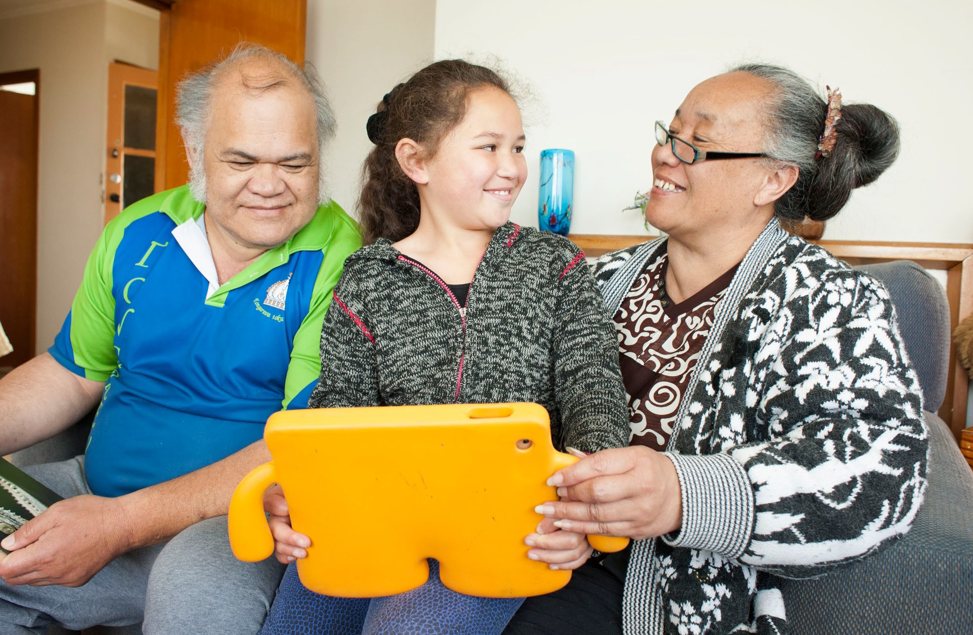

Page 16

Glossary

akomanga | classroom(s)
ākonga | learner(s)
kaiako | teacher(s)
Kāhui Ako | a group of early learning services, ngā kōhanga reo, schools, kura, and post-secondary providers that work together to improve education pathways for the students in their community and help them achieve their full potential
kura | school(s)
marau ā-kura | local curriculum
tumuaki | principal(s)
wānanga | workshop(s)

Page 17

