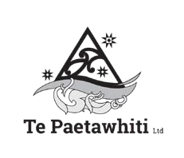

Aotearoa New Zealand’s Histories: Findings from school engagement on the draft curriculum content

Published in 2021 by the Ministry of Education, PO Box 1666, Wellington 6140, New Zealand.
www.education.govt.nz
Copyright © Crown 2021 All rights reserved.

Enquiries should be made to the publisher. Developed in collaboration with Te Paetawhiti.
Written by Roxanne Smith.
ISBN 978-1-77690-256-9 (Online)

Aotearoa New Zealand’s Histories: Findings from school engagement on the draft curriculum content

Report prepared for the Ministry of Education by Te Paetawhiti

July 2021

Contents
Part 1 Review of the Aotearoa New Zealand’s Histories framework 6
Background 6
Survey respondent information 6
Summary survey findings NZC 7
Understand | Purpose statement and big ideas 7
Know | Contexts, progressions and progress outcomes 8
Do | Inquiry practices 10
What we do now | Social sciences and Aotearoa New Zealand’s histories 11
What we do now | Resources and relationships 11
Final comments 12
Part 2 Te Takanga o Te Wā 14
Background 14
Te Marautanga o Aotearoa 14
Wānanga 14
Summary of online survey feedback 16

Part 1
Review of the Aotearoa New Zealand’s Histories framework

Background

In 2019 the Prime Minister Jacinda Ardern and Education Minister Chris Hipkins announced that Aotearoa New Zealand’s histories will be taught in all schools and kura from 2022. To support the implementation of The New Zealand
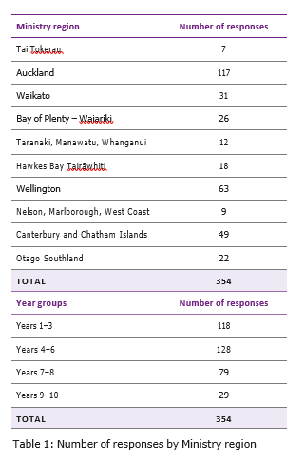

Curriculum (NZC) Aotearoa New Zealand’s histories, the Ministry of Education partnered with a range of stakeholders to develop the content that would support schools to integrate specific concepts and content into their local curriculum.
This report provides a summary of the feedback from schools that reviewed the draft curriculum content and completed the online survey. There were few responses received from kura using
Te Marautanga o Aotearoa therefore a more responsive process of gathering feedback was adopted and summarised in Part II of this report.

Survey respondent information
In total, 354 responses were received from 157 schools that use the New Zealand Curriculum. Table 1 shows responses received by Ministry regions and by year groups. Note that 86 of the 157 school groups provided more than one response to the survey.

Summary survey findings NZC

Understand | Purpose statement and big ideas
Feedback was sought on whether the content had a strong bicultural focus; captured what was important for all young people to learn; and was clear that local contexts need to be locally agreed. In summary, the majority of respondents across all year groups were in agreeance with the statements as follows:
» Over 80% agreed that the content had a strong bicultural focus.
» Over 70% agreed that the content captured what was important for all young people to learn.
» Over 75% agreed that local contexts for Aotearoa New Zealand’s histories should be agreed locally was clear.
» Over 80% agreed that the big ideas were integral to Aotearoa New Zealand’s histories learning.

Strong bicultural focus
There were a range of comments affirming the importance of a bicultural approach to history in New Zealand and the benefit this approach will have for all learners. Four key points were raised by all year groups:
» The need for a stronger reflection of Aotearoa New Zealand’s multicultural history including settlement stories from those who migrated to New Zealand.
» The need to balance what some considered to be a negative and biased view of colonisation.
» The inclusion of specific content including pre-Treaty history, Moriori history, and important events in New Zealand history including natural disasters.

» Age-appropriate resources and professional development for teachers to understand the ‘Big Ideas’ to ensure the content is implemented with authenticity and to become critically aware of their own biases.
Specific comments included:
» Adding a glossary of terms.
» Creating a bilingual document to recognise the bicultural framework.
» Clarifying the term biculturalism and the terms used for the two partners to the Treaty e.g. British, Pākehā or Tauiwi and Tangata Whenua, Tangata Tiriti, Māori, iwi, or hapū.

Content captures what is important
The majority of respondents (over 79%) felt the content focused on the most important parts of Aotearoa New Zealand’s history.
Furthermore, the content was comprehensive, clear, relevant and the structure easy to follow. The focus on critical thinking skills was considered vital to creating a generation who can weigh bias, look at and question where
a source comes from and theorise as to why this might be the case. Of the three elements in the draft document ‘Understand’ and ‘Do’ were the most challenging for the year groups with language considered too complicated
for young learners to understand in particular big ideas such as ‘power’, ‘colonisation and its consequences’ and ‘ethics’. The inquiry
practices were also considered too challenging for junior learners in particular.
Some respondents thought there needed to be a focus on the development of Aotearoa New Zealand as a nation – economically, socially, politically; consideration given to including
a fourth element, Understand, Know, Do and Why? And changing ‘Understand’ to ‘Big Ideas’ and ‘Do’ to ‘Action’.

Local contexts
Over 74% of survey respondents across all year groups agreed that local contexts for Aotearoa New Zealand’s histories should be agreed locally. The year 7–10 groups tended to rate their agreement with the statement lower than the year 1–6 group, however the feedback was the same. Comments mostly related to:
» Understanding what is meant by ‘local context’ and ‘local contexts agreed locally’.
» The practical difficulties in accessing resources and authentic local stories easily and efficiently especially in schools where existing relationships with knowledge holders including hapū, iwi, marae were non-existent or tenuous.
» The time and cost needed to establish local relationships especially in areas with multiple iwi and contested iwi boundaries.
» The balance between delivering national and local content.
Schools felt resources, professional development and/or a co-ordination system/ person to support relationship building were needed to do this well.

Learning about the big ideas will be integral to all Aotearoa New Zealand’s histories learning
The majority of respondents (over 80% across all year groups) agreed with the statement,
in particular they thought the big ideas were clear and concise, easy to understand and user friendly. Respondents also thought it was easy to see how the content progressed and deepened over the year levels from year 1 to year 10.
Despite their agreement, respondents also felt the content needed to be more balanced, the language simplified for students, and the big ideas broken down and unpacked into
clearer progression and development steps for students. Respondents were also interested
to know what year 0 students are expected to be able to understand, know and do; what assessment looks like; and how students with special needs will be catered for.

Know | Contexts, progressions and progress outcomes

Clarity of progressions
Feedback was sought on the extent to which the progressions made it clear what students would have experienced and learnt. There was general agreement across all year groups (over 65%) that the progressions were clear across all contexts and showed progress. The year 9–10 group tended to rate their agreement lower than other year groups (between 65 and 76%) compared to the other year groups (over 80%). Their concerns were similar to other year groups and included the potential for repetition of content each year; the impact of the new content on teacher workload; how the new content will relate to the Social Science curriculum; and the complexity of the content especially for younger students.
Comments included:
» Including a glossary for new vocabulary/ terminology in English and in te reo Māori.
» Ensuring a strong connection to ECE and the needs of learners with special needs.
» Breaking down the progressions by year to provide more specific guidance to teachers as to what progress at the end of each year looks like. This may smooth transitions and reduce repetition of content across years/ schools and/or ring fence certain topics for certain years.
» Consider whether the amount of content introduced in each year group is weighted appropriately across all year groups and also takes into account how much time schools have in their timetable to deliver the content.

Progress outcomes and current social science programmes
The majority of the year 1–8 respondents (70– 80%) agreed that the outcomes fit well with what they already teach particularly across all contexts for those who have a strong place- based curriculum. Less than half the year 9–10 respondents (38–48) however agreed with the statement. All respondents were concerned about the limited time and resources they had to rewrite their current curriculum content to accommodate the Aotearoa New Zealand’s Histories (ANZH) curriculum; the increased workload and impact this will have on being able to cover other social studies topics including global perspectives, economics/ commerce and geography, and world history; and the appropriateness of language used
for primary students. Those respondents that engaged in inquiry-based teaching and learning considered that implementing the new content would be a change in approach
for their school. One year 9–10 respondent felt the content was currently more than what was expected at NCEA Level 1.

Progress outcomes are engaging for students
Agreement on this statement was more divided with less than 55% of year 9–10 respondents agreeing to the statement across all the contexts and over 70% in all the other year groups.
All groups commented that student engagement relied on the ability of the teacher to engage students in the content or deliver content in an engaging and purposeful way; the rich learning activities the teachers provide; the interests and prior knowledge of the learners; the quality of the resources available to support learning; and how well histories is integrated with other curriculum areas.
Year 9–10 respondents were concerned with the limited time and resources currently available to support teaching; the time they have to deliver the content in an already full
social science curriculum programme; the limited curriculum content and inability to digress; and the potential for repetitive content over the years. These limitations may also impact on student’s interest in continuing history as an NCEA level topic.
Year 1–8 respondents while positive about the progress outcomes and contexts were concerned that the content might be too repetitive and teacher-led and that the concepts and content may be too difficult for students to understand and engage with.

Outcomes are at the right level
Overall the majority of respondents across years 1–8 (70–73%) agreed that the outcomes are at the right level although the progress outcomes require further unpacking, particularly for those who teach multi-level classes. Furthermore, to be able to achieve the outcomes relied on teachers in prior years ensuring students meet their respective progress outcomes.
The year 1–6 group were interested to know why the outcomes are not aligned to curriculum levels; or why the levels are not split into two year groups rather than three.
They also raised concerns around outcomes being too wordy and the appropriateness of the inquiry practices for their respective year groups.
The year 7–8 age group were also concerned about the amount of content; the risk of content being too prescriptive; and the need for students to develop their inquiry practices and content knowledge prior to this year level. Those that disagreed felt the skill set was more appropriate for years 9–10.
The year 9–10 group were less likely to agree that the outcomes were at the right level. Only 55% of respondents agreed mainly due to their concerns about the depth and breadth of content that had to be covered in a short period of time and the complexity of the inquiry practices needed.

Do | Inquiry practices
Feedback was sought on the extent to which it was clear what inquiry practices students will develop as they progress from years 1 to 10; and whether the inquiry practices fit easily with current social science programmes and engage students to think critically about the past.

Inquiry practices students will develop
There was general agreement across all year groups (65–80%) that the inquiry practices were clear, concise and age-appropriate and it was easy to see how students were being progressed through the content. The year 9–10 and year 1–3 groups tended to rate their response to this question lower, 65% and 72% respectively.
Broader comments related to how the inquiry practices will be introduced to each year group and how this will support inquiry models already being used by schools.

Inquiry practices fit easily with current social science programmes
Agreement to this statement was relatively high across all year groups except year 9–10 where less than 62% of respondents agreed that the inquiry practices fit easily with their current social science programme. Year 9–10 respondents noted that the content was extensive and complex for students in this year group and the inquiry practices were more relevant for older year groups.
‘Interpreting past decisions and actions’ tended to be the least favoured inquiry practice and ‘identifying and using sequence’ was the most favoured across all year groups. The second inquiry practice area ‘Identifying and critiquing sources and perspectives’ was not a practice that was used by the younger year groups.
Furthermore, critical thinking was considered ambitious for most year groups but particularly for younger students.
However, respondents noted that students could develop these skills over time with age-appropriate resources and teacher upskilling.

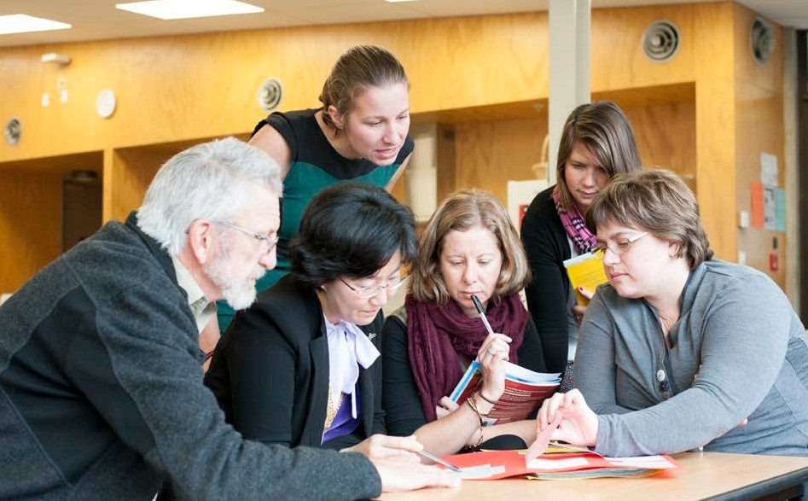

Inquiry practices engage students to think critically
The majority of year 4 to year 10 respondents (over 80%) agreed that the inquiry practices engage students to think critically about
the past. The year 1–3 group were less likely to agree (60–67%) due to the age of the children and their ability to think critically and comprehend abstract concepts of time (past, present, future). All groups commented that the extent to which the inquiry practices engaged students to think critically relied on teacher practice and content that is relevant, challenging and meaningful.
‘Identifying and using sequence’ was considered more appropriate and easy for students to relate to however the year 9–10 group commented that this inquiry practice could develop into a broader category called ‘skills’ as the students get older.

What we do now |
Social sciences and Aotearoa New Zealand’s histories
This section focuses on what schools are currently doing in terms of social science programme design; what content and expertise they already have access to; and to what extent they collaborate with teachers from other schools around curriculum design and problem solving.

Social science programme and expertise
The results showed that across years 1–8, less than 65% of respondents agreed that they have an effective social sciences programme in their school that engages students, and that they have social science expertise (in their school or in their network cluster/Kāhui Ako) that they could draw on. Respondents in years 9–10 were more agreeable, rating effective programme design (69%) and access to social science expertise (93%) higher than all other year groups.

Aotearoa New Zealand’s histories content and expertise
In terms of Aotearoa New Zealand’s histories, the survey data showed that:
» Less than 45% of all year group respondents agreed that there was histories expertise in their Kāhui Ako.
» Year 9–10 respondents were more likely to agree (73%) that they had quite a lot of Aotearoa New Zealand’s histories content in their social science programme, than other year groups.
» Years 4–6 were less likely to agree (29%) that they had access to Aotearoa New Zealand’s histories expertise in their school.
» Overall, years 1–8, in particular, need support to build their capacity and capability to implement the curriculum.

Collaboration with other schools
Less than 40% of respondents across all schools collaborate on curriculum design and problem solving with teachers in other schools.

What we do now | Resources and relationships

Quality resources
Respondents were asked to rate the extent to which they agreed that they have quality resources to support teaching and learning in Aotearoa New Zealand’s histories. Less than 21% of respondents across all year groups agreed that they had quality resources. The
majority either disagreed or were neutral. The year 9–10 group were more likely to agree that they had resources (29%) and only 7% of year 1–3 respondents agreed. Overall, across all year groups, the extent to which they have quality resources to support the curriculum is low.

Across all year groups, the main resources they use, and need more of in the future, included access to:
» People (whānau, hapū, iwi, local knowledge holders, community experts).
» Content that is relevant and local.
» Relevant professional learning and development (PLD) and discretionary funding to secure local PLD and access to events and organisations that hold information.
» Resources including a bank of resources that are downloadable, printable, reliable, authentic, age-appropriate and multi-media; and access to reliable websites and online content.

Relationships
Respondents were asked to rate the extent to which they agreed they have strong
relationships with iwi and hapū that they could draw on for resources, strong relationships with the wider school community, and strong relationships with local/regional organisations.
Overall, across all year groups respondents were less likely to agree that they had strong relationships with iwi and hapū (13–35%), followed by the wider school community (33–40%) and then local/regional organisations (36–57%). However, of the 354 respondents:
» 25% (90) named an iwi that they had a strong relationship with.
» 25% (89) named a community entity that they had a strong relationship with.
» 98% (348) named a local/regional history organisation that they have a strong relationship with. The majority of these organisations were libraries and museums (local, regional and national) or universities/ wānanga/polytechnics. Other organisations included archives, government house,
art galleries, city councils, Department of Conservation, and Radio NZ.

Final comments

Greatest challenges
A summary of the greatest challenges across all year groups included:
» Finding the time to develop and implement an engaging programme and being supported with appropriate resources
and professional support.
» Delivering with authenticity and pitching delivery and content at an appropriate level to make it engaging and understandable for young learners; addressing teacher
unconscious (or conscious) bias; and finding specialist teachers at secondary level.
» Building and strengthening relationships with the local community (parents, whānau, hapū, iwi, marae) and breaking down prejudices and racism in the community.
» Building upon learner’s prior knowledge, empowering learners to engage in and share their inquiries, developing critical thinking skills and having the confidence to teach the curriculum with integrity including pronouncing te reo Māori correctly.

Greatest opportunities
A summary of the greatest opportunities across all year groups included:
» Breaking the colonial view of Aotearoa New Zealand’s and influencing positive change in the community.
» Promoting self-identity and pride and sense of belonging for learners. Providing all learners with access to understanding the past, in order to appreciate the present, and make change for the better in the future.
» Building better citizens and leaders.
» Building a consistent understanding of core knowledge in relation to Aotearoa New Zealand’s histories and using this to make teachers more confident in teaching histories.
» Connecting more deeply with iwi, mana whenua, marae, local community and learning more about local narratives and the stories that informed place; and renewed respect for Māori.

» Creating empathy and broadening understanding of others and accepting diversity. Creating self-possessed, agentic people who know where they come from and where they are going. Developing
an inquiring/open-minded approach to learning.
» The opportunity to modernise the social science curriculum, refresh topics and make it more relevant for learners by including local contexts.
» Enhancing the teaching of important critical thinking skills and creating better cross-curricular learning opportunities; ensuring learners are critically informed of history so they are able to genuinely participate as critical, active, informed, and responsible citizens.

Further comments
Generally the comments were positive and affirming with respondents commenting on their excitement to implement the curriculum.
The main comments received related to needing more resources to support teaching and learning (including a glossary of Māori terms and resource bank), support to access local stories and people, and timely access to appropriate and continuous (and non- contestable) professional development. Time
for planning and implementation and funding to support excursions to sites of significance locally and/or regionally and/or make access (that is entry fees) to local organisations free for schools/teachers was also needed.
Concerns were still raised around topics and the fit of current social science topics in the school wide curriculum; the fit of multicultural, post-colonial perspectives; ensuring the

language and inquiry practices are relevant for primary aged children, in particular the younger age groups (years 1–3); and changing the year bands, or breaking down content into individual year groups for easier application.
A level of anxiety was also expressed with school readiness to implement in 2022 and the request for more time to design (redesign) their programmes with their communities.
An option of staggering implementation has been suggested (similar to the NCEA roll out in 2002), which will reduce the pressure on teachers but also iwi and mana whenua to respond to demand.

Part 2
Te Takanga o Te Wā

Background

In 2019, it was announced that Aotearoa New Zealand’s histories will be taught in all schools and kura from 2022. To support the implementation of The New Zealand

Curriculum (NZC) Aotearoa New Zealand’s histories, the Ministry of Education partnered with a range of stakeholders to develop the content that would support schools to integrate specific concepts and content into their local curriculum.

This report provides a summary of the feedback from schools that reviewed the draft curriculum content and completed the online survey. There were few responses received from kura using Te Marautanga o Aotearoa therefore a more responsive process of gathering feedback was adopted and summarised below.

Te Marautanga o Aotearoa
There were four schools that used
Te Marautanga o Aotearoa that provided feedback using the online survey. As a result of the low response a more targeted approach using facilitated wānanga was used to gather feedback from kura Māori. An independent facilitator was engaged to conduct the wānanga. In total 98 individuals attended the ten workshops held across six regions. It is unclear from the documentation who attended the workshops, e.g. whānau (parents/board
members), hapū, kaiako; what year groups they represented and/or what kura type.

Wānanga
The wānanga outcomes were to gather feedback on:
» The appropriateness of the content to support teaching and learning programmes.
» Preferred teaching and learning resources.
» Appropriate professional support required to implement Te Takanga o Te Wā.
The following summaries are based on the feedback provided from participants and summarised in the facilitator reports across three of the six regions.

Is the content appropriate?
Overall feedback was positive and those in attendance commented that Te Takanga o Te Wā was relevant and appropriate and participants could see themselves in the Huatau Matua and how it would fit within
Tikanga ā-Iwi. The introduction of Aotearoa New Zealand histories was considered long overdue and its implementation supported.
Participants commented that the document acknowledged tangata whenua but was equally inclusive of all cultures, and focused on what was most important from a Māori world view, that is, who are we? Where do we come from? Where are we going?
One group thought key concepts missing from the Te Takanga o Te Wā included:
» Manaakitanga and aroha – these were key principles applied by whānau, hapū, iwi in the past but also reflected current Māori responses to national and international disasters and tragedies.
» Ukaipotanga – Hauora, how is wellbeing affected by each Huatau and vice versa.
» Whakapono – this should underpin and interweave all the Huatau as it ensures everything is taught with integrity and the correct message is being given.
It was also noted that local Māori stories should be shared by the local whānau and hapū
not Pākehā therefore participants wanted to know how the Ministry was going to value and compensate local experts and specialists.

Preferred resources
Preferred resources included:
» Online resource banks that can be accessed by teachers as needed including pūrākau shared through Māori eyes captured and archived digitally and in print.
» Lesson/unit plans and second tier resources linked to other classroom resources e.g.
Manu Tuhituhi to support the writing of pūrākau; reo ā-waha for questioning/ interviewing.
» Local experts who can be approached for support.
» Timelines and lists of historically important events/dates that should be covered
NZ wide to ensure there is continuity of education across the country.
» Funding to visit sites of significance and also support for a Risk assessment and management process that is simple to use and less time consuming.
» Release time for teachers in school who can help kura develop and/or integrate the content into their programmes.
» Teacher support materials for Te Aho Ngārahu resources.

Professional development
Respondents required professional support to unpack the document, which is ongoing, high quality, localised and appropriately funded:

Teachers want to teach this really well, so we have to be set up for success first and foremost – so the Ministry needs to give it the time it deserves to support teachers…nobody wants to be taught their own history from people who are “out of towners”. This will be
very important to support teachers who do not come from the area where they teach.

Being able to access funding and support at a local level in terms of local history, local myths and legends would be beneficial as
well as being able to access key personnel on a daily basis. Questions were raised around local experts and whether they will need to be accredited providers or not in order to
be funded through the PLD system, or what other systems and processes will be available to kura to access localised PLD; the readiness of hapū and iwi to respond to demands from kura and schools for support; and issues of intellectual property rights and how these will be addressed.

Voice of tauira
One wānanga facilitated a discussion with tauira. Their feedback included the following:
» We need our teachers to be educated before they can educate us. They need to be motivated and interested in teaching. Career advisors in schools need to be up to date with Māori scholarships, and Māori avenues post school.
» We have to teach ourselves our history, our everything, but we are taught maths and english etc.
» Colonisation is the whakapapa of racism. Our teachers say racism doesn’t happen. Colonised learning suppresses our practices.
» We want to learn on the marae. To be understood and listened to. Genuine learning that is not tokenistic. Learning that is real world, offsite.

Summary of online survey feedback
Five online survey responses were received from three schools, all of whom were dual medium schools. One of the five responses was received from a Resource Teacher Māori. The responses were received from Auckland (4) and Wellington/Te Upoko o te Ika (1) and relate to years 1–8.

Te hītori o Aotearoa me ngā kōrero hukihuki mō te marautanga
Respondents all agreed that:
» Te Iho explicitly articulates the purpose of teaching histories.
» The statement of Mātauranga Māori strengthens Tikanga ā-Iwi.
» Te Takanga o Te Wā provides clear direction for Aotearoa New Zealand’s Histories to be taught.
» The description of mōhio gives clarity to the types of knowledge students will develop.
» The description of mātau gives clarity to the types of skills students will develop.
Respondents commented that the content was relevant from a te ao Māori perspective and the learning outcomes were achievable if appropriately (including cultural appropriateness) scaffolded by teachers to ensure tauira progress and stay engaged.
One kura thought the draft was excellent and aligned well with their current social science programme:

In my view TTOTW is no doubt a wonderful resource that enables learners to travel in any time and space around Aotearoa and historical knowledge, stories, organisation culture, movements etc. I think the draft is excellent in
the way it is prepared and obviously evolved through deep discussion around its content and wānanga around the concepts and kupu and structuring of the huatau matua.
The teaching of tikanga ā-Iwi is somewhat kaha in our kura, especially
in our rumaki because we’ve always tried to fit hītori, Te pakanga o Aotearoa,
Te Kīngitanga, Ko wai au and prehistoric times, under either Social Organisation and Culture, in Tikanga a-Iwi. We gravitate naturally to People, Time and Change, but it’s exciting that the new history strand will make things easier
in terms of unit planning and covering sub-strands as they interweave with each other. While I think the draft itself umbrellas the concepts well, it seems there is a lot of room for teachers to be creative in their modes and methods
of content delivery, and perhaps the support needed will be in how this whenu is rolled out, and not so much in what might improve the draft.
I’m still not entirely sure what I’m looking for to improve the draft, but if I take things we’ve done in the past and try to place it under one of the huatau matua, I’m certain there’ll be several ways to link. So speaking on behalf of my own kura, and from a “Māori lens,” we think the draft is excellent, and at this stage cannot add anything to enhance or improve it.

Whāinga Paetae
Respondents all agreed that:
» The whāinga paetae are at the right taumata for the year level.
» The whāinga paetae are useful and allow kaiako to determine important learning steps for tamariki.
» Learning Progressions (tīrewa ako) provide a better pathway of progression than Whāinga Paetae. Ngā Tīrewa Ako were considered more explicit and detailed for kaiako to use.
It was noted however that as teachers become more familiar with the document they will be in a better position to know whether the whāinga paetae are appropriate to the year levels.
Participants did not answer the questions around NCEA requirements given they were all teaching in a primary/intermediate context.

Ngā horopaki ā-motu
Respondents were asked to list national contexts they would like to see compulsory in the curriculum. Their responses included:
» Te Ika a Māui
» Te Waka a Māui
» Te Waka a Aoraki
» Te Punga a Māui
» Ngā Pou Matua o Aotearoa – Landmarks of Aotearoa, Te Puna Wai, Te Puna Kai, Te Puna Reo, Te Puna Ora
» Land Wars from a Māori perspective and injustices
» History of the rohe/iwi/hapū of the kura
» Te Kīngitanga, Ngā Momo Whakapono – Ringatū, Rātana, Pai Mārire, Parihaka
» Te Tiriti o Waitangi
» Te Whakaputanga o Niu Tireni
» Ngā Tāngata Rongonui – Mira Szaszy, Ngoi Pewhairangi, Rua Kenana, Ta Apirana Ngata etc.
» Taonga – whare tipuna, whakairo, artefacts etc. Kōrero – tuku iho, pūrākau, ā-iwi
» Atua Māori
» Pre-colonial Aotearoa. Respondents all agreed that:
» The content is broad enough that the histories of all mokopuna can be taught (although teachers with no connection to te ao Māori will need lots of support from facilitators, school leaders, whānau etc.).
» They are confident to access local narratives about people, places or events that support the implementation of this kaupapa.
» They are confident to engage with iwi, hapū, whānau and others to support the teaching and learning in Te Takanga o te Wā.
To support their local curriculum respondents noted that they needed:
» Pūtea for resources, trips and accessing experts as well as for running kura wānanga with community, board, whānau etc. on
Te Takanga o Te Wā.
» Resources including experts to build understanding of the curriculum and connections to community (where needed).
» PLD for leadership.
All respondents noted that they already had enduring relationships with iwi and didn’t need any support to engage:
As we built our relationship with our Kaumātua and it became stronger, they said to us that they appreciated and valued that we did not see them as a “dial a Māori” (their words) for blessings of our whenua, our new buildings.
We seek their input in our decision- making processes that help improve our knowledge of Tikanga etc. We invite them to events at our kura. This has
happened because we have our Principal, Board of Trustees, key teachers that connect with our iwi and have the same vision and walking the pathway together.

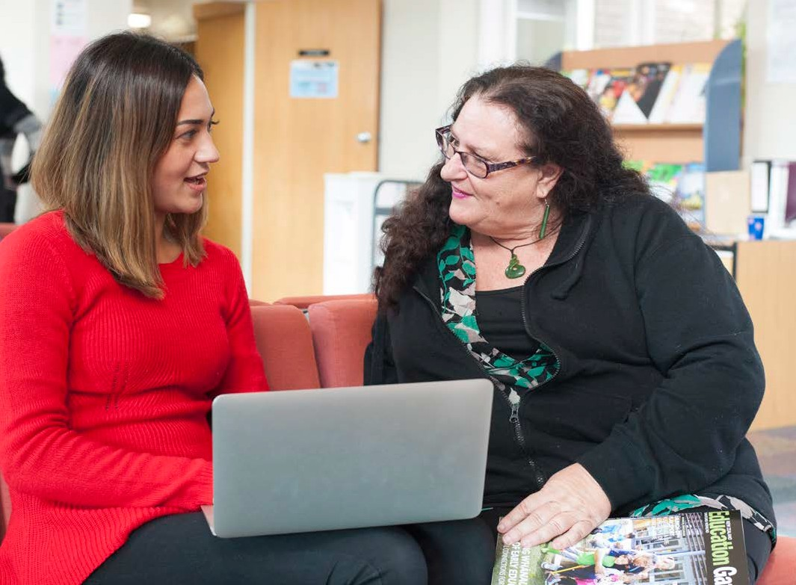

Kura did however need pūtea to maintain the relationship especially if more is being required of iwi in order to support kura/kura auraki
to implement the curriculum. Their time and expertise should be compensated.

Ngā Rauemi
Only one kura agreed that they had sufficient teaching and learning resources available
to achieve the aims of Te Takanga o te Wā. While these kura had access to people and places and had the capability within their kura they still required a range of age-appropriate resources, local stories (for example learning packs for each Huatau Matua) in different forms and supporting PLD:
There are three of us in our ‘Māori Unit’ that have a wealth/spread of knowledge. However, we all agree that that is not enough. We need more resources that are factual and from a wider variety of perspectives (Iwi/hapū). If this is already out there can you direct us that way?
Most websites are adult oriented and we have to put into ‘student friendly’ language for the history of different kaupapa. If we want our tamariki mokopuna to access this learning
as stated in Ngā Pūkenga, then we need experts to help us, we need student-friendly literature (in hardcopy and digital formats).

Two schools (three respondents) agreed that they had kaiako with expertise to achieve the aims of Te Takanga o te Wā and the other school was unsure. This school thought an appropriate strategy for them was to
wānanga where the resources are within their communities including online resources.

Te ako ngaiotanga
Kura responded that they would like facilitators to come to their kura to run whole kura PLD. Ideally facilitators are from kura Māori who know the kaupapa of kura Māori as well as the curriculum:

Hikoi te hikoi…Mahi ngatahi… Awhi mai, awhi atu…Tohaina e ngā kaiako, ko wai, no hea…Mena ka mōhio, ka mārama, ka mātau ngā kaiako ā karawhiua mai te kaupapa.

The learning also needs to be relevant, engaging and fun. There also needs to be a tailored PLD package for kura leadership including Boards.

Ngā aukati me ngā rongoā
Respondents did not consider there were any major barriers to implementing the curriculum, however, PLD, resources and relationships would support and accelerate quality implementation. One respondent commented that implementing Te Takanga o Te Wā and Aotearoa New Zealand’s Histories might be challenging for teachers and there needed
to be opportunities and safe places for any differences to be heard:

Some kaiako may hold personal grief in relation to some history concepts. There needs to be a space for mamae to be let off, so these kaiako can move forward and teach the curriculum content without the endangerment of any ill emotions impacting on the understanding of our tamariki.

Ngā hononga
Two schools (three respondents) agreed that they have strong relationships with local iwi and hapū and two were not sure. Four of
the five respondents agreed that they have strong relationships with local/regional history organisations (e.g. local museums) to draw on as resources.

Ngā wero me ngā huarahi nui e tuwhera ana
Respondents thought the greatest challenges were accessing information that is reliable and drawn from a Māori world view; helping whānau to understand the importance of history and not offending those with different views of history especially on topics that may be confronting for Māori and non-Māori; and
ensuring that content is taught without bias so teachers are not passing on their unresolved feelings and issues to students.
Similar to other survey feedback, respondents thought the greatest opportunities were to connect tamariki to who they are and their communities; to learn about local history; to improve race relations through knowledge and understanding; and to grow student citizenship and confidence to stand proud as Māori:

Ka mōhio, ka mārama, ka mātau ngā tamariki mokopuna te kōrero tika, te kōrero pono ki te Māori, aa Ko wai rā rātou? Ki te tuhono ki ngā taonga Māori ara ko te hikoitanga o ngā iwi, hapū, whānau. Ko ngā painga e pa ana ki ngā tangata whenua. Mo ngā tamariki e Māori ana ki te Tū Whakahira, te Tū Angitu i tēnei ao, aa, i te ao hurihuri. Tino harikoa taku ngākau.

MINISTRY OF EDUCATION
TE TAHUHU O TE MATAURANGA

We shape an education system that delivers
equitable and excellent outcomes
He mea tarai e matou te matauranga
a rangatira ai, kia mana taurite ai ona huanga

