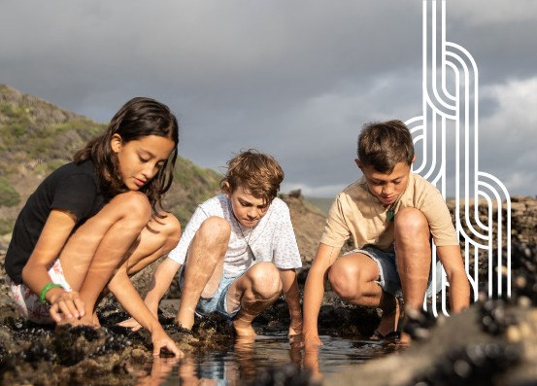

Aotearoa

New Zealand’s histories
Findings from the public engagement on the draft curriculum content

Aotearoa New Zealand’s histories
Findings from the public engagement on the draft curriculum content

Rangahau Mātauranga o Aotearoa | New Zealand Council for Educational Research

2021

Images in this report are Crown copyright, used with permission of the Te Tāhuhu o te Mātauranga | Ministry of Education.

Rangahau Mātauranga o Aotearoa | New Zealand Council for Educational Research P O Box 3237
Wellington New Zealand

www.nzcer.org.nz

ISBN 978-1-99-004017-7

© NZCER, 2021

Ngā wāhanga o roto | Contents

Whakarāpopototanga | Summary 1
Key messages from the consultation 1
Section 1: He whakamārama mō ngā tātai kōrero o Aotearoa | Introducing Aotearoa
New Zealand’s histories 3
About the consultation 4
How did the public give feedback? 4
Approach to analyses 4
Who responded? 5
An overview of Māori respondents 7
General remarks 7
About the structure of this report 7
Section 2: He aha ngā whakaaro o te iwi whānui mō ēnei kiko hukihuki me tōna whakaata i te motu nei? | Do people think the draft content reflects us as a nation? 9
Main insights—Do people think the draft content reflects us as a nation? 10
He whakarāpopototanga | In summary 20
Section 3: He aha ngā mea hira ki te iwi whānui? | What is most important
to people? 21
Main insights—What is most important to people? 22
He whakarāpopototanga | In summary 27
Section 4: He aha ngā tino wero kei mua i a tātou? | What do people see as the challenges in implementing this curriculum change? 28
Main insights—What do people see as the challenges in implementing this curriculum change? 29
He whakarāpopototanga | In summary 31
Section 5: Ngā tirohanga mai i ngā ākonga | Perspectives from learners 32
Survey responses from ākonga and learners 32
He whakarāpopototanga | In summary 38
Section 6: Ngā tirohanga mai i ngā kaiako | Perspectives from teachers 39
Survey responses from kaiako and teachers 39
He whakarāpopototanga | In summary 44
Section 7: The New Zealand Curriculum and Te Marautanga o Aotearoa: Ngā tirohanga mai
i te iwi Māori | Perspectives from Māori 45
Survey responses from Māori to The New Zealand Curriculum and Te Marautanga o Aotearoa 45
Themes from feedback about Te Marautanga o Aotearoa and The New Zealand Curriculum 49
He whakarāpopototanga | In summary 56
Section 8: Te Takanga o te Wā: Ngā tirohanga mai i te iwi Māori | Perspectives from Māori 57
He whakarāpopototanga | In summary 60
Section 9: Ngā tirohanga mai i ngā tāngata o te Moana-nui-a-Kiwa | Perspectives from
Pacific peoples 61
Survey responses from Pacific peoples 61
He whakarāpopototanga | In summary 68
Section 10: Ngā tirohanga mai i ngā tāngata o Āhia | Perspectives from Asian peoples 69
Survey responses from Asian peoples 69
He whakarāpopototanga | In summary 73
Āpitihanga | Appendices 74
Appendix A | Who responded to the online survey? 74
Appendix B | Content questions by role 79
Appendix C | Content questions by ethnicity 81

Tables
Table 1 | Survey responses from ākonga and general survey responses responding to which parts of history they thought were most important | 25
Table 2 | National, regional, local, and iwi topics | 27
Table 3 | I believe the content will encourage more diverse local stories to be acknowledged and learnt by young people in school and kura | 53
Table A1 | Breakdown of which curriculum content survey respondents chose to respond in relation to | 75
Table A2 | Main respondent role type by region | 78
Figures
Figure 1 | General survey respondents’ agreement with the three items about the draft curriculum content | 10
Figure 2 | What general survey respondents are most interested in young people learning and developing | 22
Figure 3 | What general survey respondents perceive to be the greatest challenges | 29
Figure 4 | Ākonga and learner responses to the four items about the draft curriculum content | 33
Figure 5 | What is most important to ākonga and learners | 35
Figure 6 | What ākonga and learners think could be improved | 37
Figure 7 | Kaiako and teacher responses to the three items about the draft curriculum content | 40
Figure 8 | What teachers and kaiako are most interested in young people learning | 42
Figure 9 | Greatest challenges identified by kaiako and teachers | 43
Figure 10 | Breakdown of Māori respondents by role | 46
Figure 11 | Breakdown of Māori respondents to the general survey by region | 46
Figure 12 | Māori respondents’ agreement with the three items about the draft curriculum content | 47
Figure 13 | What Māori are most interested in young people learning | 48
Figure 14 | Greatest challenges for implementation | 49
Figure 15 | Breakdown of Pacific peoples’ respondents by role | 62
Figure 16 | Breakdown of Pacific respondents to the general survey by region | 62
Figure 17 | Pacific peoples’ responses to the three items about the draft curriculum content | 63
Figure 18 | What is most important for students to learn—Pacific respondents | 65
Figure 19 | Greatest challenges in implementing the draft content—Pacific respondents | 67
Figure 20 | Breakdown of Asian respondents by role | 69
Figure 21 | Breakdown of Asian respondents to the general survey by region | 70
Figure 22 | Asian responses to the three items about the draft curriculum content | 71
Figure A1 | Breakdown of respondents by role or identity | 74
Figure A2 | Ethnicity of general survey respondents | 76
Figure A3 | Ethnicity of ākonga/learner survey respondents | 76
Figure A4 | General survey respondents, by region | 77
Figure B1 | Survey responses to the item “I think the content reflects the stories our young people need to know” | 79
Figure B2 | Survey responses to the item “I believe the content reflects our bicultural history as a nation” | 79
Figure B3 | Survey responses to the item “I believe the content will encourage more diverse local stories to be acknowledged and learnt by young people in school and kura” | 80
Figure C1 | Survey responses to the item “I think the content reflects the stories our young people need to know” | 81
Figure C2 | Survey responses to the item “I believe the content reflects our bicultural history as a nation” | 82
Figure C3 | Survey responses to the item “I believe the content will encourage more diverse local stories to be acknowledged and learnt by young people in school and kura” | 83

Whakarāpopototanga Summary

Key messages from the consultation

There was general support for the history curriculum content
Across most respondent groups, there was a general sense of positivity and interest in the draft history content for both The New Zealand Curriculum and Te Marautanga o Aotearoa. Most respondents provided supportive commentary about the draft curriculum content, offering constructive feedback and pointing to areas for further improvement.
Compared to all other respondent roles, those who identified themselves as “kaiako/teachers” or “ākonga/learners” were the most positive in their survey responses and feedback about the draft content. Overall, those directly involved in education seemed most positive and hopeful about the history curriculum content. Māori were also very positive overall about the introduction of new content about Māori histories.

People saw strong links between the history curriculum content and their identity, culture, and citizenship
People made clear links that connected the teaching of history to their identity and sense of belonging, culture, and citizenship. Māori welcomed the new curriculum content with high hopes, indicating that it is a positive step towards strengthening the identity of ākonga Māori and knowledge of their own histories and genealogy. Many respondents spoke of the benefits this would bring to the wellbeing, confidence, and aspirations of all ākonga in Aotearoa New Zealand.
Some tensions were also evident, typically reported by those advocating for a singular and/or Eurocentric view of a history curriculum. Those respondent groups were concerned that privileging Māori histories and knowledge in the draft content would “devalue” their own sense of belonging and identity.

People were supportive of bringing Māori histories to the forefront of the history curriculum content alongside other histories
Support for including Māori histories in the curriculum content, provided there is space for multicultural histories, was a strong theme. Many Pacific and Asian respondents in particular spoke about wanting to see themselves and their cultures reflected in the curriculum content and tied to Aotearoa New Zealand.

Aotearoa New Zealand’s histories | Findings from the public engagement on the draft curriculum content

Partnering with hapū and iwi was seen as a significant step in the right direction, but resourcing and support is needed
There was general support for building respectful relationships with hapū and iwi to develop local curricula and marau ā-kura that incorporate hapū and iwi histories. Kaiako, teachers, ākonga, and learners expressed enthusiasm and interest in wanting to learn more about local hapū and iwi histories, but at the same time many teachers did not feel confident in their ability to establish and maintain relationships and partnerships with hapū and iwi. The need for professional development opportunities and other types of resourcing and support came through strongly.
Just as importantly, many people were concerned about whether all hapū and iwi will have the capacity, or desire, to support schools and kura.

People had differing views about the nature of history
Those who believed in the idea that there is only one “true” version of history were overall less positive in their responses. Such responses often conveyed the sense that the history content must be “objective”, “unbiased”, and “accurate”. Respondents who advocated for such a singular view offered different opinions on what content should be included or excluded from the history curriculum.

Schools and kura will play a significant role in whether or not the implementation of the history curriculum content proves successful
Many respondents were worried that too much is being expected of schools and kura in a short timeframe. Respondents were concerned that without enough time and preparation, schools and kura would not be set up to be successful in implementing the draft curriculum content.
Respondents expressed high expectations for how teachers and kaiako should teach the histories curriculum content. They thought that the ideal teacher or kaiako should be interested and knowledgeable in history, confident and competent in teaching it, and able to translate the curriculum content into relevant, relatable, and interesting learning experiences for ākonga. They should be
able to manage difficult—and potentially painful—learning conversations with ākonga and with other teachers and their communities, to care for the wellbeing of all. In kura, this would all happen in te reo Māori.
There was a general concern that many teachers would not be able to live up to this ideal without a great deal of support. People emphasised the negative consequences (both intended and unintended) of not supporting teachers to develop sound disciplinary knowledge and teaching strategies to engage ākonga with the history curriculum content. They also cautioned that teacher bias could negatively influence how, and to what extent, the content is taught.

SECTION 1

He whakamārama mō ngā tātai kōrero o Aotearoa
Introducing Aotearoa New Zealand’s histories

Aotearoa New Zealand’s histories are being incorporated into the national curriculum, both into The New Zealand Curriculum1 and into Te Marautanga o Aotearoa.2 From 2022, Aotearoa New Zealand histories will be taught in all schools and kura.
The following is a description from the Ministry of Education about the scope and context for the draft curriculum content that was recently released for public consultation.
The draft curriculum content embraces the histories of all the people who live in Aotearoa New Zealand and encourages schools and kura to develop local curriculum and marau ā-kura that reflect the histories of their communities.
Learning Aotearoa New Zealand’s histories will help ākonga understand there are multiple perspectives on historical and contemporary events and help them develop their critical thinking and inquiry skills.
The draft curriculum content for histories is the product of many months of work by teams of writers and the Ministry, in collaboration with stakeholders that include historical and curriculum experts, Māori, Pacific, migrant communities, disabled peoples, teachers, kaiako and curriculum leaders.
It describes the histories learning that can’t be left to chance. It outlines the breadth and depth of learning required for children and young people to progress in histories and what learners are expected to understand, know and do at the end of each stage.
The draft curriculum content has been developed to align with the wider work to refresh the national curriculum over the next four to five years.3
This statement positions the work as significant for the future of education in Aotearoa New Zealand. The Ministry of Education wishes to understand diverse views, and to carefully review the draft content, before finalising an area of learning that is critically important and a fundamental pillar for understanding who we are as a nation.

- https://nzcurriculum.tki.org.nz/The-New-Zealand-Curriculum
- https://tmoa.tki.org.nz/Te-Marautanga-o-Aotearoa
- https://www.education.govt.nz/news/aotearoa-new-zealands-histories-in-our-national-curriculum-now-open-for- consultation/

Aotearoa New Zealand’s histories | Findings from the public engagement on the draft curriculum content

About the consultation
The Ministry of Education (referred to hereafter as “the Ministry”) ran a public engagement campaign from 3 February through to 31 May 2021 to support the implementation of content changes to the national curriculum to explicitly include Aotearoa New Zealand’s histories in schools and kura.
The purpose of the consultation process was to answer three key questions:
  - Do people think the draft content reflects us as a nation?
  - What is most important to people?
  - What do people see as the challenges in implementing this curriculum change?
This report is written by an independent educational research organisation—the New Zealand Council for Educational Research | Rangahau Mātauranga o Aotearoa (NZCER). NZCER was contracted by the Ministry to analyse and report the findings from the public engagement about the Aotearoa New Zealand’s Histories in The New Zealand Curriculum and Te Takanga o Te Wā in Te Marautanga o Aotearoa.

How did the public give feedback?
People gave feedback about the draft curriculum content in the following ways:
  - general online survey (4,323 people)
  - ākonga/learners online survey (168 people)
  - submissions (488 submissions)
  - over 90 workshops, fono, and hui.
It should be noted that some survey responses were submitted on behalf of groups; for example, a group of nine kaiako submitted one survey response. Not all responses state the number of people they represent, so the total number of survey respondents is likely higher than stated.

Approach to analyses
To analyse the quantitative data from the surveys, we used descriptive statistics (frequencies and percentages). These provided an overall summary of responses to the closed-ended questions and allowed us to highlight possible associations between survey responses and key demographics.
To analyse the qualitative data from both the surveys and the submissions, we applied a Critical Grounded Theory4 approach. The three questions posed by the Ministry were used to guide the analysis and we were mindful that it was important to capture a range of voices from diverse groups of people. All qualitative data were imported into NVivo (a qualitative data analysis package).
Responses other than those in English and te reo Māori were translated into English then included in the analysis.
Our approach to analysing the qualitative survey data was as follows.
  - We developed a broad framework of coding categories for each of the three questions.
  - We tested the coding framework against a set of early responses.
  - A dedicated team used the coding framework to code the data, refining subcategories as they came to the fore.
  - Coders checked regularly that they were consistent in their approach.

- See, for example, Timonen, V., Foley, G., & Conlon, C. (2018). Challenges when using grounded theory: A pragmatic introduction to doing GT research. International Journal of Qualitative Methods, 17, 1–10.

SECTION 1 | He whakamārama mō ngā tātai kōrero o Aotearoa | Introducing Aotearoa New Zealand’s histories

Submissions, and notes from workshops, hui, and fono, were read and coded against the key questions, themes, and respondent groups.
We then ran a series of coding queries and text searches in NVivo, the results of which were analysed to identify key themes. The team of writers used quotes from respondents to exemplify these themes.

Who responded?

Who responded to the online survey?
In total, there were 4,4915,6 responses to the online survey, of which 4,303 were responses in English. The remaining 188 responses were provided in languages other than English: 19 in te reo Māori, 18 in Samoan, one in Tokelauan, one in Tongan, 85 in Korean, 55 in Simplified Chinese, one in Hindi, and eight in Punjabi.
Appendix A includes a detailed description of who responded to the survey. Below we present a summary of respondents by role, curriculum, ethnicity, and region.

Respondent roles
Respondents to the survey were asked to select one role or identity. The majority of responses to the survey were from community members and parents or caregivers. Just over a quarter of the respondents were kaiako/teachers. This category comprises those who teach across different
education levels. We combined responses from all kaiako/teachers to ensure that the unique voice of educators can be heard. Overall, there were 168 responses from ākonga/learners, who responded to a separate (but parallel) set of survey questions.

Curriculum
The online survey asked respondents which curriculum document their answers related to. The majority of responses related only to The New Zealand Curriculum, with just 58 responses relating only to Te Marautanga o Aotearoa. A sizable minority indicated their responses were in relation to both curriculum documents. Appendix A includes a breakdown of these responses by curriculum document.
With a relatively small number of responses pertaining solely to Māori medium, most of the reporting of survey results combines responses pertaining to Te Marautanga o Aotearoa and/or to The New Zealand Curriculum. However, there is a discussion later in the report where the views of Māori respondents on Te Marautanga o Aotearoa and The New Zealand Curriculum are considered in more depth.
Quotes in this report have predominantly been made in reference to The New Zealand Curriculum. The exception to this is in the two sections relating to Māori perspectives, where we have distinguished whether comments have been made in reference to either The New Zealand Curriculum, Te Marautanga o Aotearoa, or to both curriculum documents. Te Marautanga o Aotearoa is the curriculum for Māori-medium schools.

- This number includes the 168 responses from ākonga/learners.
- Our total number of survey responses is lower than that reported by the Ministry due to data cleaning.

Aotearoa New Zealand’s histories | Findings from the public engagement on the draft curriculum content

Ethnicity
The majority of general survey respondents self-identified as NZ European/European (64%) and Māori (14%). This pattern was the same for the ākonga/learner respondents (59% NZ European/European and 32% Māori).

Region
The greatest number of responses were from respondents in Auckland – Tāmaki Makaurau and Wellington – Te Whanganui-a-Tara. The lowest number of responses were from Nelson, Marlborough, West Coast – Te Tai o Poutini and Hawke’s Bay – Tairāwhiti.

Who were submissions received from?
Although the Ministry did not request submissions, 488 online submissions and email contributions were received in the mailbox for this project. Of these, 195 were identical and many more were short, negative contributions.

Who attended workshops, hui, and fono?
To support public engagement in the Aotearoa New Zealand’s histories draft curriculum content, the Ministry commissioned a number of community and sector-based workshops, hui, and fono throughout the consultation phase. Summaries of workshop discussions were sent to NZCER for analysis.
While many of the workshops, hui, and fono were led through the Ohu Matua membership, the Ministry supported over 90 engagement events, both face-to-face and online.
Targeted engagement with key stakeholder groups included Pacific fono with community and church leaders (13), workshops hosted in partnership with ethnic and faith-based communities (23) (for example, the Korea–New Zealand Cultural Association and ACOFI representing African Community Groups throughout Aotearoa), hui hosted at a number of Te Wananga o Aotearoa campuses, groups of university and school students, and a number of culture and heritage organisation events.
Participants were encouraged to complete the online survey. However, where the preferred method of feedback was through discussion, notes were recorded and submitted to NZCER for analysis as part of written submissions.

Māori focus
Ten workshops about Te Takanga o te Wā were held with 98 participants in Tāmaki Makaurau, Waikato, Rotorua, Te Tairāwhiti, Wellington, and Christchurch. Notes from workshop discussions were provided to NZCER.

Pacific focus
Face-to-face fono with Pacific communities took place in Wellington, Auckland, and Christchurch, including a fono for Pacific church leaders hosted in Auckland. These resulted in five group feedback submissions. Several smaller engagements included hosted conversations with Pacific historians and students of the University of Auckland, Pacific secondary teachers and students, individual church sessions in Auckland and Porirua, and a focus group with Pacific students of Victoria University of Wellington. These resulted in eight sets of written feedback submitted to NZCER.

SECTION 1 | He whakamārama mō ngā tātai kōrero o Aotearoa | Introducing Aotearoa New Zealand’s histories

An overview of Māori respondents
Here we provide information specifically about survey responses from Māori respondents. These responses were included in the overall analysis and separately analysed for the sections on Perspectives from Māori.
There were 620 survey responses from Māori to the general survey. The responses from the general survey pertained to the following curricula:
- responses relating to both Te Marautanga o Aotearoa and The New Zealand Curriculum: 288 (46%)
- responses relating to The New Zealand Curriculum only: 272 (44%)
- responses concerning only Te Marautanga o Aotearoa only: 30 (5%)
- respondent was unsure which curriculum their responses were in relation to: 30 (5%).
In addition, there were 53 responses to the Ākonga/Learners Survey from Māori.

General remarks
History is a contentious and contested space. How history is taught in Aotearoa New Zealand influences how we see ourselves, our cultures, and our views of how we fit into society. The consultation exercise about Aotearoa New Zealand histories elicited some strong opinions from the public, both positive and negative.
As will be described in this report, many respondents saw the inclusion of Aotearoa New Zealand histories in schools and kura as being necessary to help fulfil Te Tiriti o Waitangi obligations. Many respondents also saw the proposed changes to the curriculum as important, overdue, and of benefit to learners and to Aotearoa New Zealand.
In some instances, we saw opposing views taken on the same issues and these have been described in the report. For example, whereas some respondents indicated that history is not important or relevant to today, others saw history as being extremely important and essential for learning critical thinking skills. Moreover, whereas some respondents insisted that the proposed history curriculum must recognise us as one nation, others called for stronger recognition of diverse multicultural communities within the Aotearoa New Zealand histories curriculum. We also saw opposing opinions on which historical facts were “real” and which were not.
In other instances, we saw outright rejection and serious concern expressed about the proposed ideas introduced in the draft curriculum content. At the extreme end of the negative commentary, we read many responses that were anti-Māori, anti-Māori history, and anti-Māori language.
To give insights into the range of views expressed by the public, our approach has been to report separately on the overall positive and negative feedback received, as well as reporting by major ethnic groups and respondent roles. We have omitted from our reporting quotes or references that exemplify extreme racist views.

About the structure of this report
The next three sections of the report present the findings from our analysis of the survey data and submissions. Each section responds to one of the three questions of specific interest to the Ministry:
Section 2: Do people think the draft content reflects us as a nation? Section 3: What is most important to people?

Aotearoa New Zealand’s histories | Findings from the public engagement on the draft curriculum content

Section 4: What do people see as the challenges in implementing this curriculum change? Sections 5 and 6 present perspectives of ākonga/learners and kaiako/teachers respectively.
Section 7 presents perspectives from Māori about Te Marautanga o Aotearoa and The New Zealand Curriculum, followed by feedback solely about Te Takanga o te Wā presented in Section 8.
Sections 9 and 10 present perspectives from Pacific peoples and Asian peoples respectively. Each of these sections presents the findings from the quantitative and qualitative data analysis of responses.

SECTION 2

He aha ngā whakaaro o te iwi whānui mō ēnei kiko hukihuki me tōna whakaata i te motu nei?
Do people think the draft content reflects us as a nation?

This section reports the overall responses to the Ministry’s first key question: “Do people think the draft content reflects us as a nation?”. The section starts with the quantitative responses to the survey and then presents four main insights from the analysis of both the quantitative and qualitative data.
The nature of the draft content—both what it is and what it is not—is explained in this message from the Ministry:
The draft histories curriculum content for Social Sciences and Tikanga ā-Iwi set out broad ideas, contexts, and skills to learn. They do not set out specific topics and kaupapa to be taught. These are decided by kura, schools and their communities as they are set in their local curriculum and marau ā-kura. (Ministry of Education, communication 25 May 2021)
A set of questions in the online survey asked respondents to indicate their level of agreement with three statements about the draft Aotearoa New Zealand histories content. Figure 1 below shows those statements and how people responded to them. For each statement, there are sizeable proportions of responses at each level of agreement/disagreement. This pattern shows a lack of consensus among survey respondent views.
In regard to the statements “I think the content reflects the stories our young people need to know” and “I believe the content reflects our bicultural history as a nation” responses were evenly split between agreement and disagreement.
There was a slightly greater level of agreement among respondents that the content will encourage more diverse local stories to be acknowledged and learnt in schools and kura. Just over half of the respondents agreed or strongly agreed with this statement, compared with 34% who disagreed or strongly disagreed.
Graphs that show responses to the three statements about content, broken down by role and ethnicity, are provided in Appendices B and C. These graphs show that teachers/kaiako indicated much higher levels of agreement across the three statements, whereas community members and parents/caregivers had higher levels of disagreement.

Aotearoa New Zealand’s histories | Findings from the public engagement on the draft curriculum content

Those who selected the “Prefer not to respond” and/or the “Other” ethnicity category tended to have higher levels of disagreement with the three statements.
FIGURE 1 General survey respondents’ agreement with the three items about the draft curriculum content

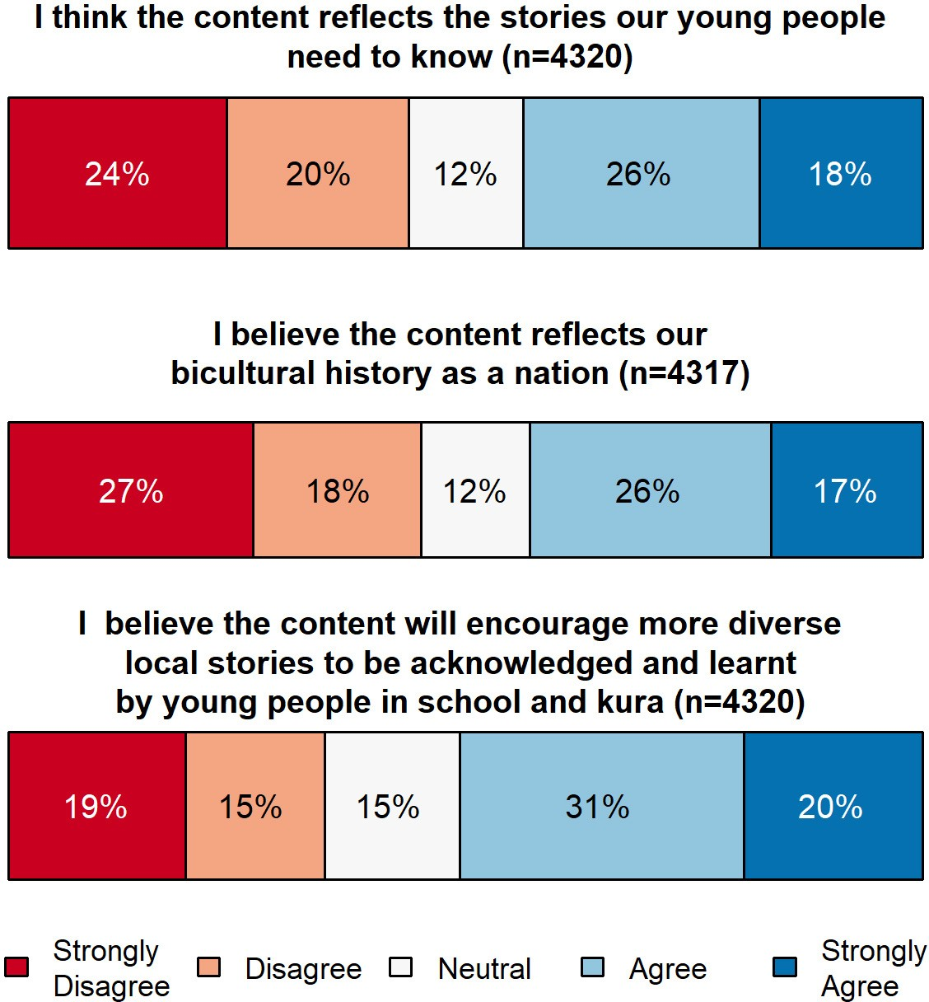

Main insights—Do people think the draft content reflects us as a nation?
This section provides analysis of four main types of responses that emerged from the analysis:
- the general tenor of responses
- getting the balance right
- the multicultural and diverse histories of Aotearoa New Zealand
- suggestions for specific improvements.

The general tenor of responses
The quantitative survey data showed mixed views about the content. Similarly, the qualitative comments provided by respondents showed a range of views. This section gives a brief overview of the tenor of responses across the breadth of the survey, submissions, and workshop notes.

SECTION 2 | He aha ngā whakaaro o te iwi whānui mō ēnei kiko hukihuki me tōna whakaata i te motu nei?
Do people think the draft content reflects us as a nation?

A generally positive response
Many respondents made generally positive comments. This feedback conveyed a sense that the draft content for the history curriculum is important, overdue, and essential learning for all students.
Ka pai te kōrero me te mahi o te Draft mea. Well done team, there is much scope to be able to get right into localised learning and making connections not only through the kōrero but also to the tangata whenua me [te] hau kāinga. Oh, how our people have wanted and waited for this. (Survey, primary kaiako/teacher)
This is a fantastic idea. If we want to challenge our unconscious bias, this is a critical first step. (Survey, parent/caregiver)
I’m just very excited by all of this and how I see it as a hugely important step towards building a better, more equitable and fair New Zealand into the future. I hope I can be part of it in some way. (Survey, community member)
Many positive comments described benefits to learners, and to Aotearoa New Zealand society more generally. The diverse range of benefits mentioned included: having a more secure sense of place and identity; eliminating racism; developing critical thinking skills; learning to take different perspectives; and understanding how current social dynamics were arrived at. Other benefits mentioned were: having an established framework of ideas to draw on when learning about history in informal ways; being better prepared for the future; and tackling difficult issues such as climate change.
Outside school teaching, we now have a vast range of ways of learning our history from places, people, media etc. But to put it together you need the foundation knowledge. (Survey, community member)
It is vital young people are taught about New Zealand stories in context to the global issues we face due to the past three centuries of globalisation … This is an opportunity to put the local into global context, allowing history to make sense of the world around them. One of the greatest challenges of the future will be how the world and New Zealand will combat climate change and other huge global issues, therefore children need to understand how we got to this situation. (Survey, tertiary lecturer)
Many who supported the curriculum also expressed a sense of regret about lost opportunities from their own time at school. They did not want today’s students to grow up in ignorance, as they now felt they had.
I studied history through high school. I went to University after high school and then realised that I was taught a white-washed version of NZ history about the land wars this was in the late 90’s and was shocked at the difference of reality in what was taught in the classroom. I now have children at school and have made sure to educate my child on the reality of NZ history as this is still not being taught today. This is a great step forward. (Survey, parent/caregiver)
I am strongly in support of the teaching of local and regional history. When I was at school in the 90s, we learnt about the Russian Revolution, WW1, and early US history. All of which are interesting and important, but we were taught basically nothing about the history of our own local area, as if we just happened to live in this beautiful sub-tropical vacuum. Since then, I have learnt about the history of where I grew up (Whangārei) and as a result have a much deeper understanding of the place and where all the contemporary issues that people are still arguing about spring from. I wish I had had this knowledge as a younger person as it would have given me a much greater sense of place and of belonging in it. (Survey, community member)

Aotearoa New Zealand’s histories | Findings from the public engagement on the draft curriculum content

Positive feedback from teachers and kaiako included comments on the design, structure, and content of the curriculum, and its usability by teachers.
I think that the three big ideas are good. Power, colonisation and Māori history are great central ideas. (Survey, senior secondary kaiako/teacher)
I found the draft concise and practical to implement in a classroom programme. I am excited to build this knowledge within my classroom and kura with both students and teachers. (Survey, primary kaiako/teacher)
As a migrant from Wales, I often feel unsure how to approach the rather complex and sometimes controversial episodes in the history of Aotearoa. This gives clear acknowledgement to the bicultural history and shows where emphasis can be given. (Survey, primary kaiako/teacher)

Some caveats to positive responses
While most responses were generally supportive, some people expressed reservations about specific aspects of one or both draft curriculum documents. The perceived neglect of cultures and histories of other migrant groups was the most commonly raised issue. This will be a recurring theme throughout the report.
A few respondents expressed concern about how specific terms were being used. Most often, they questioned the scope and meaning of “bicultural” versus “multicultural”. Some people were concerned that the version in The New Zealand Curriculum was not clear enough about Te Tiriti o Waitangi and the Treaty of Waitangi which are two distinct documents. The general tenor of these concerns is encapsulated in the following comment:
Generally, the usage of the term “bicultural” sidelines non-Pākehā migrants. However, the term “multicultural” is no better and has been used to sideline Tangata Whenua. It’s potentially too early to be rolling out the terms Tangata Whenua and Tangata Tiriti given that there has not been enough public discussion about the relationship between these two groups and what Tangata Tiriti means (this terminology is the focus of my research at the moment). However, the wairua of these terms is better than that of “bicultural” or “multicultural”. (Survey, tertiary lecturer)

The general tenor of negative comments
Some respondents expressed strongly negative sentiments about the draft materials. At the most general level, some did not believe that learning about history should be a curriculum priority.
I learnt history of NZ at school and don’t recall it, so felt was a waste of time. (Survey, parent/ caregiver)
Wasting your time. Future is only going to happen faster and faster. Better to teach them how to think and adapt. (Survey, parent/caregiver)
A number of respondents were concerned about the ideas introduced in the draft curriculum content concerning power, colonisation, and Māori history. Through the analysis of the feedback, it appears that some of this concern may be based on resistance to sharing space or power, and/or a conviction that different historical accounts cannot be told differently by different peoples. The latter concern appears to be associated with the belief that there can only be one true version of history, although different “perspectives” could be acknowledged.
Alongside an insistence that history must be taught from a “neutral” point of view, these respondents were worried about Pākehā being blamed for the negative impacts of colonisation on Māori.

SECTION 2 | He aha ngā whakaaro o te iwi whānui mō ēnei kiko hukihuki me tōna whakaata i te motu nei?
Do people think the draft content reflects us as a nation?

A major challenge will be to prevent teachers from demonising colonialism and subsequently making the European descent students feel guilty for their connection to it. (Survey, parent/ caregiver)
Some in this generally negative group also refused to accept Māori accounts of history as reliable or valid, given their oral nature. At the extreme end of the negative commentary, we also read disturbing and hateful anti-Māori and anti-Māori language sentiments.

Getting the balance right
The idea of “getting the balance right” emerged as a clear theme. Responses were predominantly from people who thought there was too much emphasis on Māori history in the draft content and wanted equal emphasis on Māori/Pākehā histories.

Equal emphasis on Māori and Pākehā NZ European perspectives
Many respondents supported having an equal emphasis on Māori and Pākehā histories to show Aotearoa New Zealand as a bicultural nation. They saw positive opportunities for students to develop deeper bicultural understandings and critically explore different views of the same events. These respondents supported a shift in the curriculum from primarily Pākehā-centred narratives of history to a more balanced narrative that includes both Māori and Pākehā viewpoints.
Both cultures should receive equal time for their stories to be told and learnt. (Survey, community member)
Bicultural history should be about both cultures. Understanding Māori/Polynesian culture pre- 1840 and subsequently, is important, but so is understanding settler culture. Both partners to Te Tiriti had a perspective that should be understood in order to gain an appreciation of our bicultural history. (Survey, community member)
Some respondents commented on the absence of Māori histories in past curricula, seeing the new draft content as an important and timely way to redress a Eurocentric, monocultural imbalance in the curriculum.
National History needs to be presented in bi-cultural ways, as too often we frame our anything ’national’ in strictly Pākehā perspectives—by default. It is critical to seek, represent and enhance our historical understanding of NZ from the perspectives and experiences of both Māori and non- Māori. (Survey, community member)
We can no longer stand by and accept only the Pākehā view of history. (Survey, primary kaiako/ teacher)
Additionally, some respondents expressed the view that balanced content should allow ākonga to critically engage with historical thinking and form their own ideas and opinions about the past.
A person who has some knowledge of history should be able to gather lots of information and then form their OWN view of what has happened. (Survey, junior secondary kaiako/teacher)

Resistance to sharing space in the curriculum with Māori histories
While not representative of the majority view, some respondents expressed concerns about the draft content, pushing back against the inclusion of Māori histories because they felt there would now
be too much emphasis on Māori history and not enough emphasis on Pākehā/European history. Some comments showed concern that the draft curriculum’s focus on Māori history will encourage negativity and divisiveness.

Aotearoa New Zealand’s histories | Findings from the public engagement on the draft curriculum content

Too much focus on one view or group will ensure push back from groups who are not affiliated to that group. (Survey, community member)
Other respondents felt that the draft curriculum was not respecting the culture of Pākehā families. They expressed the opinion that New Zealanders are one people, and Māori culture should not be valued more than Pākehā culture.
A practically monocultural curriculum that almost entirely overlooks the Pākehā side of the story. (Survey, parent/caregiver)
I agree that [for] too long [a] time Māori history has not been taught as in-depth as European history, and I also agree that both Māori and European history should be taught to all students. At the same time, I am slightly concerned that the new proposal simply sways the emphasis from mostly-European to mostly-Māori based history. The opportunity here is for equal emphasis to be placed on both perspectives. (Survey, parent/caregiver)

A wide range of events in Aotearoa New Zealand
Some people wanted the stories that are told in the curriculum to reflect a wide range of events in the history of New Zealand.
Where is the balanced examination, over extended time, of technology, business, farming, social change, environment, religions and beliefs, science, the arts, politics, natural events, war, medicine, the contribution and motivations of various groups of settlers …? (Submission, community member)

World histories
Some respondents warned that the draft curriculum is making a mistake by focusing too narrowly on the histories of Aotearoa. They expressed the opinion that the curriculum should locate New Zealand’s histories on the world stage and develop global as well as local understandings.
Yes, it does reflect our bicultural history and it is important that it should. But we are a lot of other things as well as being bicultural, and we need students to think beyond this. They need to know about our place in the larger world, about our social history including how our family and community lives have changed over time, the development of our systems of government, our changing economy, our cultural life, and many other aspects of the past. The emphasis on Māori history and colonisation, while essential, reduces a complex history to a narrow one (Survey, tertiary lecturer).
Teachers and kaiako critiqued specific language and concepts presented in the draft.
I like the general framing; but please do note that the crown is an obscure legal concept—it is not an entity with its own hopes, schemes and dreams! Too often we say ‘the crown’ when we mean the settler body politic—Europeans. The crown is an insidious concept because it lets people off the hook too easily. (Survey, tertiary lecturer)

Sharing positive and negative views of historical events
There were also concerns that histories might be portrayed either too positively or too negatively. Some respondents thought the content put forward a negative view of New Zealand’s history. Others felt that both positive and negative experiences should be included (for example, both the negative and positive impacts of colonisation).

SECTION 2 | He aha ngā whakaaro o te iwi whānui mō ēnei kiko hukihuki me tōna whakaata i te motu nei?
Do people think the draft content reflects us as a nation?

We can only embrace and understand the diversity of our country if we understand and acknowledge ALL aspects that create this nation, including the ’unsavory’ aspects. (Survey, community member)
I believe it is important that neither the history of pre-European Māori society, nor of nineteenth century colonial society are idealised, but that the good and bad of both should be taught to students so that they are exposed to a rounded and nuanced view of our national history. (Survey, community member)

The multicultural and diverse histories of Aotearoa New Zealand
The third theme in relation to the question of whether the content reflects us as a nation is about the need to ensure that the multicultural and diverse histories of Aotearoa New Zealand are addressed. Many survey responses and submissions expressed concerns that learners and communities from diverse cultural backgrounds might feel left out or excluded by the curriculum.
People identified a range of communities whose histories they felt needed to be more visible, including Asian communities such as Chinese and Indian communities, Pacific communities, European groups other than British, former refugees, and other religious and cultural groups with particular histories of migration and influence in New Zealand society.
According to the 1918 census, more than a quarter (27.4 percent) of the NZ resident population was born overseas, following the upward trend from 22.9 percent in 2006 and 25.2 percent in 2013. These people have their own histories, and many including refugees came to NZ to escape political, social and economic oppression. Their prior experiences of power are also worthy of consideration; the nexus of historical and current similarities and differences is a rich place to explore. (Submission, retired educator)
Very limited to only the Māori and British stories. What about the stories of all the other elements of NZ society that have been crucial in weaving together the shared history that makes NZ the country it is today? ... From a purely historical point of view, the following group’s arguably have played the largest roles over the course of NZ history and this should all be mentioned in the curriculum: Māori, British, Chinese, Pasifika, Dutch, French. (Senior secondary kaiako/teacher)

Is Aotearoa New Zealand’s history bicultural or multicultural?
Public feedback included a range of sentiments on the question of biculturalism and multiculturalism. Some people supported a focus on recognising Aotearoa New Zealand’s bicultural histories, while also saying it was important to recognise diverse multicultural histories.
I agree with this if we are only seeking a bicultural approach. Whilst under Te Tiriti o Waitangi a bicultural nation is acknowledged, if we are to truly put ākonga interest and perspectives at the heart of our teaching we must have an openness to multiculturalism. (Survey, community member)
Acknowledging and understanding the history of Te Ao Māori in NZ is long overdue. I think it does a disservice to our history and to other cultures who have played an important part in our current national identity, not to include them in the curriculum as well (Chinese, Samoan / other Pacific Islanders, Europeans etc). (Survey, parent/caregiver)
Some people indicated an understanding of biculturalism as having a specific meaning in reference to Te Tiriti o Waitangi, which identifies two groups: Māori, and all other groups represented by the Crown. Even if this definition of bicultural histories could be understood to encompass all cultural groups,

Aotearoa New Zealand’s histories | Findings from the public engagement on the draft curriculum content

some people felt that the draft curriculum gave priority to Pākehā/British peoples and histories—or would be interpreted in this way when put into practice.
Te Tiriti o Waitangi defines two groups: Māori and “everyone else,” who are represented by the Crown. Pākehā / British colonial settlers do not need to be prioritised ethnically in the history of our nation, particularly given the enormous waves of Chinese, Japanese, Polish, Dalmation and other European early settlers. However, I believe this content provides lots of space for classrooms to explore multicultural histories of Aotearoa as a nation. (Survey, tertiary lecturer)
Others argued that Aotearoa New Zealand is only multicultural and not bicultural. These sentiments were often expressed alongside views that the curriculum gave too much emphasis to Māori histories, or presented views of Aotearoa New Zealand’s colonial histories that the respondent disagreed with.

Suggestions for specific improvements
The fourth cluster of responses in this section represents suggestions for improvements made by respondents. A variety of specific and wide-ranging improvements to the draft curriculum were suggested. Some of the improvements and suggestions referred specifically to the content or structure of the draft curriculum documents. Some suggestions related to improving how the curriculum would be interpreted and expressed in teaching and learning practice.
The four prominent improvement ideas visible in the feedback were:
  - suggestions to add or strengthen the visibility of particular histories
  - ensuring nuance and complexities are present in the teaching of Aotearoa New Zealand’s histories
  - feedback about the overarching themes or structure of the curriculum
  - requests for more specificity and details about what will be taught.

Suggestions to add, or strengthen the visibility of, particular histories
Some people suggested the draft curriculum could be improved by adding, or strengthening the visibility of, particular histories they felt were underrepresented; for example, histories relating to particular people and groups, thematic histories, and particular time periods in Aotearoa New Zealand’s histories.
Some respondents who emphasised the importance of the previous two themes (getting the balance right and multicultural orientation to the curriculum) have also put forward specific ideas or suggestions to ensure that the content reflects those themes.
People and groups’ histories
As previously discussed, a major theme in public feedback was the desire to strengthen the visibility of multicultural New Zealanders’ histories. Some respondents identified additional categories of people and groups whose histories they felt were not sufficiently visible in the draft curriculum, including women, people with disabilities, religious groups, early settlers, LGBTQIA+ communities, and various other groups.
Looking more specifically at Aotearoa New Zealand Histories will that include disability history—
e.g. reference to our institutionalisation of those with intellectual disabilities and how NZSL became an official language alongside Te Reo Māori? (Group submission)
I’d like to see women in our history elevated into the curriculum (many of their stories are not known, celebrated or understood as the stories of men are). (Survey, parent/caregiver)

SECTION 2 | He aha ngā whakaaro o te iwi whānui mō ēnei kiko hukihuki me tōna whakaata i te motu nei?
Do people think the draft content reflects us as a nation?

Some people mentioned the visibility and accuracy of Moriori histories.
It will be crucial that Moriori histories are included, and the myths about them addressed, especially as these myths have been perpetuated through education and are still present today. (Survey, community member)
Iwi histories were also mentioned.
Kaore anō kia tapiri ngā pūrakau ngā kōrero a te mana whenua. Tribal Cultural knowledge has still not been added or given its place! (Survey, hapū/iwi)
Some people noted that cultural and other identity grouping histories are intersectional.
In telling the story of the suffragist movement, it should be acknowledged that wāhine Māori had political power, land ownership etc before colonisation. Framing NZ as the first country to ‘give women the vote’ without acknowledging this can serve to erase this and other Indigenous histories around the world. (Survey, community member)
Thematic histories
Some respondents suggested strengthening the visibility of peace history, environmental history, sports history, history of government, economic history, labour history, the histories of inequality and poverty, disease and demographic histories, popular culture, and histories linking Aotearoa New Zealand and its peoples to the rest of the world.
Te Tiriti is a foundational part of our history and identity post 1840. It is not, however, the only element worth teaching. Our agricultural history, involvement in world wars, more recent nautical history, Antarctic relationships, Rogernomics, state welfare, and nuclear stances are all important elements to cover too. (Survey, community member)
Economic activity as a driver of New Zealand history is largely absent. For example, the curriculum identifies environmental change (Years 4–6) as being the result of ‘different values and cultures that sometimes coincided and sometimes clashed’. Surely, economic opportunities and stresses were more significant causes for environmental change. New Zealand’s welfare measures from 1938 to 1984 can only be understood alongside the policy of protection, which in turn influenced migration policies, which then provided the context for migration of Pacific peoples from the 1940s to the 1970s. (Group submission)
Time periods
Some respondents drew attention to periods of Aotearoa New Zealand’s histories they felt were not addressed in the draft curriculum. This included the natural histories of Aotearoa New Zealand prior to human arrival; the 600-year period between Māori arrival and the Treaty of Waitangi, early contact between Māori and European and other cultures, and 20th century and contemporary histories.
Māori History prior to ToW (1840) missing eg: He Whakaputanga—Declaration of Independence (Survey, parent/caregiver, Māori medium PLD facilitator)
Is there a place about Māori history before Pākehā came? That is important too. That children understand that they were different before colonization. (Survey, junior secondary kaiako/teacher, School counsellor)
One substantial submission discussed seven key themes that had been part of the 2019 announcement about the new histories curriculum content. The submission suggested that two of these themes were not very visible in the February 2021 draft, namely “first encounters and early

Aotearoa New Zealand’s histories | Findings from the public engagement on the draft curriculum content

colonial history of Aotearoa New Zealand”, and “Aotearoa New Zealand in the late twentieth century and evolution of a national identity with cultural plurality”.
The deletion of the ‘contact period’ (c.1769–1840), particularly as it relates to Māori innovation and exploration of the world beyond Aotearoa, the role of missionaries, Christianity, literacy in te reo, and the utilisation of introduced military technology and new agricultural resources, are critical to understanding the Treaty of Waitangi and what comes after it. This period also represents a distinctive and crucial lengthy period of interaction before a formalised colonial relationship….
The current draft says relatively little about the twentieth century. (Group submission)
Feedback about a perceived gap in the “early contact” period of Aotearoa New Zealand histories intersected with the next theme, “ensuring nuance and complexities are present in the teaching of Aotearoa New Zealand’s histories”.

Ensuring nuance and complexities are present in the teaching of Aotearoa New Zealand’s histories
A recurring theme across many submissions related to the nuance and complexities of Aotearoa New Zealand’s histories, and how these would be represented. This theme was often tied to feedback about the histories of encounters between different cultural groups, including (but not limited to) Māori and Europeans.
The content comes across as a classic case of victors versus victims and does not accurately reflect the true delicate intrigue of the times. (Survey, community member)
We are culturally diverse, but there are stories of those different cultures interacting with Māori and settlers in the early years. So those stories [should be there] too. (Survey, community member)
Some people said that the draft curriculum was too reductive in representing the experience and histories of both Māori and Europeans (see also Section 7).
I think it only paints the shallowness of the general stories. I would love to see Māori as entrepreneurs and navigators teased out and featured more. (Survey, senior secondary kaiako/ teacher)
The draft content views Māori as a whole without exploring the dynamics of tribal balance or history. It is this history that defines important aspects of current day NZ including Māori parliamentary seats. (Survey, community member)
Some people named specific people, or specific historical events, as examples of the kinds of things students and ākonga might learn about as a way to access and understand the complexities and nuances of Aotearoa New Zealand’s histories, and build their abilities to develop historical thinking skills including critical thinking and historical empathy.
Another subtheme was the importance of ensuring teachers and learners understand why diverse stories and histories are in the curriculum. This was often paired with questions about who had the right or knowledge to teach or share those stories and histories, and questions about how to weave together different cultural lenses on the nature of histories.
It’s not just stories children need to know, but why particular stories were maintained and passed on. Why were these significant. I can know the story of Māui but do I understand te ika a Māui provides navigational details on the time of year and direction to sail to NZ from the Cooks. Just watch the constellation of te mātau o Māui sink below the horizon at dawn when the sky is red

SECTION 2 | He aha ngā whakaaro o te iwi whānui mō ēnei kiko hukihuki me tōna whakaata i te motu nei?
Do people think the draft content reflects us as a nation?

with blood from te ihu o Māui and you will be sailing the right direction to land on the region of the east coast also known as the hook of Māui. (Survey, parent/caregiver)

Feedback about the overarching themes or structure of the curriculum
Some submissions provided feedback on the structure of the curriculum, including the “three big ideas”,7 the three elements to weave together (know, understand, do), and the progress outcomes. Teachers, and people who identified as historians, often provided the most detailed feedback, unpacking what they liked and did not like about the structure and organisation of the curriculum, and the wording of various constructs in the draft. There was a mixture of positive feedback and critique.
Positives: ... There is an attempt to present different views and encouragement to ensure that previously silent or ignored perspectives and interpretations are acknowledged as an integral part of NZ history (any history). This helps to inform some second order concepts. Furthermore, it can be seen that an attempt to create a transition across the year groups has been taken into consideration (as per the big ideas on p.3). (Group survey response, senior secondary kaiako/ teachers)
I like the way the progressions are set out, easily explained for teaching purposes and for learners. (Survey, primary teacher/kaiako, whānau member)
The “Understanding” section of the draft needs to show more progression. It isn›t sensible to have the same criteria for years 1–3 as years 9–10. Year 1–3 ākonga will not be able to attain these levels of understanding. (Survey, community member, education consultant)
Recommendation: Rephrase Big Idea 1 to acknowledge that Māori history and English history are the two foundational histories that shaped the development of modern New Zealand. (Submission, community member)
Some teachers commented on the relationship between the draft content and the Social Studies learning area, or the wider curriculum. This concern is further addressed in Section 6, which reports more specifically on teacher feedback.

More specificity about what will be taught
Some people, particularly parents or community members, indicated that they weren’t clear on what stories and histories the curriculum would include. They wanted more detail and specificity about what would be covered.
This seems to be an overview with no content. We need to see the stories you are talking about. (Survey, community member)
Discussion documents are very light on what actual content will be taught. In fact it suggests that much of this will be devolved to individual schools to teach the history of their own area. (Survey, parent/caregiver)

- The three big ideas are related to the New Zealand Curriculum content.

Aotearoa New Zealand’s histories | Findings from the public engagement on the draft curriculum content

He whakarāpopototanga | In summary
Overall, the public had mixed views about whether the draft content “reflects the stories our young people need to know”, “reflects our bicultural history as a nation”, and “will encourage more diverse local stories to be acknowledged and learnt by young people in schools and kura”.
Closer analysis indicates that the different groups of people who responded tended to hold different views. Teachers and kaiako were more likely to agree with these statements about the draft content, while community members and whānau/families were more evenly split between agreement and disagreement. Respondents who identified as Māori, Pacific, or Asian were more likely to agree with the statements, and respondents who identified as NZ European, other ethnicities, or “prefer not to respond” were more likely to disagree.
People’s responses expressed a wide range of sentiments, both positive and negative. On the positive side, many people said that draft content for the history curriculum is important, overdue, and essential learning for all students. Many people felt this would benefit learners and Aotearoa New Zealand society more generally, and said they wished they had learnt this during their own time at school. Teachers and kaiako expressed positive feedback about the design, structure, and content of the curriculum, and its useability.
Some respondents expressed strongly negative sentiments about the draft content. Some did not believe that learning about history in general should be a curriculum priority, and some people disagreed with the ideas introduced in the draft curriculum content concerning power, colonisation, and Māori history. The extreme end of the negative commentary included disturbing racist comments about Māori.
Clear themes across much of the public response were the importance of balance, in the many varied ways that people interpreted that term, and a desire to ensure the nuance and complexities of
Aotearoa New Zealand’s histories will be communicated to learners. Many people supported having an equal emphasis on Māori and Pākehā histories to show Aotearoa New Zealand as a bicultural nation.
However, some people said that the draft curriculum was too reductive in representing the experience and histories of both Māori and Europeans. Many people also shared concerns that diverse cultural groups were overlooked in the draft curriculum and wanted to see more emphasis on the histories of (and encounters between) the many different cultural groups that live in Aotearoa New Zealand.

SECTION 3

He aha ngā mea hira ki te iwi whānui?
What is most important to people?

This section reports the overall responses to the Ministry’s second key question: “What is most important to people?” The section starts with the quantitative responses to the survey question about what respondents are most interested in young people learning and developing. We then present further information about the three most frequently selected categories in response to this question which were: critical thinking skills, a deeper understanding of Aotearoa New Zealand, and a greater interest in history. A short section on different perspectives about knowledge follows, and finally we provide lists of the events that people considered to be important at national, regional, local, and iwi levels.
Survey respondents were asked to indicate what they were most interested in seeing young people learning or developing. They could select up to three options from a provided list. There was also an “Other” option that allowed people to specify their own interests. Figure 2 shows the proportion of respondents who selected each option. Critical thinking skills was the most frequently selected option. The next two most frequently selected options were a deeper cultural understanding of Aotearoa New Zealand and a greater interest in history. A breakdown of these responses by role and ethnicity is provided in later sections of the report.

Aotearoa New Zealand’s histories | Findings from the public engagement on the draft curriculum content

FIGURE 2 What general survey respondents are most interested in young people learning and developing
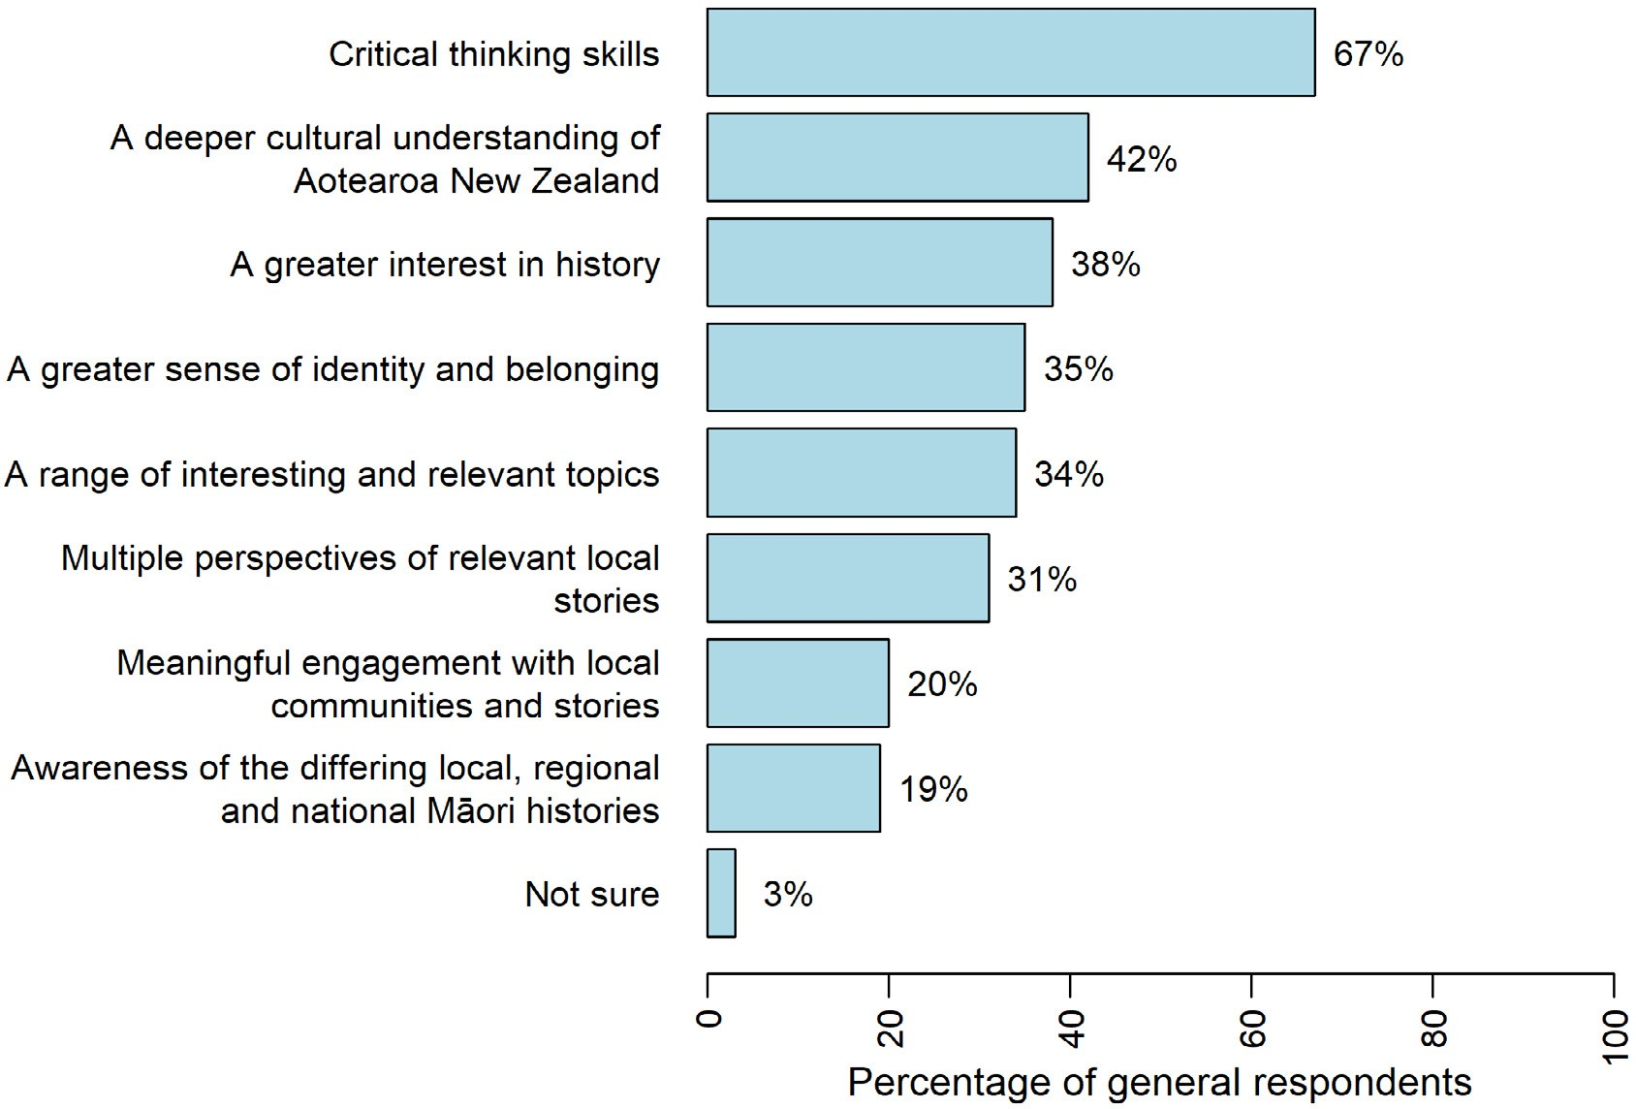

Main insights—What is most important to people?

Critical thinking skills
A large group of respondents acknowledged the importance of encouraging critical thinking in learners. They saw histories as an area that will enable learners to explore events through different perspectives and have critical discussions about what these events mean to them.
Encouraging students to think about structures of power, and which interests of which groups benefit or lose from the use of power, is a good way of fostering critical thinking skills in future citizens of a democratic society. (Survey, community member)
Waitangi Day is taught each year but this is usually from the perspective of the Europeans (due to the fact that most resources relating to the treaty signing are English). It would be fantastic to have the knowledge and resources to be able to accurately give both accounts of the events leading
up to the treaty and the aftermath. This would allow for robust discussion and critical thinking. It would also help students of European descent and other nationalities understand the massive implications the treaty had on our indigenous people. (Survey, primary kaiako/teacher)

A deeper cultural understanding of Aotearoa New Zealand
Many respondents felt that learning about the new content will enable deeper cultural understandings to take place that will contribute to the evolution of our collective national identity.
Learning about the Land Wars and the evolution of NZ national identity is very important to creating a deeper cultural understanding. (Survey, community member)

SECTION 3 | He aha ngā mea hira ki te iwi whānui? | What is most important to people?

It will open up avenues for depth of learning not only around the treaty but also cultural events that have an impact on us all. (Survey, primary kaiako/teacher)
This opportunity for an Aotearoa/NZ history curriculum is a really exciting development, and the consultation document gives me hope that this may enrich and deepen cross-cultural understanding, based on an intersectional power analysis. (which is vital). (Survey, parent/ caregiver)

A greater interest in history
Respondents were enthusiastic about the potential for the new curriculum content to spark interest in learning about Aotearoa New Zealand histories.
The introduction of a compulsory Aotearoa New Zealand history curriculum is a once-in-a- generation opportunity to improve New Zealanders’ understanding and love of the past and to create a thriving historical culture. It is therefore crucial that we get it right. (Submission, community member)
I think this is an awesome step forward in terms of prioritising NZ history and also making history more relevant and interesting as a subject! I’m hoping to have a career in history because I love it, and I really attribute that passion to the great teachers that I had growing up. I hope that this
ties in with a greater prevalence of Te Reo Māori in the curriculum and a push for Te Reo and Te Ao Māori to be taught alongside other subjects, especially history! (Survey, community member)
Teaching a wide range of stories provides more opportunities to spark young people’s passion for and interest in the past. (Survey, tertiary lecturer)

Different perspectives about knowledge
During the analysis process it became apparent that people had different ideas about the nature of knowledge, and specifically the nature of history as a field of disciplinary inquiry. These ideas
appeared to shape responses in critical ways. We created a code called “ideas about history” to catch this thread in the feedback. Broad themes that emerged are briefly outlined below.

History tells the true story about events
The view that “history tells the true story about events” does not leave room for the idea that multiple histories can be recounted based on different perspectives. Historical narratives that people have encountered through past curricula have typically been Eurocentric, which tends to be seen by Europeans/Pākehā as the most reliable form of knowledge. In this view of history, anything else is, at best, a different perspective on the actual truth.
History is factual events & should be told & related as such facts, not embellished, changed, skewed or dramatised in any way. (Survey, tertiary lecturer)
History is not about encouraging ‘diverse local stories’ to be acknowledged. History is not ‘story time’ or nursery rhymes, or bedtime reading fantasies for the little ones. History is a factual account of events of the past. (Survey, tertiary lecturer)
There is and can only be one history of an event, time period or even a national story. There can be differing perspectives on that history, and when I went to school we were taught the
perspectives of other groups or races. However pretending there can be different histories of the same period, is counter to fact and plain English. (Submission, community member)

Aotearoa New Zealand’s histories | Findings from the public engagement on the draft curriculum content

Respondents who held this view also said that the only true history is written history.
A naïve view of the nature of history also appeared to be a contributing factor to some racist comments. Some respondents have absorbed and believed stories about the past that historians now disclaim, particularly in relation to Moriori history.

History should be objective and unbiased
Many respondents did recognise that historical accounts are created by people and would accept these accounts as long as they believed that people had done “proper” research, using an established “historical method” to create them. These respondents felt that historical accounts can and should
be objective and unbiased, and that there is little or no place for emotion. There seemed to be an implicit trust in the authority of published historians, alongside a worry that many teachers would not be unbiased in the same way. A number of teachers expressed views of this type and worried about the consequences for students:
Despite my very deep respect to these people I don’t think we need to learn history based on one- sided narrative and should be researched as a science, not as an emotional story. (Survey, parent/ caregiver)
“Contexts chosen by students when inquiring into the history of the rohe and local area”: as it would be rather difficult for school aged children to validate sources and information, this is open to abuse and manipulation. (Survey, community member)
The idea that the past can be re-interpreted in the light of new knowledge was highly problematic for some respondents who believed in an objective, unbiased version of history. The term “revisionist” was often used to express this type of concern. The focus on historical thinking in the “do” strand of the curriculum did not seem to ameliorate this concern:
It does ‘push’ 21st Century eyes onto what happened in the past and seems to encourage judgments made with hindsight, rather than understanding of the context to the decisions at that time. History become ‘blinkered’—already ‘know’ what looking for (subjective) rather than letting history speak for itself (objective). Thus it may not allow discussions into the contested (and complex) nature of history as seems to have pre-determined judgment made from the outset.
Some thought to teaching ‘historiography’ needed to place this view in context? (Survey, senior secondary kaiako/teacher)

History as disciplined knowledge-building
Some responses appeared to be shaped by the belief that historical accounts are constructed knowledge, underpinned by disciplined knowledge-building practices. The general nature of concerns expressed by these respondents differed markedly in both substance and tone from those outlined above. Further elaboration of the “do” strand of the curriculum might help address some of these concerns.
The Draft Curriculum makes reference to Māori history in a way that frames it in a binary relationship to (presumably) Pākehā history. This is a false dichotomy. History, as a discipline, requires its practitioners to incorporate evidence and perspectives from as wide a range of relevant sources as possible. (Survey, tertiary lecturer)
Rather than ‘learnt’ we should be aware of a wide range of perspectives with regard to historical events and our tamariki should be taught how to place events in a wider perspective of that time and be able to assess what the stories might mean ... what was their purpose, why were they told,

SECTION 3 | He aha ngā mea hira ki te iwi whānui? | What is most important to people?

who told them, what was the context for their telling and how accurate are they really from what we know. We should be equipping our tamariki/ako to have the ability to view history from other perspectives. (Survey, primary kaiako/teacher)

National, regional, local, and iwi histories
Respondents had the option to provide a comment about national, regional, local, and iwi histories. Many of the comments indicated that these categories are flexible, and that making distinctions between them is difficult, particularly when some events in history may be local or regional but have national significance. Outside of these categories, some respondents advocated for the inclusion of whānau and world history in the curriculum.
Overall, people acknowledged the importance of history at national, regional, local and iwi levels, and said that learning Aotearoa New Zealand’s histories will:
- give ākonga and learners a greater sense of identity and belonging
- make ākonga and learners more informed and active citizens
- allow ākonga and learners to understand their local, regional and national landscapes
- teach ākonga and learners more about where they come from, and why Aotearoa New Zealand is the way that it is today
- encourage respect of others and discourage racism and hostility.
Survey respondents were asked to select which parts of history they thought were most important, out of: national history, regional history, local history, and iwi history. Table 1 below shows that national history was selected as the most important. Ākonga showed comparatively greater interest in local, regional and iwi history.

TABLE 1 Survey responses from ākonga and general survey responses responding to which parts of history they thought were most important

Ākonga responses (n = 168)

National history 73% Regional history 45% Local history 47% Iwi history 43%

General responses (n = 4,323)

National history 71% Regional history 29% Local history 31% Iwi history 24%
The following subsections present respondents’ reasons for why national, regional, local, and iwi histories were important to them, along with the most frequently mentioned topics that people would like to see included in the curriculum.

National history
People who said national history was important to them gave the following types of reasons:
- National history can unite us with a shared understanding of what has happened in our country.
- National history will give children big picture context about our nation.
- National history will also help students to understand more about New Zealand’s place in the world.

Aotearoa New Zealand’s histories | Findings from the public engagement on the draft curriculum content

- There are more resources available to effectively teach national histories, as opposed to regional, local and iwi histories.

Regional history
People who said regional history was important to them gave the following types of reasons:
- Regional history helps connect national and local histories in a way that children will understand.
- Regional history will help children know how their communities were formed and what the demographics of their region are.
- Regional history will allow children to become more familiar with the key geographical characteristics of their region.

Local history
People who said local history was important to them gave the following types of reasons:
- Local history means more to children, as they are able to contextualise it in their local environment.
- Learning local history will encourage children to care for their local environment and communities.
- Starting with local histories will be an easier way for children to learn about history; they can branch out into regional and national histories later.
- By visiting local places, and learning about key people in local communities, history will be brought to life and be fun.

Iwi history
It is important to note that many people considered iwi history to be important at every level of national, regional, and local histories teaching. Some argued for giving iwi history its own place within the curriculum to ensure that it gets the full attention it deserves.
People who said iwi history was important to them gave the following types of reasons:
- Iwi history is the foundation of all New Zealand history, and a history of New Zealand without it would be incomplete.
- As iwi history pre-dates European settlement, knowing more about it will deepen children’s understanding of place.
- Iwi history will help all students (Māori and non-Māori) to understand what’s happened here, and whose whenua they stand on.
- Iwi history will help children understand the impacts of colonisation, which is important for addressing racism.
- Iwi history will help all students (Māori and non-Māori) strengthen their identities.
- Iwi history will help Māori students reconnect to their culture and know who they are.
- Iwi history will allow Māori students to see themselves reflected in what they learn.
Respondents had the option to provide topics pertaining to national, regional, local, and iwi histories that they thought should be included. Table 2 below shows the ten most frequent responses given by respondents in relation to each category of history. The repetition of some topics across categories, for example the New Zealand Land Wars, shows that some topics are important in every category.

SECTION 3 | He aha ngā mea hira ki te iwi whānui? | What is most important to people?

TABLE 2 National, regional, local, and iwi topics

National topics  The Treaty of Waitangi and Te Tiriti o Waitangi  New Zealand Land Wars  Migration of all people to New Zealand  Colonisation and its impacts  The World Wars and ANZAC  Pre-European Māori life  New Zealand’s connection with world events  New Zealand politics  Women’s suffrage  Economics and industry | Regional topics  New Zealand Land Wars  Geography and landscape  Migration between regions, and development of regional populations  Economics and industry  Parihaka  South Island and Ngāi Tahu history  Chinese gold miners in Otago  Māori loss of land in different regions  Religion and missionaries  Important people and regional heroes | Local topics  Geography and landscape  Landmarks and infrastructure  Important people and local heroes  New Zealand Land Wars  Economics and industry  Pūrākau and iwi stories  Migration of all people to New Zealand  Pre-European Māori life  Māori concepts and mātauranga  First contact; place names | Iwi topics  Pūrākau and tribal histories (including oral histories and waiata)  Inter-iwi warfare  Key landmarks, such as maunga and marae  Important people and rangatira  Pre-European Māori life  Geographical iwi regions  New Zealand Land Wars  Colonisation and its impacts  Ancestry and origins of different iwi  Moriori history; relationships between different iwi

Note: The 10 most frequent responses (from most to least frequent) are listed top to bottom. New Zealand Land Wars is repeated across the four categories.

He whakarāpopototanga | In summary
Across all public responses, the four things people were most interested in young people learning and developing were: critical thinking skills, a deeper cultural understanding of Aotearoa New Zealand,
a greater interest in history, and a greater sense of identity and belonging. Closer analysis indicates that different groups of people tended to hold slightly different views about what is most important. For example, Māori, and teachers and kaiako, tended to be interested in learners developing a deeper cultural understanding of Aotearoa New Zealand, followed by critical thinking skills, and a greater sense of identity and belonging. Community members and families tended to choose critical thinking skills, a greater interest in history, and a range of interesting and relevant topics as their top priorities.
It was clear in public responses and submissions that different people have different ideas about the nature of history, the purposes for learning history, and what it means to develop an understanding of history as a discipline.
Histories at national, regional, local, and iwi level are all considered to be important and intertwined. Many respondents felt that iwi history in particular is important at every level and should be woven through all national, regional, and local histories teaching.

SECTION 4

He aha ngā tino wero kei mua i a tātou?
What do people see as the challenges in implementing this curriculum change?

This section reports the overall responses to the Ministry’s third key question: “What do people see as the challenges in implementing this curriculum change?”. The section starts with the quantitative responses to the survey and then presents the main insights from the analysis of both the quantitative and qualitative data.
Respondents to the general question set in the online survey were asked to indicate what they saw as being the greatest challenges, by selecting up to three options from a list. There was also an “Other” option that allowed people to specify their own challenges. Figure 3 shows the most frequently selected option was managing teacher bias, followed by lack of kaiako/teacher history knowledge, and finally by “making the topics engaging”.

SECTION 4 | He aha ngā tino wero kei mua i a tātou?
What do people see as the challenges in implementing this curriculum change?

FIGURE 3 What general survey respondents perceive to be the greatest challenges
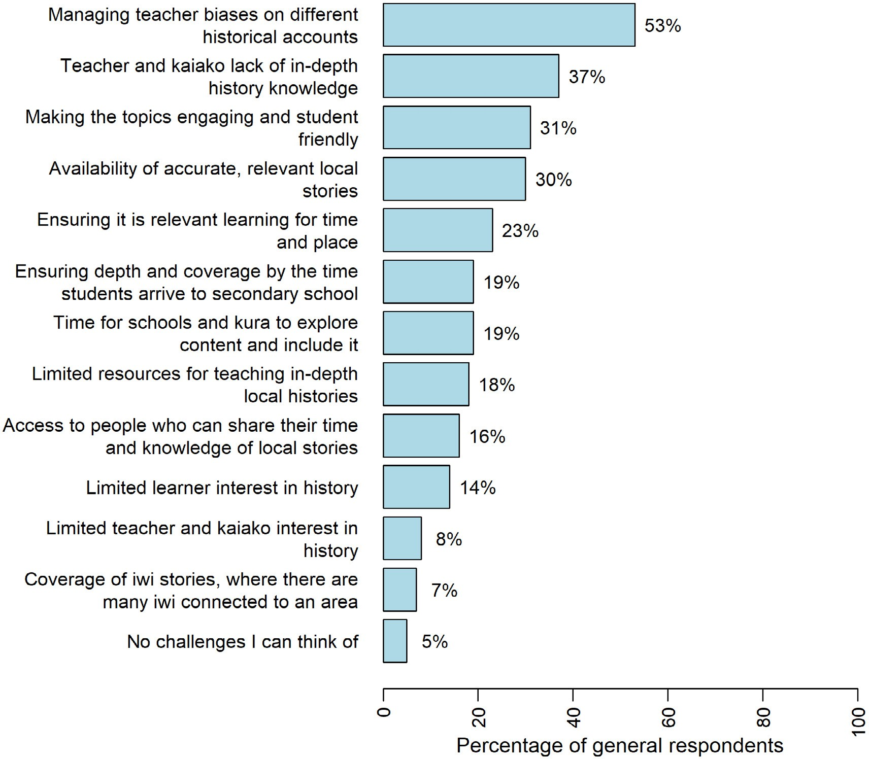

Main insights—What do people see as the challenges in implementing this curriculum change?
The two most frequent responses to the high-level question “What do people identify as the greatest challenge?” were managing biases and lack of in-depth history knowledge. Other challenges that emerged from the qualitative data concerned hapū and iwi capabilities and support, unintended consequences for ākonga wellbeing, and the expectations of schools, with limited time to prepare.

Managing biases in different historical accounts
Many respondents commented on the importance of managing teacher bias, as well as community bias. They described how bias—as well as lack of understanding—can negatively influence the ways teachers deliver the history curriculum content, as well as the type of content they choose to focus on.
Teacher bias and knowledge is going to be a problem on the ground level. At the moment the curriculum is very open to interpretation and could be misconstrued as being only teaching Māori history for example, or that it prescribes certain topics. (Survey, senior secondary kaiako/teacher)

Aotearoa New Zealand’s histories | Findings from the public engagement on the draft curriculum content

It is hugely important that teacher bias is not affecting students’ education, and this is something that is difficult to overcome. There are teachers who hold bias and although they may not be overt with it, students can still be influenced by this bias. It is also important that any bias or prejudice a teacher does have does not influence the teaching they deliver. (Survey, parent/caregiver)
Respondents also commented on community bias; the notion that certain groups or communities might push for certain curriculum content to be taught in schools over other content. The responses indicated that some parents may be opposed to their children being exposed to the histories of other cultures.
I also think managing parent and community bias as to the relevance of NZ history and why it is important to their children. (Survey, parent/caregiver)
I don’t want my children learning this. (Survey, parent/caregiver)

Teacher and kaiako lack of in-depth history knowledge
Teachers and non-teachers alike expressed concerns around teacher and kaiako preparedness and in-depth knowledge to teach the new history curriculum content. Respondents emphasised that successful implementation and delivery of the new content would heavily depend on the extent to which teachers can confidently teach the content, with many respondents generally commenting that they do not believe teachers at present are equipped to do so.
I personally do not have a lot of teacher knowledge. Therefore, I would require further resources and PD. (Survey, primary kaiako/teacher)
A lack of teacher knowledge is going to be a major issue to overcome, teachers currently appear only well-versed in the specific subjects they teach, often limited to the information required for students to pass assessments—this new content will require significant investment in teacher knowledge. (Survey, community member)
I feel many teachers, unless they have a background or interest in the history of Aotearoa/NZ, are either ill-equipped, or feel ill-equipped, to teach NZ history and or local (in my case Canterbury history). I’m referring to non-specialist teachers. (Survey, senior secondary kaiako/teacher)

Hapū and iwi capabilities and support
Although there was considerable support for the idea of schools and kura partnering with hapū and iwi to shape local and regional history content, respondents were concerned about what resourcing and support would be available to hapū and iwi. At the heart of these comments was a concern that schools might either over-burden iwi and hapū, or lack the means and understanding to form
mutually beneficial partnerships—partnerships that could translate into better learning experiences for ākonga about the histories of Aotearoa New Zealand. This idea also came through in Section 7 of this report on perspectives from Māori.
The biggest challenge will be developing authentic relationships and partnerships with iwi and learning to co-design with iwi what their localised curriculum looks like and how this includes Aotearoa NZ Histories while still acknowledging the aspirations that iwi and hapū have for their people. (Survey, whānau)
There is lots of pressure on local hapū/iwi to share their histories. Are there funds to support local hapū/iwi and historians to tell/write down local histories? What if hapū/iwi are not happy to share their histories? (Survey, museum or library representative)

SECTION 4 | He aha ngā tino wero kei mua i a tātou?
What do people see as the challenges in implementing this curriculum change?

Unintended consequences for ākonga wellbeing
Respondents expressed a concern around managing ākonga wellbeing if teaching the histories of Aotearoa New Zealand triggers negative thoughts or feelings. For Pākehā and non-white migrant learners alike, respondents wondered what would happen if young people reacted negatively to learning about the histories of their ancestors and whether that might lead to feelings of guilt and shame. They reported wanting the new curriculum content to foster feelings of belonging and identity.
Please consider how this impacts children and teachers with non-white settler heritage (will they feel left out? how can they feel a greater sense of identity and belonging?). Also, considering how to create a culturally safe space for children with dual or multiple heritages is important + explicit support for teachers/kaiako to teach this curriculum when there is a minority of a group within the student setting. (Survey, parent/caregiver)
In classes with a mix of Māori and Pākehā students, will the new curriculum create tensions between the students? This is not a reason not to teach the new curriculum, but rather is a reflection of tensions that no doubt existed in historical times. The challenge is that teachers/ kaiako will need skills to manage any tensions. (Survey, parent/caregiver)
Respondents were also concerned that learning more about the impact of colonisation on their culture, heritage, and people would be traumatic for ākonga Māori. Respondents wanted the teaching of histories to include the wellbeing of ākonga at its centre. The need for teachers to create safe spaces for challenging or potentially hurtful conversations is also addressed in Section 7.

Expectations of schools, with limited time to prepare
Some respondents described the curriculum as already “over-full” and saw the proposed addition of new content as a challenge. They were also concerned that teachers will not be prepared to deliver the curriculum without significant support.
I am concerned about the full curriculum already in our schools and how the kaiako will be able to fit this in with all the other things that the need to do. What will be missed out on to fit this in and will the kaiako be able to ensure the depth required at each level. (Survey, tertiary lecturer)
You are asking too much from too many teachers. They will not be able to deliver the promises made by the curriculum plan. It will take years for them to develop the resources you expect them to be using. If you want to do this, give them a full set of deliverable content at launch. Give them time to develop the resources directly relevant to their communities. If you expect a bunch of overworked teachers to do the hardest element of the work for you, many will, understandably, underdeliver. (Survey, senior secondary kaiako/teacher)

He whakarāpopototanga | In summary
People saw a range of challenges for implementing this curriculum change. This included concerns about teachers and kaiako lacking in-depth history knowledge, and managing teacher bias. Although there was considerable support for partnering with hapū and iwi when shaping the local and regional history content, respondents were concerned about the resourcing and support available to hapū and iwi to respond to these requests.
Some people raised concerns around managing ākonga wellbeing, if teaching about the histories of Aotearoa New Zealand triggers negative thoughts or feelings. Some people felt that teaching the draft curriculum content would require too much of schools, and they would struggle to implement the curriculum change well, without significant support.

SECTION 5

Ngā tirohanga mai i ngā ākonga Perspectives from learners

This section highlights some of the key ideas and themes shared by ākonga and learner respondents to the survey.8 This group included ākonga and learners from all education levels. The opinions of this group were therefore wide ranging.

Survey responses from ākonga and learners

Do ākonga and learners think the content reflects us as a nation?
The ākonga/learner online survey included a set of four statements about the draft content.
Ākonga and learners were asked to rate their agreement with each statement. Figure 4 shows these statements and how ākonga and learners responded. Across all four items, ākonga and learners were positive in their views:
- 70% agreed or strongly agreed that they would be interested to learn about the proposed history content
- 61% agreed or strongly agreed that the content reflects Aotearoa New Zealand’s bicultural history as a nation
- 78% agreed or strongly agreed that the proposed history content will mean they learn more about Aotearoa New Zealand’s local history and stories at school and kura
- 75% agreed or strongly agreed that they want to learn more about Aotearoa New Zealand’s local history and stories at school and kura.

- We report on overall views from ākonga and learners only, as the sample size is small and the survey did not gather demographic information such as student age or education level.

SECTION 5 | Ngā tirohanga mai i ngā ākonga | Perspectives from learners

FIGURE 4 Ākonga and learner responses to the four items about the draft curriculum content
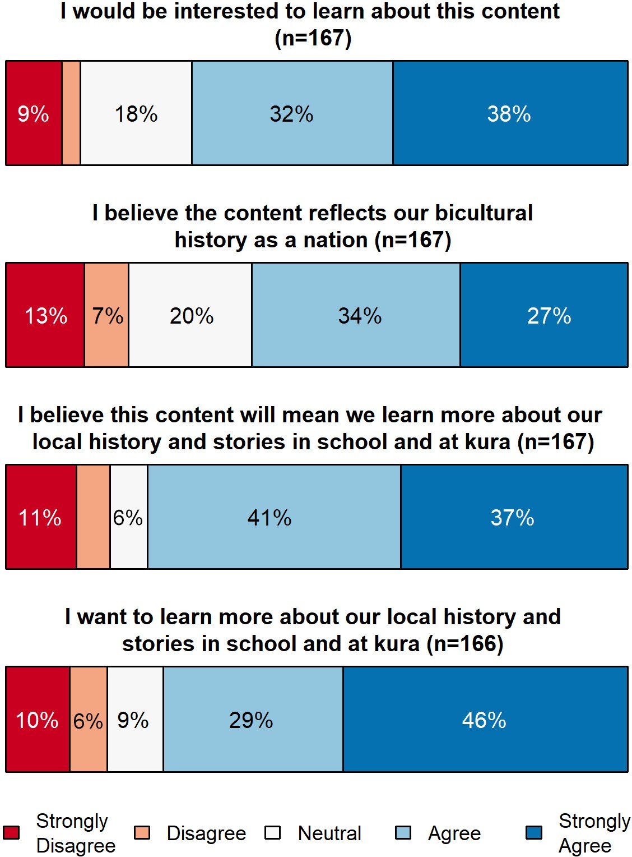

Interested in knowing more
Overall, ākonga and learners were positive about the new histories curriculum. Many expressed an interest in learning more about Aotearoa New Zealand’s histories, even if they had not been exposed to much learning in this area before.
I don’t know much of any history in New Zealand, but I would like to learn more. (Survey, ākonga/ learner)
I’m very interested in learning the truth about our history. I have done a decent amount of study in this regard to date but would like to see the truth about it all and be taught in schools. (Survey, ākonga/learner)
I think it would be good to learn more about it. (Survey, ākonga/learner)
Some ākonga and learners who had encountered histories teaching and learning in the past expressed their shock at not having been exposed to this content earlier in primary school. They saw that the histories learning they did have, beyond primary school, had opened their eyes to greater equity issues in New Zealand society.

Aotearoa New Zealand’s histories | Findings from the public engagement on the draft curriculum content

I did New Zealand history for a section of high school, and it was then that I found part of the truths about New Zealand history. This shocked me as I felt guilty for what my people did back then. I think it is important for everyone to be educated in our history to help us better understand the grievances today. (Survey, ākonga/learner)
I’m currently a student but NZ trained health professional. I recently learned about colonisation history in NZ and now I see why we have to work to reduce health disparity in Māori. I’m afraid my Kiwi colleagues do not quite understand this as they only learn benign NZ history in school. It wasn’t in our professional course, either. Not good. I wish I would have learned earlier! (Survey, ākonga/learner)

History must be interesting and engaging
Ākonga and learners said that they would like the way they learn histories to be interesting, and the content engaging and relevant. One Māori ākonga spoke about how learning about the history of her culture in a self-guided way engaged her interest.
Our kura did a mix of world and Kiwi history, however, a lot of our work was driven by self-interest and was self-motivated. Students chose stories that reflected their own culture, or sheer interest, which included non-New Zealand stories. For example, I did the Northern Wars as a Ngāpuhi wahine who was interested in my own history ... This self-directed study also means that Māori students and Pasifika students can research things relevant to their roots, rather than learning another iwi’s history while being blind to their own just because they attend school in an area where they are not the dominant iwi, or are a sizeable minority. (Survey, ākonga/learner)

Multicultural lenses
Many of the ākonga and learners who responded to the survey spoke about the importance of learning about history from multiple cultural perspectives.
We’re a multicultural country so all cultures should be considered, However, for Māori and Pākehā culture alone, the content is good. (Survey, ākonga/learner)
Asians are 15 percent of the population and the Chinese have been here for 180 years I would like more history on Chinese settlers and the struggles they faced. (Survey, ākonga/learner)
I would like me and my friends to learn more about Pacific history and people and how amazing we are. (Survey, ākonga/learner)

More Māori knowledge and stories
Māori history and knowledge were important for some Māori and non-Māori ākonga and learners. Adult learners, at a tertiary level, also talked about how learning about Māori perspectives on history had helped them to understand more about inequities in the Aotearoa context.
I would be interested to learn about the content, but also hearing different stories from different sources, such as hearing stories directly from the local iwi. (Survey, ākonga/learner)
I have just read a lot on Māori reclaiming their education and found this topic very interesting. Up until I had read it, I was always a bit confused as to why my Māori peers and friends during school were often falling behind so I believe if this information was more in the public’s eye, we would be able to excel more as a nation in education. (Survey, ākonga/learner)

SECTION 5 | Ngā tirohanga mai i ngā ākonga | Perspectives from learners

A group of ākonga and learners of multiple ethnicities made a joint response to the survey. Their teachers summarised their feedback on what learning Māori content meant for them, as Māori, Asian, European, and recent immigrants from Africa and the Middle East.
Strengthening Māori knowledge will enable our tamariki without Māori ancestry to explore their own culture and to develop a cultural identity. This is vitally important for the wellbeing and identity of all New Zealanders. (Group survey response, ākonga/learners)

What is most important to ākonga and learners?
In the online survey, ākonga/learners were asked to indicate what aspects of the draft content they were most interested in, by selecting three options from a list. Figure 5 shows the percentage of ākonga and learners who selected each option.
The most frequently selected aspect was the opportunity to learn more about local, regional, or national Māori history. This was followed by understanding Aotearoa New Zealand more, and opportunities to learn local stories and histories.
FIGURE 5 What is most important to ākonga and learners
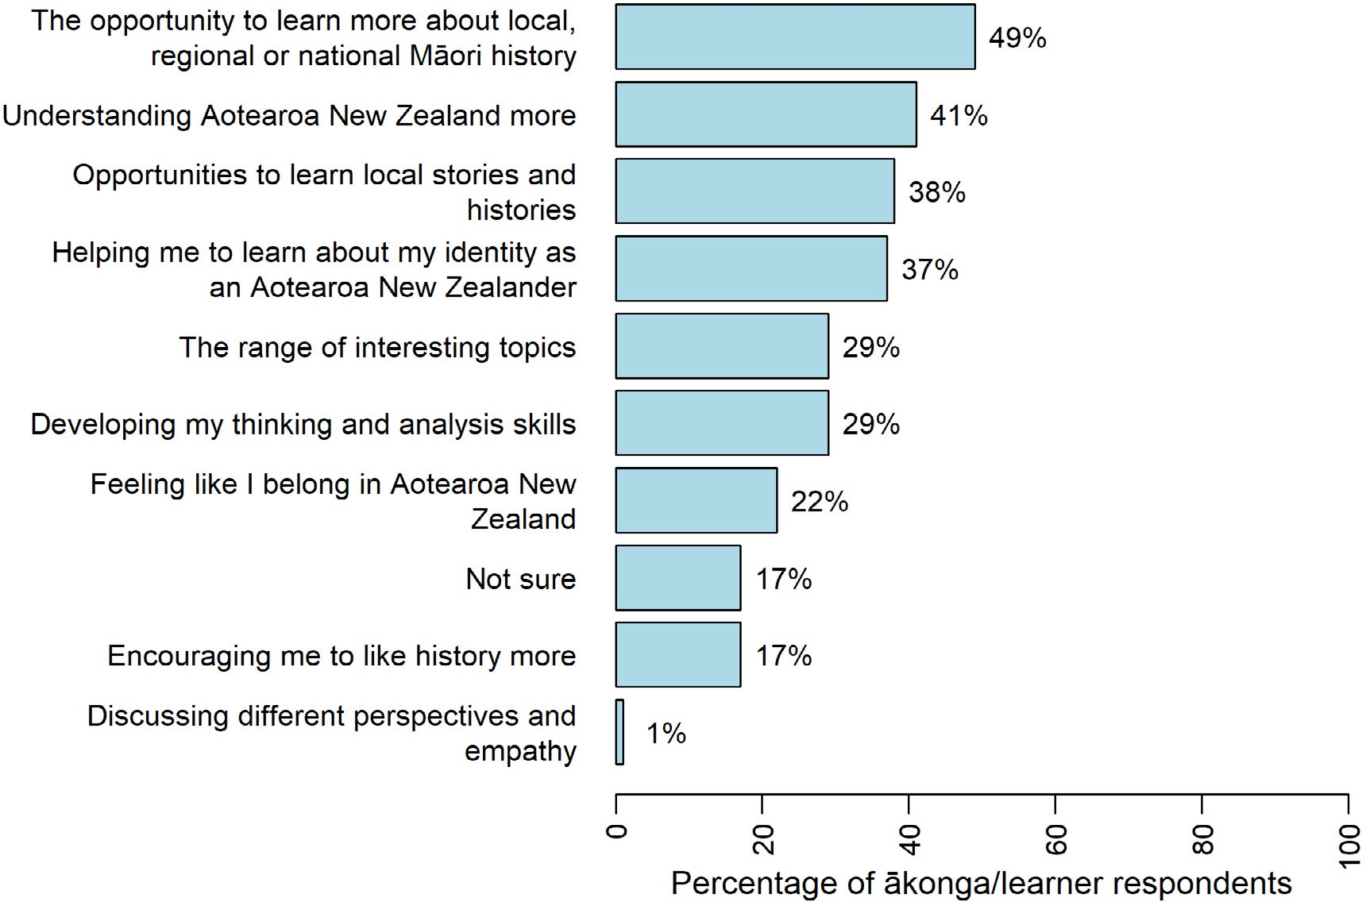

A wide range of histories
National, local, iwi, and regional histories were all thought to be important according to responses by ākonga and learners, many having had little or no exposure to the subject previously.
Ākonga and learners mentioned a range of different historical subjects they would be interested in learning more about, including the New Zealand Wars, women’s suffrage, and the Treaty of Waitangi. In

Aotearoa New Zealand’s histories | Findings from the public engagement on the draft curriculum content

keeping with their desire to see more multicultural histories, students also mentioned the importance of learning about the contributions Pacific and Chinese people have made to New Zealand.
This is particularly with regards to the New Zealand Wars which I see as a fascinating moment in our national history. I previously learned about the Waikato Wars as a Year 10 student but did find it to be a somewhat dull topic at the time. It’s only now after reading more about my local history and the works of NZ historians (especially James Belich) as a Year 13 scholarship student that I have become deeply passionate about the topic and wish it was incorporated with these sorts of details when I was younger. (Survey, ākonga/learner)
I find that this content is rather good ... However, I don’t believe it has enough information on the background of the Māori/Polynesian roots … You NEED to include the Great T’ui Tongan Empire, a vast pan Polynesian Empire that spanned from the Solomon Islands, Fiji, Tonga, Niue, Cook islands, etc. (Survey, ākonga/learner)
I am more interested that the draft is done up and rewritten, proof read and includes way more Pacific history. (Survey, ākonga/learner)

Connecting to relevant local stories
Ākonga and learners expressed an interest in knowing more about, and therefore feeling more connected to, their national and local environments. They spoke about how this would give them a greater sense of belonging, would help them to understand where they came from, and would teach them more about why New Zealand is the way it is today.
It’s super important to focus on that idea of place, but also to focus on a particular place of importance to learners. (Survey, ākonga/learner)
Having interesting topics and the opportunity to learn local stories and histories should make history interesting and though learning about their identity people will find the subject relevant. (Survey, ākonga/learner)
A few ākonga and learners also mentioned that they would like to learn about their own genealogy and ancestors. Some Māori students also said that it was important for them to be able to learn more about their own iwi and hapū.

What do ākonga and learners see as the challenges in implementing this curriculum change?
The online survey also asked ākonga and learners to indicate what they felt could be improved with the draft content, or what could help them learn it. Again, they were asked to select three options from a list. Figure 6 shows the percentage of ākonga and learners who selected each option.
The most frequently selected option was having a knowledgeable and supportive teacher. The second and third most frequently selected options were “the learning of history” and “how to deal with racism”.

SECTION 5 | Ngā tirohanga mai i ngā ākonga | Perspectives from learners

FIGURE 6 What ākonga and learners think could be improved
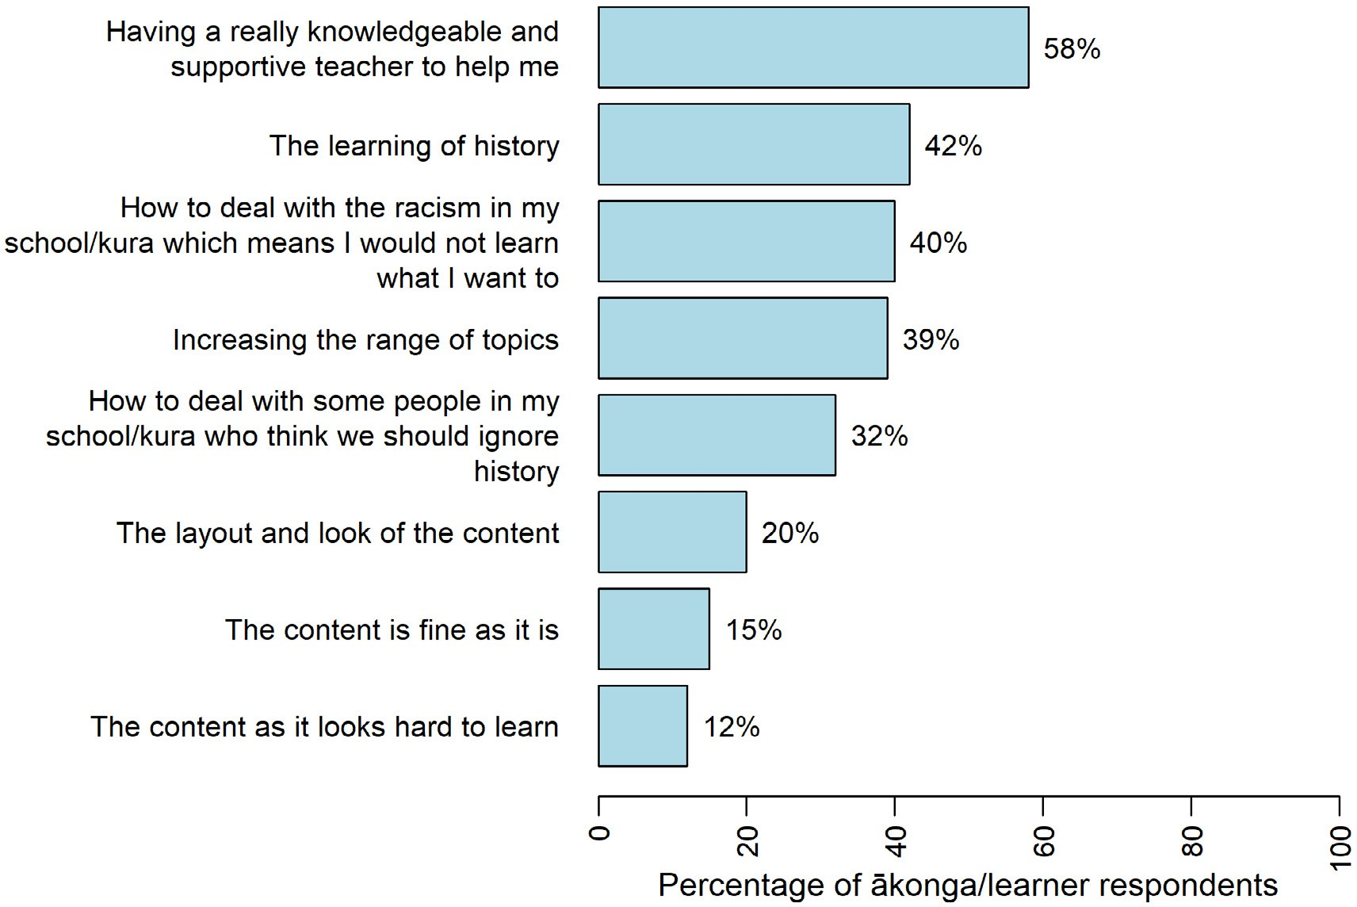

Histories teaching is teacher dependent
A strong concern expressed by ākonga and learners was that engagement with the new curriculum content will depend on the knowledge base and enthusiasm of their teachers.
This is a very tricky situation and I believe that some of the teachers themselves might not be as passionate about it as others. You will only ever be as good a learner as the person teaching you. (Survey, ākonga/learner)
I think it will depend on what the teacher wants to teach us. (Survey, ākonga/learner)
Depends on how it is taught although I understand you cannot change that but it has a big impact. (Survey, ākonga/learner)
Teacher knowledge, time, and enthusiasm could also impact on the depth of the histories teaching and could lead to children with less enthusiastic teachers having less time and resources put into their histories learning.
I do think that this leaves some room for teachers to not engage as heavily as I would like with local history. I think that there is also the chance that it will be sort of jammed on the end rather than centred within anything. I worry that teachers of certain places don’t know and may not feel comfortable learning much about local history and will learn just enough to be sufficient. (Survey, ākonga/learner)

Aotearoa New Zealand’s histories | Findings from the public engagement on the draft curriculum content

Ensuring learning is relevant to students of all cultures
A few of the ākonga and learners from minority groups were concerned that if their histories were not included in the curriculum, they might continue to feel marginalised in the classroom. The context of their particular schools might also impact on whether or not their history learning is diverse.
If it is better than this draft, then I hope it will mean I don’t feel like a second-class citizen. (Survey, Pacific student)
It feels like NZ history is shaped solely by Pākehā and Māori and the future of NZ is in the hands of Pākehā and Māori. As an Asian, I’m irrelevant to NZ, including in the past and in the future
… Interpreting everything as binary (e.g. Pākehā and Māori) is tunnel vision, no better than interpreting everything via a single lens. (Survey, Asian student)
Don’t think me and my friends gonna learn anything Māori or Pacific for that matter … White schools, white neighbourhoods, white teachers/staff and white kids means white-ish local histories. (Survey, Pacific student)

He whakarāpopototanga | In summary
Ākonga and students held wide-ranging opinions. Despite the relatively low number of responses from ākonga, clear themes emerged, such as students’ positivity about the new curriculum content, their concerns about whose histories are included, and the preparedness of teachers to teach histories content.

SECTION 6

Ngā tirohanga mai i ngā kaiako Perspectives from teachers

We analysed comments across all categories of teachers and kaiako, including early childhood, primary, junior and senior secondary, and tertiary lecturers.9 As with other groups, teacher/kaiako responses reflected a range of views and opinions, mirroring key themes already discussed in the section that covers what people say about the draft content. A third of all kaiako/teachers’ responses were from Auckland – Tāmaki Makaurau.
However, there were also some noticeable differences in response from teachers and kaiako when compared with other groups such as family/whānau, and community members. Most noticeably, collective responses from teachers were more positive than those from other groups.

Survey responses from kaiako and teachers

Do teachers and kaiako think the content reflects us as a nation?

Overall, teachers were more positive about the curriculum than other groups
Similar to the findings from the ākonga/learner responses reported in Section 5, kaiako and teachers were positive in their views of the curriculum content:
- 66% agreed or strongly agreed that the content reflects stories young people need to know
- 65% agreed or strongly agreed that the content reflects Aotearoa New Zealand’s bicultural history as a nation
- 72% agreed or strongly agreed that the content will encourage more diverse local stories to be acknowledged and learnt by young people in school and kura.
A breakdown of kaiako/teacher responses to the three items is shown in Figure 7.

- Some people in these categories indicated that they were retired or former teachers.

Aotearoa New Zealand’s histories | Findings from the public engagement on the draft curriculum content

FIGURE 7 Kaiako and teacher responses to the three items about the draft curriculum content
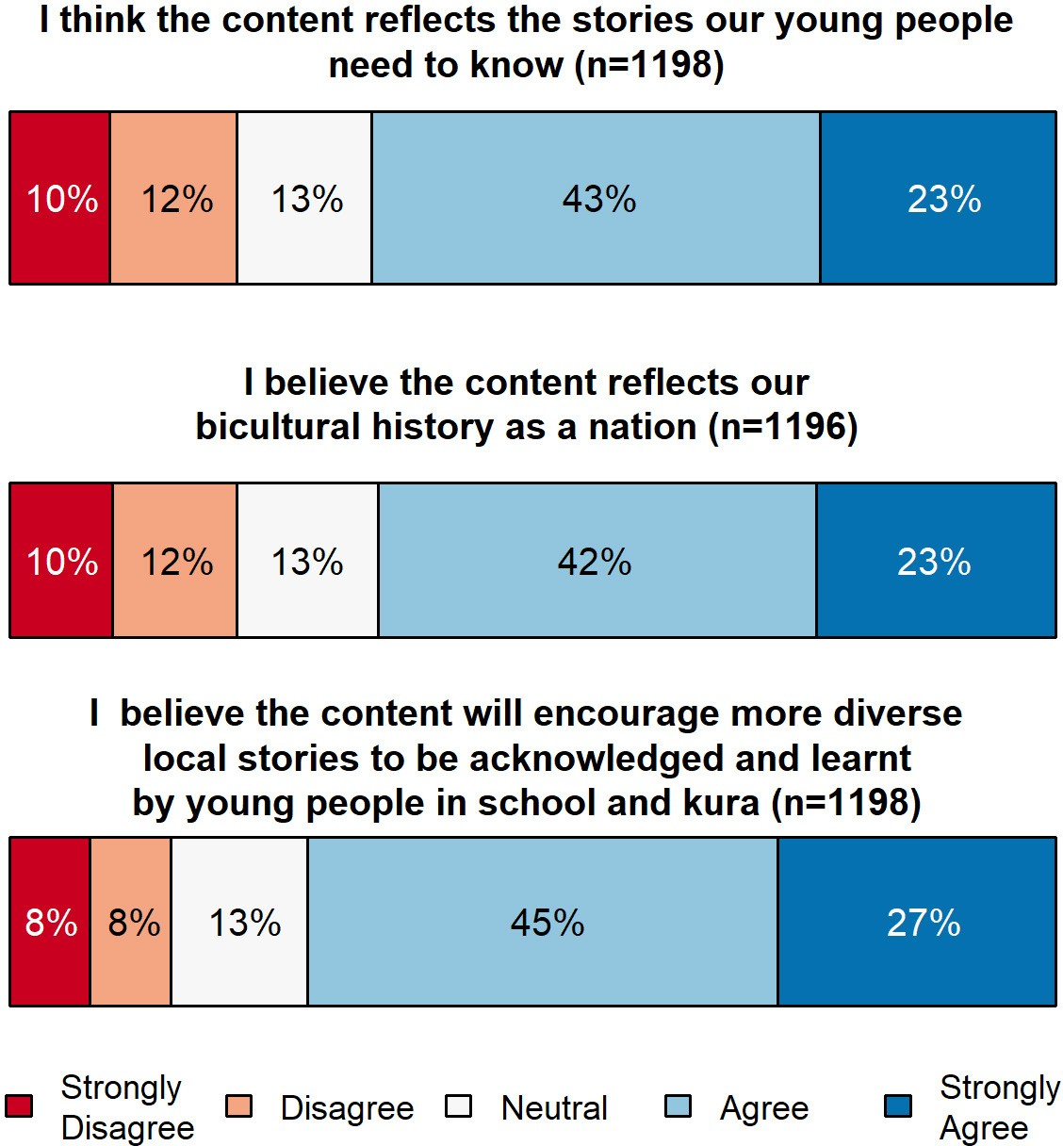

It is worth noting that teachers and kaiako were much more likely to respond positively to the survey items about the draft content, compared with people who identified as “whānau/family” or “community member” (see Appendix B for a comparison of survey responses by these three respondent groups).

Overall positive comments
Positive feedback from teachers and kaiako included comments on the design, structure, and content of the curriculum, and its useability by teachers.
I think that the three big ideas are good. Power, colonisation and Māori history are great central ideas. (Survey, senior secondary teacher)
I found the draft concise and practical to implement in a classroom programme. I am excited to build this knowledge within my classroom and kura with both students and teachers. (Survey, primary teacher)
Some commented that this addition to the curriculum was important, overdue, and would benefit learners and Aotearoa New Zealand.
This is essential learning for all New Zealanders and I am excited to see it becoming a priority in our curriculum. (Survey, primary teacher)
I personally think it is about time this became compulsory—ignorance is not acceptable. (Survey, junior secondary teacher)

SECTION 6| Ngā tirohanga mai i ngā kaiako | Perspectives from teachers

Multicultural and diverse histories
Like other respondents, some teachers/kaiako questioned the bicultural focus and emphasis on Māori histories and colonisation within a specific time period. Some argued that New Zealand
is a “multicultural” society and expressed concern that culturally diverse histories may be underrepresented, or that some learners and communities may feel excluded. This was described in Section 2 of this report.

Balance and nuance
Some teachers/kaiako raised concerns about the draft content, often in relation to there being too much Māori content and not enough Pākehā/European content, or in histories being portrayed
as either “too positive” or “too negative.” Some teachers/kaiako commented on the nuance and complexities of historical interactions between Māori and European colonists, and the different values and ideas that underpinned different cultural groups’ actions. Some teachers questioned what theoretical views of learning history underpinned the draft, indicating that the very definite tone in the wording of the concepts might work against the intention to support historical thinking.
Statements like ‘Mana motuhake’, ‘New Zealand’s settler government and the Crown were determined to undermine mana Māori, especially by acquiring Māori territories’, ‘The New Zealand Wars and the legislation that followed demonstrated their willingness to do this by any mean’ suggest that there is little complexity. Words like ‘determined’ and phrases like ‘willingness to do this by any means’ infer an intentionalist lens and silence historiography. This is a strong position statement, but it needs to have room to be contested. (Survey, senior secondary teacher)

Specific improvements suggested
Some teachers and kaiako suggested improvements or changes to the content or structure of the draft curriculum content or wanted further guidance for teachers about how to use it. Some
questioned how the draft related to the social sciences learning area and the wider curriculum. Some queried what it would look like in practice across year levels, and whether the content was levelled appropriately.
Could we see what this draft looks like embedded in existing curriculum i.e., Social Sciences as it is not overly clear now re strands, skills, requirements etc. (Survey, primary teacher)
At this stage it is hard to tell what this will look like as a curriculum document used throughout primary and secondary schooling. (Survey, primary teacher)
Other comments suggested some of the content was better suited for teaching at senior secondary levels, or that there was simply too much content in the “know” strand.
Where the content talks about NZ’s relationship with the Pacific Islands … a lot of schools teach this at Year 11 when they study NZ post World War Two. There is a vast amount of required content here for schools to teach; I think perhaps too much. (Survey, senior secondary teacher)
Due to the large amount to cover under the ‘know’ strand, I would hate to see schools focus entirely on this curriculum and forgo the Social Studies curriculum as there is so much wonderful work being done in Social Studies classes in many high schools. Therefore, where can it all
be taught? The size of this curriculum is a concern. And this is from someone who does think Aotearoa NZ history is important and wants to do it justice. (Survey, senior secondary teacher)
Interestingly, while some teachers/kaiako thought the content was too prescriptive, others said it was not specific enough.

Aotearoa New Zealand’s histories | Findings from the public engagement on the draft curriculum content

The content on offer is relevant, however having it so prescribed to the letter, feels like we are moving into an ‘old school’ way of teaching. When looking at the Social Studies curriculum, a lot of the content relates to the big ideas specified in the Social Studies curriculum. Students should put their own ‘lens’ on what their views and outcomes should be. (Survey, primary teacher)
It was unclear to me whether the local study/story had to be about one of the four or five ‘national’ stories or could proceed independently. (Survey, tertiary educator)

What is most important to teachers and kaiako?
When asked what they thought young people should learn about and develop, the three most commonly-selected options by teachers/kaiako were: a deeper cultural understanding of Aotearoa New Zealand (59%), followed by critical thinking skills (54%), and a greater sense of identity and belonging (48%). In contrast, the general population was more likely to choose critical thinking skills (67%), followed by a deeper cultural understanding of Aotearoa New Zealand (42%), and a greater interest in history (38%). This is shown in Figure 8 below.

FIGURE 8 What teachers and kaiako are most interested in young people learning
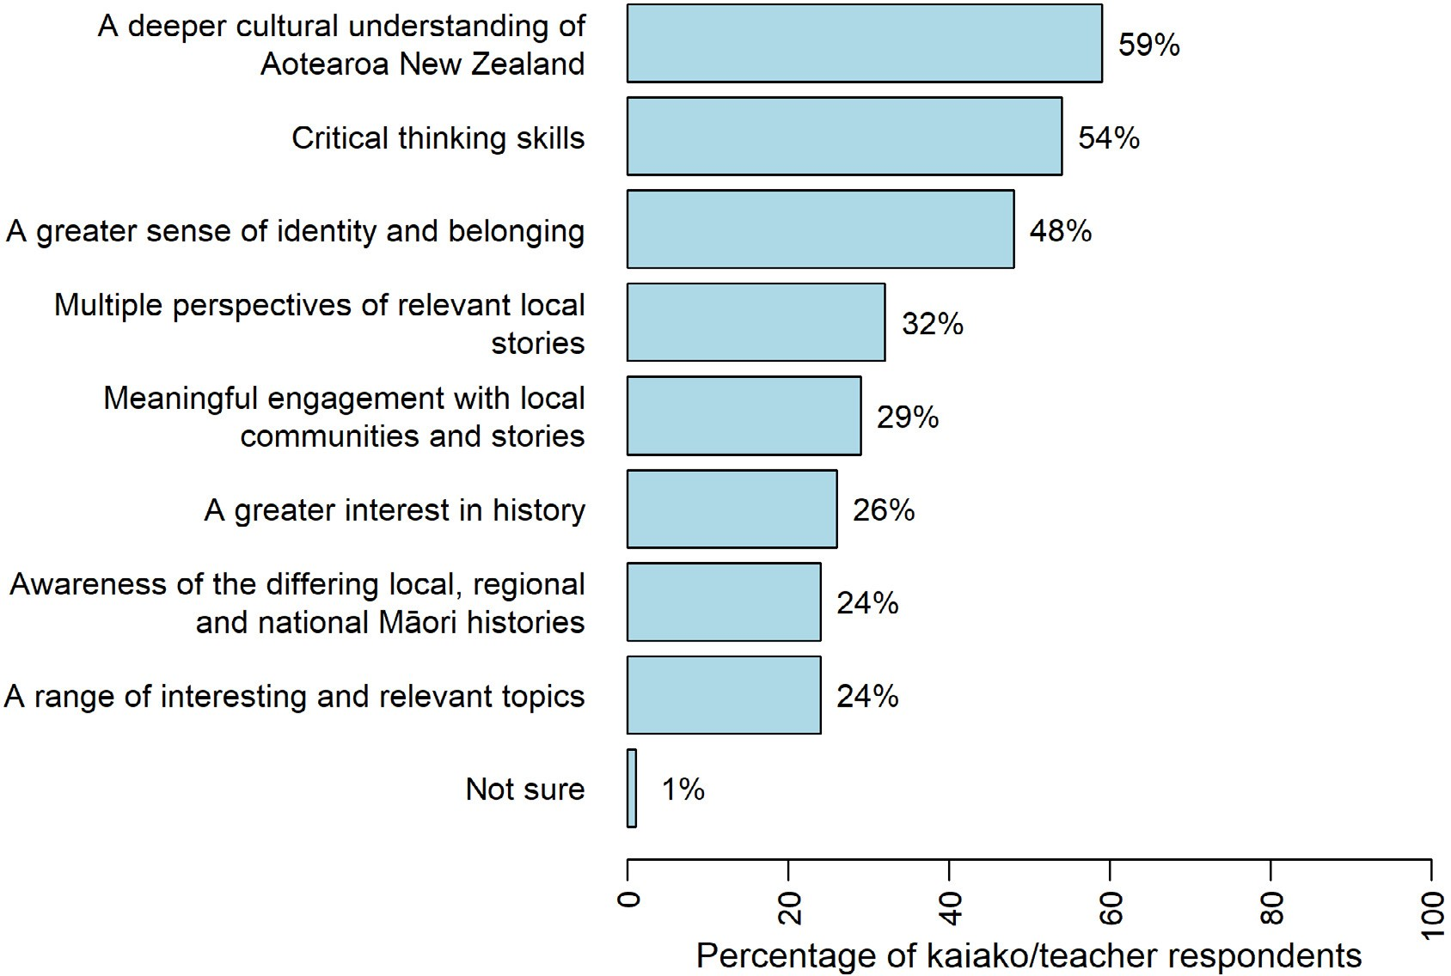

SECTION 6| Ngā tirohanga mai i ngā kaiako | Perspectives from teachers

What do teachers and kaiako see as the challenges in implementing this curriculum change?

Teachers see their lack of in-depth history knowledge as the biggest challenge
As shown in Figure 9, teachers were most likely to select “teacher and kaiako lack of in-depth history knowledge” (51%) as the biggest challenge, followed by “managing teacher biases on different historical accounts” (38%). This contrasts with the concerns of the general population, and for particular groups including Māori, Pacific peoples, and Asian respondents who saw teacher biases as the biggest challenge, followed by teacher and kaiako lack of in-depth history knowledge.

FIGURE 9 Greatest challenges identified by kaiako and teachers
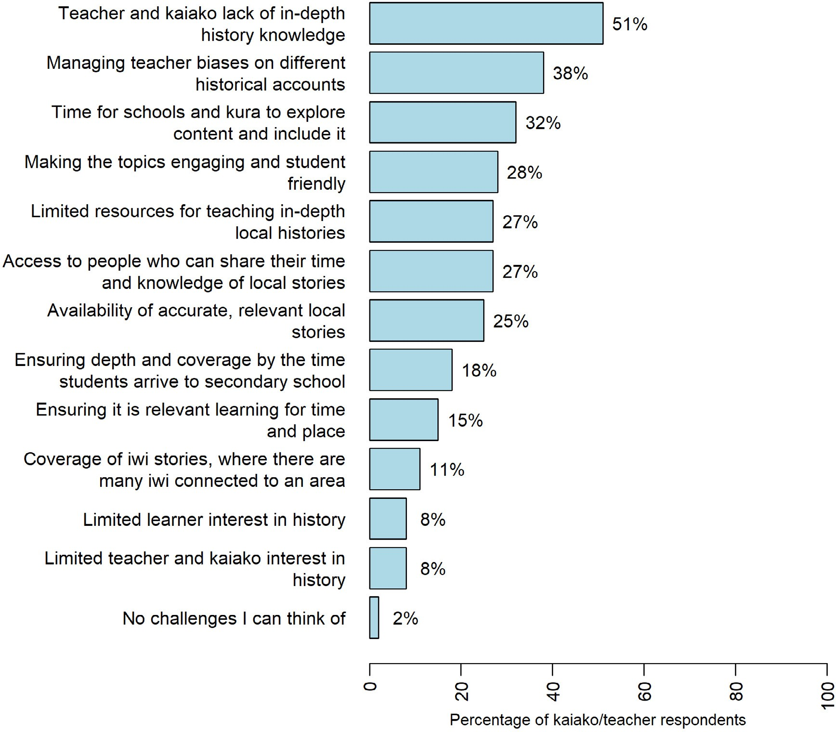

Elaborating on the challenges they expected to face, teachers and kaiako most commonly discussed resources, teacher knowledge, and professional learning, biases, and consultation with mana whenua and iwi. These are described next.

Aotearoa New Zealand’s histories | Findings from the public engagement on the draft curriculum content

Resources
Resourcing was a major concern for kaiako and teachers at every level.
What about a resource for early childhood? We are marginalised by the education sector in much the same way as Māori are by society. We already teach biculturally, but we need more resources. (Survey, ECE teacher)
Where are all the resources coming from to implement this curriculum? Is the government going to provide us with additional funding? Are there going to [be] textbook[s], worksheets? interactive sites? (Survey, senior secondary kaiako/teacher)
Some teachers spoke about difficulties with accessing local resources in particular.
I am concerned about how this will happen especially in urban areas where access to local histories is not always easy to find. (Survey, secondary teacher)

Teacher knowledge, and professional learning, and biases
Many teachers spoke about the need for professional development to build their knowledge in this area.
Again, it needs massive resourcing and teacher education because none of them have actually really been taught this either. (Survey, secondary teacher)
Some spoke about the need to provide professional learning for kaiako and teachers that will help them address their bias when it comes to teaching the histories content.
As we have only ever been taught through a Pākehā lens (shameful, considering the broader history and social sciences constantly compare perspectives!), there may not be enough access to accurate information. (Survey, secondary teacher)
Some talked about the need to train teachers in how to respond to biases coming through from their students and/or school communities.

Consultation with mana whenua and iwi
Finally, teachers mentioned the importance of iwi consultation, particularly expressing concerns about pressure being put on iwi to provide resources for schools in their area.
There also needs to be a great deal of resourcing. We cannot expect local Iwi to have to bear the burden of potentially hundreds of well-meaning approaches by schools at every level. (Survey, secondary teacher)

He whakarāpopototanga | In summary
Overall, teachers and kaiako were more positive about the draft curriculum content than other groups such as parents/family and community members. However, teachers and kaiako also expressed
a similar range of concerns as other people who provided feedback in the public consultation. Teachers and kaiako think it is important for young people to learn and develop a deeper cultural understanding of Aotearoa New Zealand. They see teachers’ lack of in-depth knowledge about histories as the biggest challenge, and also acknowledge challenges relating to biases, including their own, and those held within communities. Teachers and kaiako are concerned about the support and resources that will be in place to help them implement the curriculum.

SECTION 7

The New Zealand Curriculum and Te Marautanga o Aotearoa: Ngā tirohanga mai i te iwi Māori Perspectives from Māori

This section presents perspectives from Māori in response to the public consultation engagement about The New Zealand Curriculum and Te Marautanga o Aotearoa. It begins with findings from the quantitative data from the survey, followed by a discussion of themes pertaining to Te Marautanga o Aotearoa and The New Zealand Curriculum. A separate section (Section 8) follows with a discussion of themes related solely to Te Takanga o te Wā which sits within Te Marautanga o Aotearoa.
The themes here are drawn from five submissions, several hui and workshops, and 620 survey responses from individuals and groups who identified themselves as Māori. The survey responses pertain to the following curricula:
- responses relating to both Te Marautanga o Aotearoa and The New Zealand Curriculum: 288
- responses relating to The New Zealand Curriculum only: 272
- responses relating to Te Takanga o te Wā only: 30
- respondent was unsure which curriculum their responses were in relation to: 30.
Given the small number of people whose responses related solely to Te Takanga o te Wā, separate analysis of their survey responses was not possible beyond the general themes that are included in Section 8. Survey findings in this section combine responses from all Māori who answered the general survey, including the 30 responses relating to Te Takanga o te Wā.

Survey responses from Māori to The New Zealand Curriculum

and Te Marautanga o Aotearoa

Respondent roles
Figure 10 below shows that parents/caregivers, primary kaiako/teachers, and community members make up the majority of respondents across all regions.

Aotearoa New Zealand’s histories | Findings from the public engagement on the draft curriculum content

FIGURE 10 Breakdown of Māori respondents by role
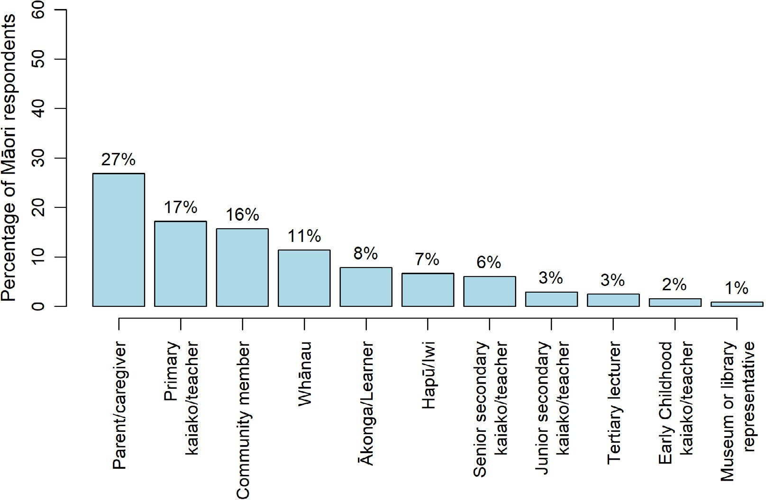

Region
Figure 11 below shows that the greatest number of responses to the general survey were from respondents in Auckland.

FIGURE 11 Breakdown of Māori respondents to the general survey by region
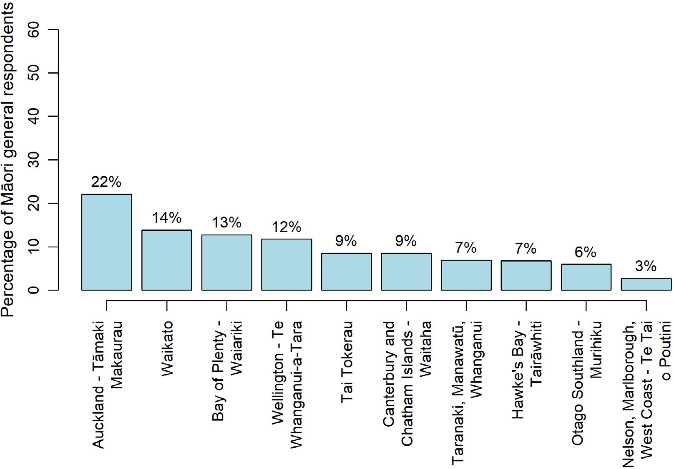

SECTION 7 | The New Zealand Curriculum and Te Marautanga o Aotearoa: Ngā tirohanga mai i te iwi Māori Perspectives from Māori

Do Māori think the content reflects us as a nation?
Figure 12 below presents reported levels of agreement with the three statements about the draft content by Māori respondents. The figure shows that 60% of Māori respondents agreed or strongly agreed with the statement “I think the content reflects the stories our young people need to know”, whereas 29% disagreed or strongly disagreed. Also, 57% of Māori respondents agreed or strongly agreed with the statement “I believe the content reflects our bicultural history as a nation” whereas 32% disagreed or strongly disagreed. Lastly, Figure 12 also shows that 67% of Māori respondents agreed or strongly agreed with the statement “I believe the content will encourage more diverse local stories to be acknowledged and learned by young people in school and kura”, whereas 24% disagreed or strongly disagreed.
Overall, half or more of Māori respondents believed the content reflects stories young people need to know, and that it reflects their bicultural history as a nation, with two thirds hopeful that the content will encourage more diverse local stories to be learnt through the new curriculum.

FIGURE 12 Māori respondents’ agreement with the three items about the draft curriculum content
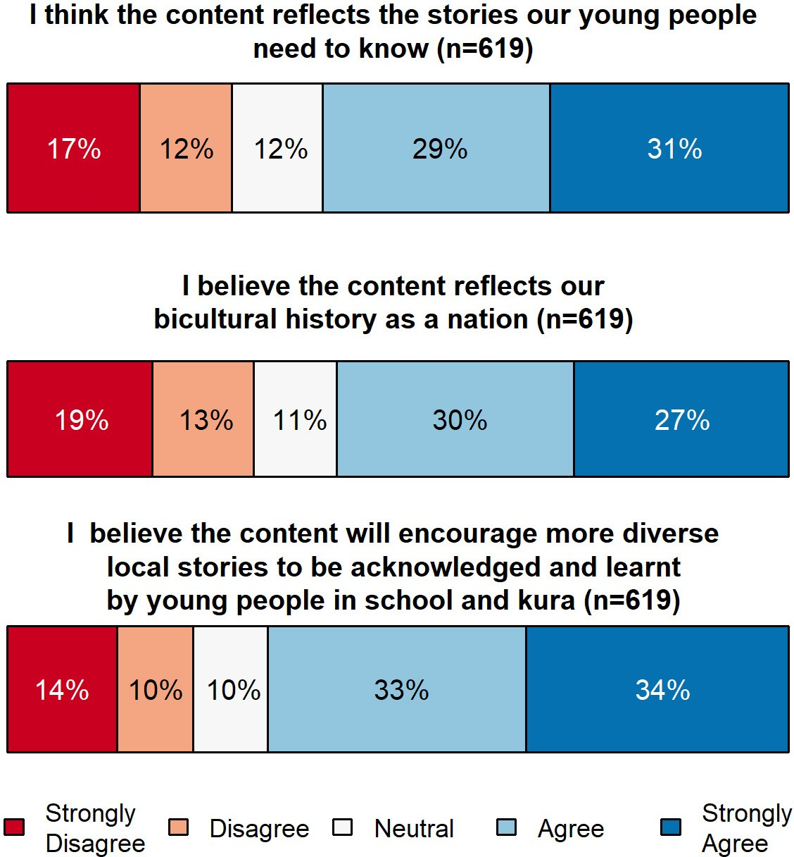

Aotearoa New Zealand’s histories | Findings from the public engagement on the draft curriculum content

What is most important to Māori?
Figure 13 shows how Māori responded to a question about what they are most interested in young people learning and developing. The three most frequently selected responses were “A deeper cultural understanding of Aotearoa New Zealand” (57%), “Critical thinking skills” (54%), and “A greater sense of identity and belonging” (45%).
FIGURE 13 What Māori are most interested in young people learning
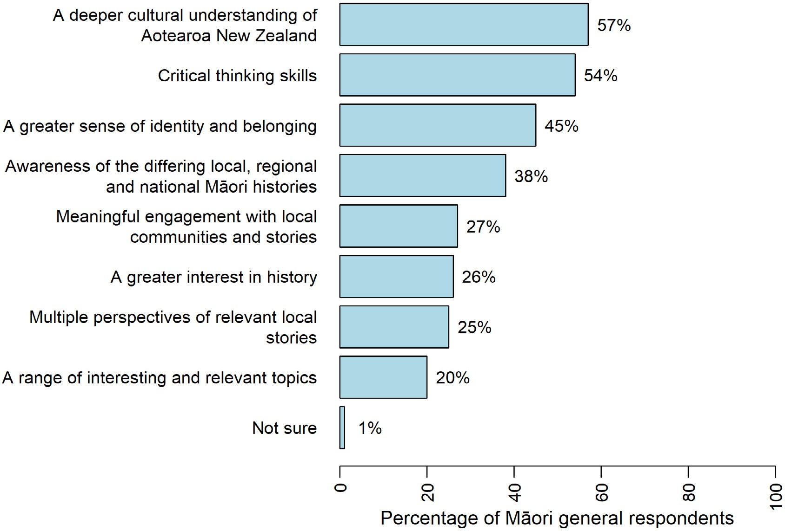

What do Māori see as the challenges in implementing this curriculum change?
Figure 14 shows how Māori responded to a survey question about what they believe the greatest challenges will be. The two most frequently selected responses expressed concerns about teachers’ and kaiako ability and readiness to work with the new curriculum: managing biases (58%) and lack of in-depth history knowledge (47%).

SECTION 7 | The New Zealand Curriculum and Te Marautanga o Aotearoa: Ngā tirohanga mai i te iwi Māori Perspectives from Māori

FIGURE 14 Greatest challenges for implementation
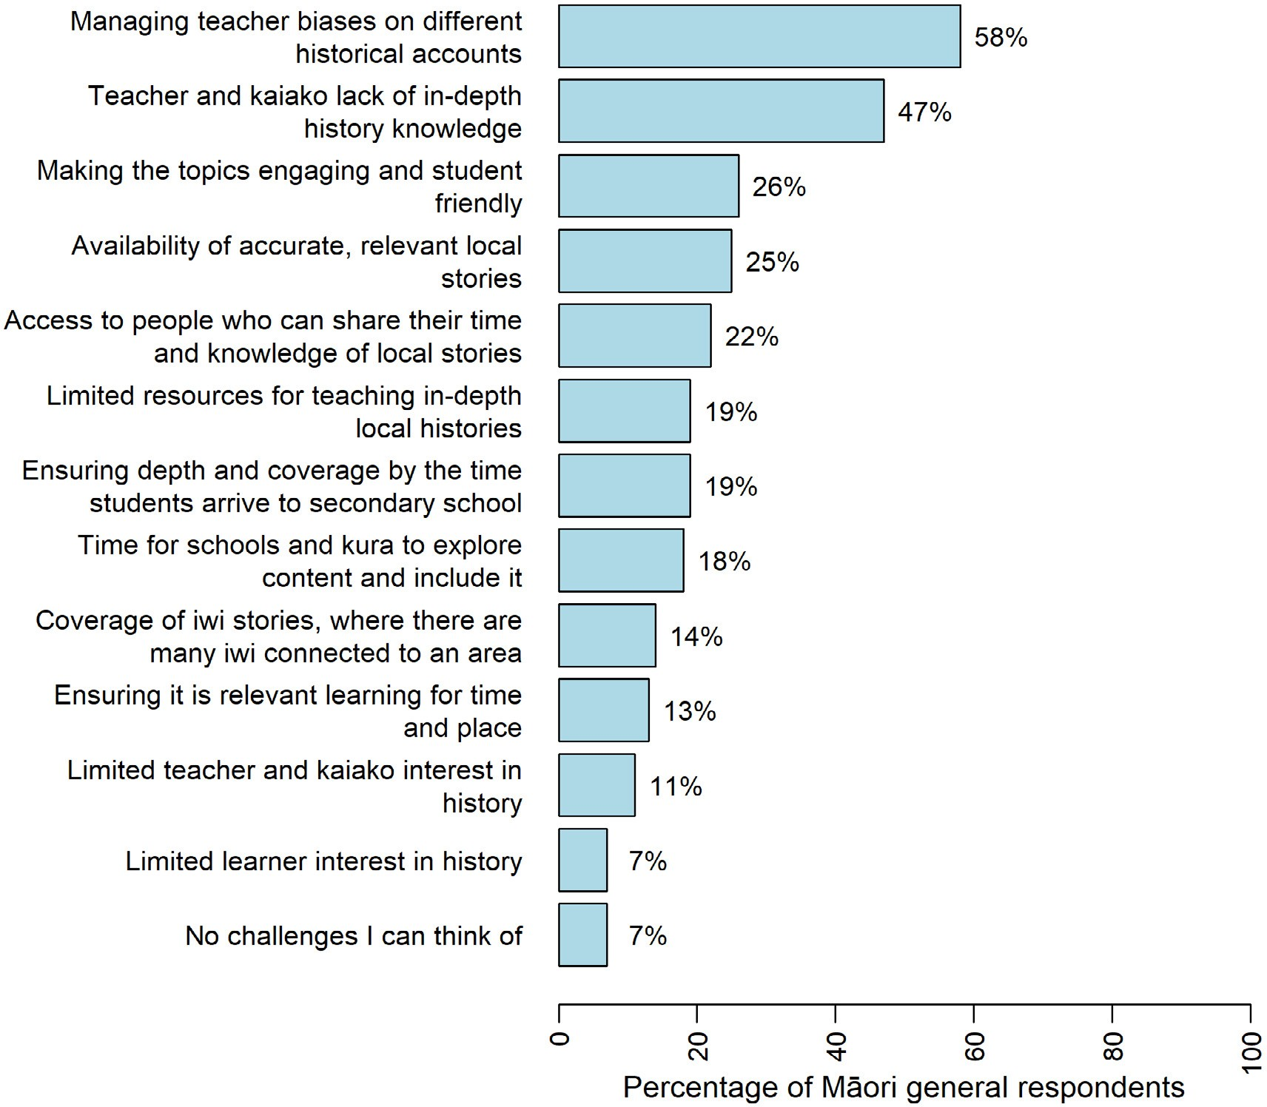

Themes from feedback about Te Marautanga o Aotearoa and

The New Zealand Curriculum
Some of the themes shared by Māori respondents are discussed below. These responses related to the draft content for the “New Zealand Curriculum”, or to “both the New Zealand Curriculum and Te Marautanga o Aotearoa”. A few respondents chose “not sure”, presumably because they did not know which of the two curriculum documents their comments would be most relevant to.

Do Māori think the content reflects us as a nation?

A positive response to the content overall
Overall, Māori respondents tended to be positive about the new histories curriculum content, often describing it as a good beginning. The new content was seen as being long overdue and respondents emphasised the importance of this curriculum for future generations.
It has been a long road to get to this point and I’m delighted to see history poised to finally be taught in a meaningful way in schools. (Survey, community member, NZC)

Aotearoa New Zealand’s histories | Findings from the public engagement on the draft curriculum content

I cried when I read all that was proposed for our tamariki. I have spent 30 years in an education system that doesn’t value my culture and our history as both a learner and an educator. It would be revolutionary to have a curriculum that presents an accurate and broad account of the history of our country and presents it with conviction. (Survey, community member and teacher responding to both curricula)
I’ve been using Te Takanga o te Wā with ākonga for a few years now. It`s a brilliant starter guide for exploring personal, local and national histories. The histories pertinent to our young people can be reflected here. (Survey, junior secondary kaiako/teacher responding to both curricula)
We like the progression—it makes it very clear about the learning that goes before and after—so supports the learning. The big ideas help us strengthen our critical histories, while the contexts help us set it at the right level. (Submission, senior leadership teams of 10 South Auckland primary schools)

Pride in identity and culture
The potential for the new curriculum content to instil pride about identity and culture in young people, and to challenge negative beliefs and stereotypes about Māori, was important to Māori respondents.
I think the content teaches our tamariki essential lessons about who we are as Māori. (Survey, whānau member, NZC)
It is important to connect Mātauranga Māori to other theories and philosophies to allow learners to make connections and realise that Māori were/are theorists and philosophers just alongside well known Pākehā. This could also encourage them to explore and value their own indigenous knowledge. (Survey, tertiary lecturer, responding to both curricula)
This will also give non-Māori tamariki and rangatahi a better idea of why whakapapa narratives are important to Māori, this would also be an opportunity [for] tamariki and rangatahi Māori to have their identities shared in a way that would reflect positively on them and pull away from the negative characterisation they are faced with every day. (Survey, tertiary lecturer, NZC)
I think the content will help remove negative stigmas associated with Māori stories and ways of looking at things, it will help new generations dissociate negative stereotypes as being on the same as “being Māori”. It will open up acceptance and subsequent proliferation of Māori stories and art forms / creativity. (Survey, parent/caregiver responding to both curricula)

Connections to whenua and tāngata
Many Māori saw opportunities for the curriculum content to support all learners to strengthen connections to the land and to the people. Some asked how ākonga who connect to a different waka or rohe from the one they live in will be supported.
I also think that given the diaspora of iwi across NZ, teachers should be aware of where their students whakapapa to and (where possible) allow those students to explore their own histories alongside that of where they live. (Survey, community member, not sure which curricula to respond to)
Māori respondents also talked about the opportunities to strengthen relationships between schools and Māori communities.
It is an opportunity to strengthen relationships between iwi/hapū/marae/kaumātua/whānau and schools/whānau/communities. The possibilities that can be explored and rich learning had. It will

SECTION 7 | The New Zealand Curriculum and Te Marautanga o Aotearoa: Ngā tirohanga mai i te iwi Māori Perspectives from Māori

definitely encourage more diverse local stories and deeper research into local history, its effects on different peoples in the community/area and provide opportunities for deeper and critical thinking skills to be further developed. (Survey, primary kaiako responding to both curricula)

Understanding the ongoing effects of colonisation and racism
A number of Māori respondents thought that a focus on colonisation would help learners understand the impact this has had—and continues to have—for Māori. However, some respondents were also concerned about oversimplification of the colonisation story, and wanted a history curriculum that reflects a more complex reality where Māori took different stances, including armed resistance.
Many expressed the hope that understanding our shared history will help learners to talk about, and challenge, racist and bias views in our society.
Tamariki need to learn both sides of history of Aotearoa, so that they are able to understand the intergenerational trauma that is still felt by Māori today. This will also widen their own
perspectives and worldviews, and create healthy discussions in regards to colonisation and racism. This will hopefully address the misinformation shared by others in regards to Māori history. (Survey, tertiary lecturer, NZC)
It needs to be made more explicit that Māori are not just victims. (Workshop, kaiako, NZC)
We will only reflect our bicultural history when we are all taught the facts about colonisation and the systematic process used to dispossess Māori of land and resources and to wipe out language and culture. Students need to learn our history in the same way they need to learn about the horrors of war; not to celebrate it but to learn from them so we don’t keep repeating it. (Survey, whānau, NZC)
Thank you, I hope this change in education can help to change generations of racism bias and discrimination. I believe if we teach our tamariki the truth about our history, and they can understand and empathise with both sides, we can move towards a more open-minded society who understands how certain events have created the systemic racism we have in our country now. (Survey, primary kaiako/teacher, NZC)

What is most important to Māori respondents?
Māori spoke about the importance of all four domains of historical events—iwi, local, regional, and national histories, with national history and iwi history featuring most prominently. One group did raise a concern that these categories might be too restrictive to recognise concepts such as pan-iwi and inter-island narratives.

National history
Many Māori wanted a focus on Māori histories prior to, and after, colonisation. They identified key national events to focus on, including Te Tiriti o Waitangi, the New Zealand Wars, the history of urbanisation and the suppression of Māori culture and language.
Learning important history of Te Tiriti o Waitangi and the arrival of Māori to Aotearoa and the first encounters and early colonial history of Aotearoa will be very important to help our younger generation for the future. (Survey, whānau member, responding to both curricula)
I think national history should cover as much of the national story as possible, but it should begin as far back as possible, covering ancient Māori history before moving onto European migration (i.e., NZ history does not begin with the Treaty of Waitangi, as significant as it is and as

Aotearoa New Zealand’s histories | Findings from the public engagement on the draft curriculum content

important as it is that it is taught well). I also think that more coverage of the 20th century history as pertaining to Māori urban migration and dawn raids etc are important aspects of NZ national history that are not always taught in schools. (Survey, community member, responding to both curricula)
More focus on the impacts of colonisation on the education system and other systems of power specifically, would help ensure an accurate understanding of the current disparities between Māori and non-Māori, which impacts the way non-Māori will view Māori history and how it relates to our current, largely monocultural, society. (Survey, senior secondary kaiako/teacher, NZC)
Respondents were supportive of the focus on Māori histories, but also wanted to acknowledge the histories of other cultures in Aotearoa as part of our collective history.

Iwi history
Māori respondents emphasised the importance of teaching iwi histories as a part of the national curriculum. Many saw iwi histories as a vital starting point.
This is important as Māori are tangata whenua. They were the first people to arrive in New Zealand and occupy land, seas and all. Iwi and hapū have strong connections to Aotearoa and hold a rich cultural and ancestral knowledge of the land. (Survey, primary kaiako, NZC)
To know local iwi is to know one’s connection to te ao Māori and how we normalise te reo, ngā tikanga, kawa and knowledge and impact of history on the local community. (Survey, secondary kaiako, responding to both curricula)
Inherent in Iwi history is the relationships / whakapapa with neighbouring hapū / the cultural landscapes and seascapes that are integral to localized histories, as well as the relationship with non-Māori. The underlying kaupapa is that we are all connected somehow or another. (Survey, hapū/iwi member, responding to both curricula)
E tika ana kia pepehatia ngā kōrero ā motu, ā rohe, ā takiwā, ā iwi hoki. (Survey, mema hapori, ngā mea e rua)
They also strongly recommended that iwi and hapū should decide what histories to share and stressed the importance of schools having good relationships with these Māori communities.
If the Iwi are teaching their local pūrākau and history of their Iwi you will get a more accurate history of those stories. (Survey, senior secondary kaiako/teacher, NZC)
Iwi should decide what is prioritised in this space, and this then contributes to local histories, regional and national histories. (Survey, whānau, NZC)
Ensuring better representation of iwi and hapū stories in schools and in the local community. Good engagement with Māori communities to ensure that the stories told are the ones they want told. (Survey, tertiary lecturer, responding to both curricula)

Local and regional history
Local and regional histories were seen as important and closely entwined with iwi histories. Topics of interest included: Māori place names, the New Zealand Land Wars, and well-known tūpuna.
Local hapū have a right to have their history taught in schools. Every child needs to know the history of the whenua they walk and live on. (Survey, primary kaiako/teacher, NZC)
The events in Parihaka are important to me as that’s region I’m from. (Survey, ākonga/learner, responding to both curricula)

SECTION 7 | The New Zealand Curriculum and Te Marautanga o Aotearoa: Ngā tirohanga mai i te iwi Māori Perspectives from Māori

This should bind together all of the threads of iwi, local and regional histories to provide the context for understand our stories. It provides the context and common understanding essential to ensuring conversations about our histories can continue long after the content is taught in schools. (Survey, community member, responding to both curricula)
Respondents had the option to provide topics they thought should be included in national, regional, local, and iwi histories. Table 3 below shows the ten most frequent responses given by Māori in relation to each category of history. The table shows that topics do not necessarily fit neatly into one category. The repetition of some topics across categories, for example colonisation, and the New Zealand Land Wars, shows that some topics are relevant in every category.

TABLE 3 I believe the content will encourage more diverse local stories to be acknowledged and learnt by young people in school and kura

National topics  Te Tiriti o Waitangi and the Treaty of Waitangi  New Zealand Land Wars  Colonisation  Pre-European Māori life  Migration of all people to New Zealand—including Māori  New Zealand and the wider world  World Wars  Women’s suffrage movement  New Zealand politics  Declaration of Independence—He Whakaputanga | Iwi topics  Pūrākau and tribal histories (including oral histories and waiata)  Important people and rangatira  Key landmarks, such as maunga and marae  New Zealand Land Wars  Hapū histories  Colonisation and its impacts  Moriori history  Ancestry and origins of different iwi  Ngāi Tahu history  Relationships between different iwi. | Regional topics  New Zealand Land Wars  Geography and landscape  Economics and industry  Colonisation and its impacts  Important people and regional heroes  Parihaka  Māori land loss in different regions  Pūrakau and iwi stories  Religion and missionaries  Migration between regions, and Pre- European Māori life | Local topics  New Zealand Land Wars  Important people and local heroes  Geography and landscape  Landmarks and infrastructure  Pūrākau and iwi stories  Māori concepts and mātauranga  Colonisation and its impacts  Place names  Pre-European Māori life  The history of te reo Māori
Note: The 10 most frequent responses (from most to least frequent) are listed top to bottom. Topics repeated across the four categories were New Zealand Land Wars and Colonisation.

Aotearoa New Zealand’s histories | Findings from the public engagement on the draft curriculum content

What do Māori see as the challenges in implementing this curriculum change?

Teacher knowledge and bias
Among Māori respondents, the two most frequently mentioned challenges for implementation were lack of teacher knowledge and bias. Many expressed concern that Māori history might not be taught properly if teachers do not know how to teach the content, or if they bring a racist lens to their teaching. They wondered how teachers who refuse to teach the content will be held accountable. They saw professional development as an important support mechanism to help teachers acknowledge and challenge their own biases and racist viewpoints.
The concept of this history curriculum is monumental however I fear it will be decades before it is taught without resentment. The greatest obstacles are our teachers; more specifically their lack of skills, knowledge and attitude, all of which have been identified in numerous education research studies. Skills and knowledge can be attained but shifts in thinking are exceedingly difficult. (Survey, community member and teacher responding to both curricula)
I am concerned that teachers that don’t acknowledge Māori as essential to who we are as New Zealanders may side-line or distort our history, short-changing our tamariki. (Survey, whānau member responding to both curricula)
I’ve encountered many teachers in my time with a blatant disregard and lack of knowledge when it comes to Aotearoa and Māori Culture/History, hopefully this change to the curriculum will help that and lead to a more understanding Aotearoa that genuinely cares for our home and our land. (Survey, hapū/iwi member, NZC)

Building relationships with iwi and hapū
Many Māori were concerned about the challenges inherent in building authentic relationships with iwi and hapū in order for schools to access information to inform local curriculum development. They also showed concern about how to manage the differing histories between iwi and hapū—whose history should be taught?
I think it will be difficult for teachers to make time to build relationships with local iwi. I also think it will be difficult for some teachers to see the relevance and importance in this kaupapa, especially in English medium schools. (Survey, primary kaiako/teacher responding to both curricula)
The biggest challenge will developing authentic relationships and partnerships with iwi and learning to co-design with iwi what their localised curriculum looks like and how this includes Aotearoa NZ Histories while still acknowledging the aspirations that iwi and hapū have for their people. (Survey, whānau responding to both curricula)
Accessing local stories can be challenging as well as the different variations of stories differ between hapū/iwi. How can we address this and how can we capture local history/stories if there is no information that is accessible? (Survey, primary kaiako/teacher, NZC)
Some shared strong concerns about how iwi, hapū, and mana whenua will be resourced and supported to work with schools. They worried that some Māori communities might feel pressured to engage with schools. They were especially concerned about iwi and hapū who do not have the capacity to do this.

SECTION 7 | The New Zealand Curriculum and Te Marautanga o Aotearoa: Ngā tirohanga mai i te iwi Māori Perspectives from Māori

Agree, if schools have made contact with local iwi or have experts in their area who they can access to help with this. This is not always easy for schools and takes extensive time and work to initiate relationships. Surely iwi will need more manpower/funding in order to support schools in an authentic manner? (Survey, primary kaiako/teacher, NZC)
Re access to people to share stories. Gotta have the ability to financially compensate community people sharing their knowledge. (Survey, community member, not sure which curricula to respond to)
Different schools will have different capacities to consult their iwi, hapuu. Different iwi, hapuu will have different capacity to meet with schools pressure on iwi, hapuu to meet with. (Group survey response, nine primary kaiako/teachers, NZC)

A need for safe spaces to kōrero
There were concerns from some Māori respondents that the content could include events that Māori teachers and learners might find traumatic. They felt it was important for kaiako to think about how they will create safe environments for these discussions.
I appreciate how the framework has been designed, but be all that as it may, I have no doubt questions will be asked, the names of tūpuna will come up, and the grief, fear, detachment and betrayal will be exposed. History is whakapapa and whakapapa is history. I sincerely karakia that this curriculum will, in time, facilitate understanding and healing that reaches from the past, to the present and into the future. (Survey, community member responding to both curricula)
How do we wrap support around those ākonga that feel the hurt? (Workshop, kaiako and tumuaki responding to both curricula)
Will this curriculum be taught by either Māori or by Pākehā or will there be a shared delivery by both? Will kaiako have an understanding of the cultural impact these discussions will have? The trauma that this could cause those who will be having these discussions? Will [there] be in-depth and safe discussions that will cover both sides of history? (Survey, tertiary lecturer, NZC)
I think this content could be problematic for people who identify as both Māori and Pākehā. Positives of both cultures could be emphasised more. Otherwise people could be ashamed of their Pākehā identity leading to internal conflict and distress. (Survey, parent/caregiver, NZC)
In the process of doing family history research I have found that I have ancestors who fought on either side of the land wars conflicts. Some of the details are disturbing and details of this
kind will have to be handled carefully but we do need it to be out in the open to understand the ‘present’ we are in. (Survey, community member, NZC)

Resources
Many of the Māori respondents wanted to see adequate resources and support provided for kaiako to assist them to teach the curriculum content.
So much of the proposed curriculum will rely on the efforts of teachers—they need to be properly supported and resourced. Walk the talk and give our histories a fighting chance. (Survey, community member, NZC)
There are numerous major events in ANZ history that must be incorporated into our ANZHC. These should be resourced with engaging and relevant resources and high-quality teacher training. (Survey, senior secondary kaiako/teacher, NZC)

Aotearoa New Zealand’s histories | Findings from the public engagement on the draft curriculum content

We particularly emphasise the need to invest in developing appropriate resources for schools, especially in relation to local history and Mātauranga Māori. We encourage greater use of Māori- authored books. (Group submission)

Time to prepare
Kaiako Māori were also concerned that schools and kura will not have enough time to get ready to deliver the content by 2022.
There is very little time given to teachers to up skill and write a curriculum for Y7–10 that should be reflective of our local community. (Survey, junior secondary kaiako/teacher, NZC)
The content will be challenging to develop and will take time. It will be an ongoing endeavour. Our school have been working on our localised curriculum, in partnership with local iwi for the past
- years and it is still a work in progress! More resources would help those of us in mainstream deliver the content effectively. (Survey, primary kaiako/teacher, NZC)

Impact on historical sites
Some respondents discussed the need to care for historic sites. Concern was expressed about the negative impact that many people visiting historical sites could have on the sites, as well as the environment.

He whakarāpopototanga | In summary
The kōrero shared by Māori included aspirations for the implementation of the new curriculum content to be successful because of the positive impact it could potentially have both for Māori, and for Aotearoa.
Respondents suggested that to be successful, implementation will require a solid foundation of respectful relationships, critical awareness of, and ability to challenge biases and racism, and adequate resourcing for kura, and for iwi and hapū.
Kaiako Māori were concerned that schools and kura will not have enough time to get ready to deliver the content by 2022. They felt they needed time, for example, to develop authentic reciprocal relationships between schools, kura, and iwi and hapū, as well as developing the capability and capacity of schools and kura to teach the curriculum.

SECTION 8

Te Takanga o te Wā: Ngā tirohanga mai i te iwi Māori Perspectives from Māori

This section of the report highlights views shared by Māori respondents whose answers related solely to Te Takanga o te Wā, within Te Marautanga o Aotearoa.
Te Takanga o te Wā is proposed as a new whenu (strand) to be added alongside the existing four whenu of Tikanga ā-Iwi which are: Te whakaritenga pāpori me te ahurea, Te ao hurihuri, Te wāhi me te taiao, and Ngā mahinga ohaoha.
The themes included in this section are drawn from sets of notes from 10 workshops (involving 98 participants), one submission, and 30 survey responses from individuals and groups about Te Takanga o te Wā.
Many of the themes reported in Section 7 of this report concern Māori perspectives about both Te Marautanga o Aotearoa and The New Zealand Curriculum, and are useful to read in conjunction with this section.

Do Māori think the content reflects us as a nation?
Māori were more likely to strongly agree that the content of Te Marautanga o Aotearoa reflects the stories young people need to know. They were also more likely to strongly agree that the content reflects our bicultural history as a nation, and that the content encourages more diverse local stories. However, we caution against generalising these findings, given the small number of survey responses received (n=30) concerning Te Marautanga o Aotearoa.

A positive response to the content
Many Māori respondents viewed the content for Te Takanga o te Wā positively, seeing it as a good base for kura to further build upon. Some were excited about the opportunities the new curriculum content might bring, and its potential for strengthening understandings of who we are and where we come from.
Te Takanga o te Wā is a great base for Marau ā-kura. It identifies what is important for our learners to learn. (Workshop participants)
This provides a framework for kōrero, whakapapa, pūrākau, waiata etc to research and continue to share, investigate and learn in kura. The changes in the Te Marautanga o Aotearoa Draft referring to Tikanga-a-Iwi with the new Whenū Te Takanga Wā supports learning of Iwi and Rohe in the area I teach (Waiariki), specifically to the Iwi Tapuika / Te Arawa. Content will encourage more local stories in kura. (Survey, primary kaiako/teacher)

Aotearoa New Zealand’s histories | Findings from the public engagement on the draft curriculum content

Fits in nicely with what iwi are developing at the moment. (Workshop participants) Lots of opportunities for our ākonga, whānau, hapū and iwi. (Workshop participants)
Who are we? Where do we come from? Where are we going? It’s all of our history—Tangata whenua and today we are multicultural, we are inclusive—I want our children to continue to be that. (Workshop participants)

Familiar content
A number of people commented positively on the familiarity of the content. Some saw it as similar or complementary to what they were already teaching.
We are already doing this but now we will have something to link it to. (Workshop participants)
We (at home and school) have taught our history and colonial history side by side mai rā anō. It is about time that it was ratified for all of Aotearoa NZ. (Workshop participants)
Isn’t this what Te Aho Matua is? Kura Kaupapa have been doing this since forever. (Workshop participants)
Can easily see ourselves in the huatau matua—tuakiri Māori. (Workshop participants)

Supporting iwi and hapū
Concern about the pressure on iwi and hapū to support kura was a strong theme here, as it was in the previous section (Māori perspectives on The New Zealand Curriculum and Te Marautanga o Aotearoa). People reiterated the need to adequately support iwi and hapū, highlighting the responsibilities of the Ministry of Education to support this kaupapa.
The Ministry want kura to work with local hapū and iwi but what is the Ministry doing to support this? (Workshop participant)
It’s important that money is invested into iwi and hapū, so that the histories that are shared are accurate and respectful of mana whenua. There needs to be an emphasis on building strong and meaningful connections with hapū and iwi. (Survey, primary kaiako/teacher)
Some people wondered whether whānau, hapū, and iwi will be accredited as professional learning and development facilitators, if they are expected to work with kura to develop histories content for marau ā-kura.
A lot of community members will hold the stories—will they need to be accredited in order to be part of the PLD system? (Workshop participants)
When will iwi be consulted about this curriculum? Will they be resourced to participate? Is there an opportunity for them to be PLD accredited? (Survey, primary kaiako/teacher)
Seems to be pressure on hapū and iwi to support kura/schools. How do we the identify people with the knowledge? How will MOE support them financially? (Survey, primary kaiako/teacher)

What is most important to Māori respondents?
The three most frequently selected survey responses in relation to Te Marautanga o Aotearoa were “A deeper cultural understanding of Aotearoa New Zealand” (73%), “A greater sense of identity and belonging” (57%). and “Awareness of the differing local, regional and national Māori histories” (43%).
Workshop participants shared their ideas about what ākonga should learn about. These included tikanga, reo and kawa, Kaupapa-basedlearning, and local, hapū/iwi history. Ākong aworkshop

SECTION 8 | Te Takanga o te Wā: Ngā tirohanga mai i te iwi Māori | Perspectives from Māori

participants talked about their interest in learning about colonisation, Te Orokohanga, Waitangi Day, learning on the marae and learningte reo Māori through all subjects.
We need offsite, real life learning, take us to [name] pā, to the marae. (Workshop participant, ākonga)
Me whakaako i ngā tātai kōrero o tēnā rohe, o tēnā rohe, kia whai paranga ki aua rohe katoa. Tino pai mehemea ka whakahuahua i ngā whakatauki, kīwaha, kupu whakameha, hei manawa reka. (Survey, kaiako teina tuarua/junior secondary teacher)
Lists of the topics Māori identified as being important at national, iwi, regional, and local level are included in Section 7.

What do Māori see as the challenges in implementing this curriculum change?
Māori responded to a survey question about what they believe the greatest challenges will be in relation to Te Marautanga o Aotearoa. The two most frequently selected responses are both related to teachers and kaiako—lack of in-depth history knowledge (57%) and managing teacher biases (43%).

Ensuring the right support is available
While Māori were generally positive about the new curriculum content, concerns were expressed about whether kura will have everything they need to ensure the implementation of the content will succeed.
I think that the inclusion of NZ history is way overdue. However, I hope that the roll out is not rushed and that time and resources are allocated to make sure its done properly. (Workshop participants)
Ongoing support will be required, so that by 2025 our people in and outside of schools are well resourced to make this the success it could be. (Workshop participants)

Professional development
The need for teachers to access localised and ongoing professional development to help them teach Te Takanga o te Wā featured strongly in respondents’ comments.
I think there will be a real need for quality localised professional development. (Workshop participants)
I am extremely concerned that without appropriate teacher professional development and support this will become poorly delivered and it is too important to allow that to happen. The five themes need significant understanding before beginning to provide teaching to our tamariki. (Workshop participants)
We would definitely need appropriate professional support in terms of local history, local myths and legends and it would be beneficial to have these support personnel available on a daily basis. (Workshop participants)

Resourcing
Respondents saw the need for good resources and stressed the importance of people and time. Some advocated for making sure that resources for Māori medium are developed early on, rather than after English-medium resources have been developed.

Aotearoa New Zealand’s histories | Findings from the public engagement on the draft curriculum content

For this kaupapa, books aren’t the necessary resource—it’s people and opportunities to visit and experience. (Workshop participants)
If the Ministry maintains their promise to support this whenu with resources created locally this is great. (Workshop participants)
Online resource banks that can be accessed by teachers as needed. Local experts who can be approached for support. Timelines and lists of historically important events/dates that should be covered NZ wide to ensure there is continuity of education across the country. Also pakiwaitara/ pūrākau tend to change slightly in different areas. It would be good to have standardised resources. (Workshop participants)
Teachers want to teach this really well, so we have to be set up for success first and foremost—so the Ministry gives it the time it deserves to support teachers. (Workshop participants)
Re-telling of pūrākau through Māori eyes that are then captured and archived digitally and in print. We still need some books, they just need to be our own. Iwi/MoE funding to support this? (Workshop participants)

English-medium schools
Concerns were raised about what might happen outside of Māori-medium spaces. Some workshop participants were concerned about their Māori colleagues in bilingual or rumaki units or classes in otherwise English-medium schools, asking “who will support them?”. They also expressed concern about whether there will be opportunities for all tamariki to learn about their histories.
How will the Ministry ensure all Māori tamariki are being provided for? What if an English medium school chooses not to teach their local history? (Workshop participants)
Some people asked whose responsibility it will be to support mainstream schools to engage with the content when Māori communities are already so busy.
How will mainstream engage with the content? Will it be up to kura, whānau, hapū and iwi to support them? And if so, how will that happen when we are already so busy? (Workshop participants)

He whakarāpopototanga | In summary
The successful implementation of Te Takanga o te Wā is important to Māori. It provides a useful framework for further learning about identity and connections to people and whenua. The content is familiar and builds on what many kaiako are already teaching.
A pressing concern was how iwi and hapū will be supported if they are expected to assist kura, with some respondents asking what the Ministry of Education plans to do to support them.
People also stressed the need for appropriate professional development and resourcing for Māori- medium kura, which means providing both in te reo Māori. They also shared concerns about implementation of the new curriculum content in English-medium schools.

SECTION 9

Ngā tirohanga mai i ngā tāngata o te Moana-nui-a-Kiwa Perspectives from Pacific peoples

This section highlights views from Pacific respondents. As described earlier, Pacific peoples provided feedback in various forms: online surveys; face-to-face fono in Wellington, Auckland, and Christchurch; and several engagement events with Pacific historians, teachers, and students in Wellington and Auckland.

Survey responses from Pacific peoples

Respondent roles
Pacific peoples were represented across the full spectrum of roles or identities (Figure 15). They were more likely to identify themselves as parent/caregiver than community member, in contrast with the overall pattern across all survey respondents. A relatively large proportion identified themselves as learners, but the small absolute number precludes presenting the ākonga/learner data separately.

Aotearoa New Zealand’s histories | Findings from the public engagement on the draft curriculum content

FIGURE 15 Breakdown of Pacific peoples’ respondents by role
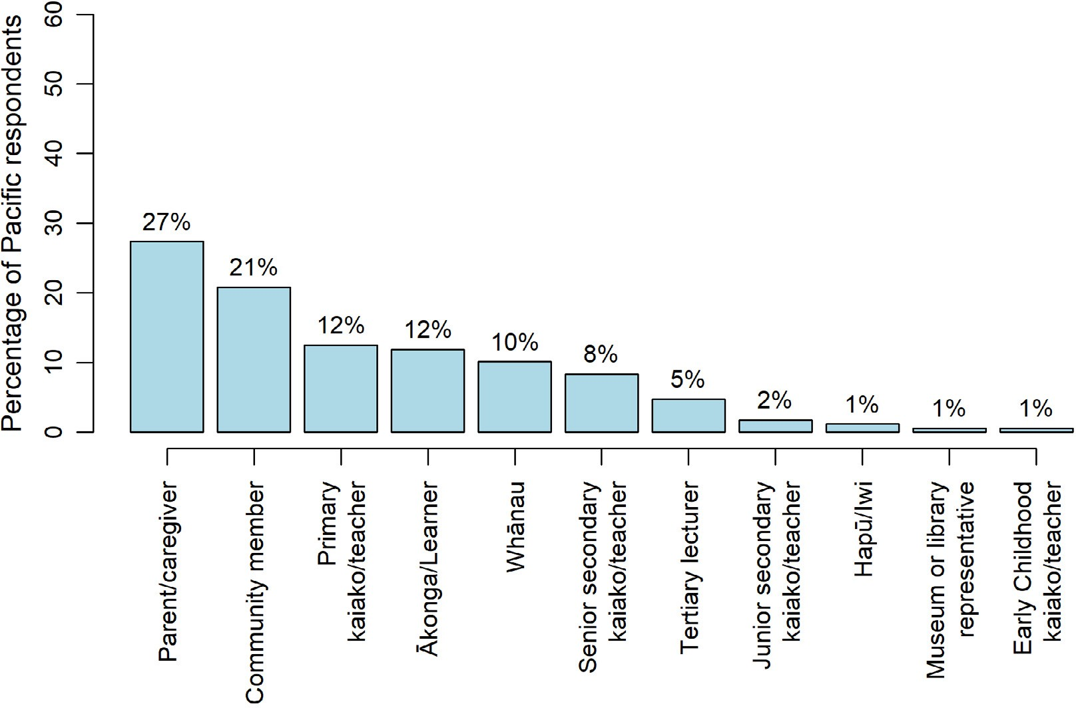

Region
Figure 16 shows that the greatest number of responses to the general survey were from respondents in Auckland – Tāmaki Makaurau and Wellington – Te Whanganui-a-Tara.

FIGURE 16 Breakdown of Pacific respondents to the general survey by region
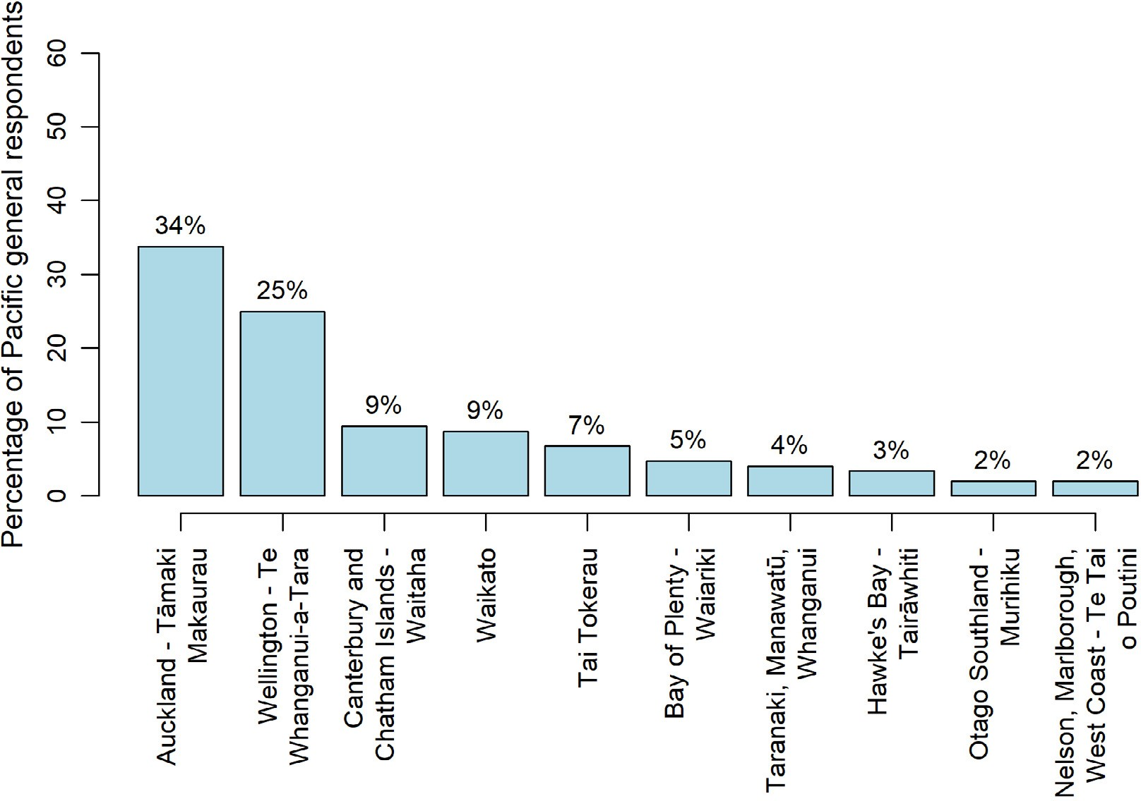

SECTION 9 | Ngā tirohanga mai i ngā tāngata o te Moana-nui-a-Kiwa | Perspectives from Pacific peoples

Do Pacific peoples think the content reflects us as a nation?
Figure 17 shows how Pacific peoples rated their agreement with statements about the draft content in the general section of the online survey.
The figure shows that 56% of Pacific peoples agreed or strongly agreed with the statement “the content reflects the stories our young people need to know”, whereas 34% disagreed or strongly disagreed. Also, 49% of Pacific peoples agreed or strongly agreed with the statement “the content reflects our bicultural history as a nation”, whereas 36% disagreed or strongly disagreed. Lastly, Figure 17 also shows that 61% of Pacific peoples agreed or strongly agreed that “the content will encourage more diverse local stories to be acknowledged and learnt by young people in school and kura”, whereas 28% disagreed or strongly disagreed.
Overall, half or more of the Pacific peoples who responded to the survey believed that the content reflects stories young people need to know, their bicultural history as a nation, with just over 60% hopeful that the content will encourage more diverse local stories to be learnt through the new curriculum.

FIGURE 17 Pacific peoples’ responses to the three items about the draft curriculum content
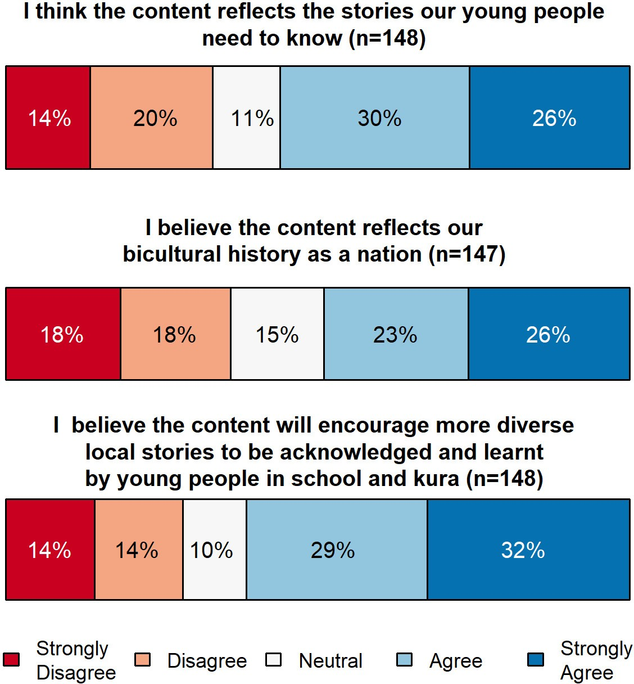

Aotearoa New Zealand’s histories | Findings from the public engagement on the draft curriculum content

A positive response to the content overall
Overall, Pacific respondents were positive about the new histories’ curriculum content, with some commenting on the positive impact it will have for the whole country.
I am very happy to see that the curriculum will better represent the stories of all immigrants and tangata whenua and our history as a nation. (Survey, parent/caregiver)
These diverse local histories will greatly help understand and appreciate the diversities in Māori societies, and open our minds towards acceptance and social harmony, not only amongst those of Māori origin but all those of non-Māori descendant. (Survey, community member)
Learning about ancient and Greek history isn’t relevant. Learning about the history of Aotearoa is crucial for survival in this country. In particular for Māori and Pasifika children. (Survey, community member)
I think this is true, this content is good for people of all ages should know. (Survey, whānau)
A few of the respondents reflected on the importance of understanding the history of the land where they live.
Children need to know their ancestral background as Māori and indigenous of the land. As children of diaspora communities, they need also to learn and know the historical background of their adopted land. (Survey, senior secondary kaiako/teacher)
One respondent spoke of the importance of oral histories in Fijian culture rather than written histories.
Written history is not the Pacific way. Our history is through our dancing and through the lyrics of our songs—the history is contained in there. I remember back in my village when I was small, I
was talking to an old man: “If people ask me about the history of Fiji, what can I tell people of the history of Fiji?” He said, “if it is written it is not our history of Fiji, it is foreign version of history”. Fiji history is written within us—within people. So, it will be great if this history can be taught / learned in school. (Survey, community member)

Multicultural perspectives
Many of the respondents wanted the curriculum to reflect diverse and multicultural perspectives, especially from groups that have contributed to the development of Aotearoa. However, it is important to note that not everyone was in support of including more diverse stories within the curriculum.
I LOVE the kōrero on Pacific peoples—but it doesn’t feel like there is space for stories from other ethnicities (other than Māori and NZ European). (Survey, parent/caregiver)
What does Bi-cultural mean? NZ is multi-cultural and colonized the Pacific and persecuted Pasifika peoples. Where are those stories. Where are the stories of pacific migration? (Survey, whānau)

New Zealand and the Pacific Islands
Some respondents felt that the relationships and connections between Aotearoa and other Pacific Island countries were important to include to provide the historical, political, cultural and geographical contexts of Aotearoa in Oceania.
Need to have content that talks about the period between Māori migration and Pākehā migration, that Aotearoa NZ is a Pacific nation, and that the pre and post colonial relationships with the Pacific are important for all NZers to know and understand. (Survey, tertiary lecturer)

SECTION 9 | Ngā tirohanga mai i ngā tāngata o te Moana-nui-a-Kiwa | Perspectives from Pacific peoples

However, it marginalises the important and significant contributions of other cultures such as the Chinese who came here as part of the Gold Rush and the pacific islanders (e.g., Samoans, Tongans, Cook Islanders) who impacted on our history to the extent that many of those islands were either under NZ “rule” (“administration”) at one time and continue to be “protectorates” of NZ. (Survey, parent/caregiver)

Pacific history in New Zealand
As well as an interest in the history of Aotearoa in the Oceania region, many Pacific respondents called for content that included history of Pacific peoples here in Aotearoa.
I think it could include more e.g. more history on migration of Pacific, Asian and the impacts this had on generations of Pacific and Asians born in Aotearoa. (Survey, parent/caregiver)
I am more interested that the draft is done up and rewritten, proofread and includes way more Pacific history. Thank you. (Survey, ākonga/learner)

What is most important to Pacific respondents?
Figure 18 shows which aspects of the draft content Pacific peoples indicated they were most interested in through the online survey. The most frequently selected option was critical thinking skills, followed by a deeper cultural understanding of Aotearoa New Zealand, and a greater sense of identity and belonging.

FIGURE 18 What is most important for students to learn—Pacific respondents
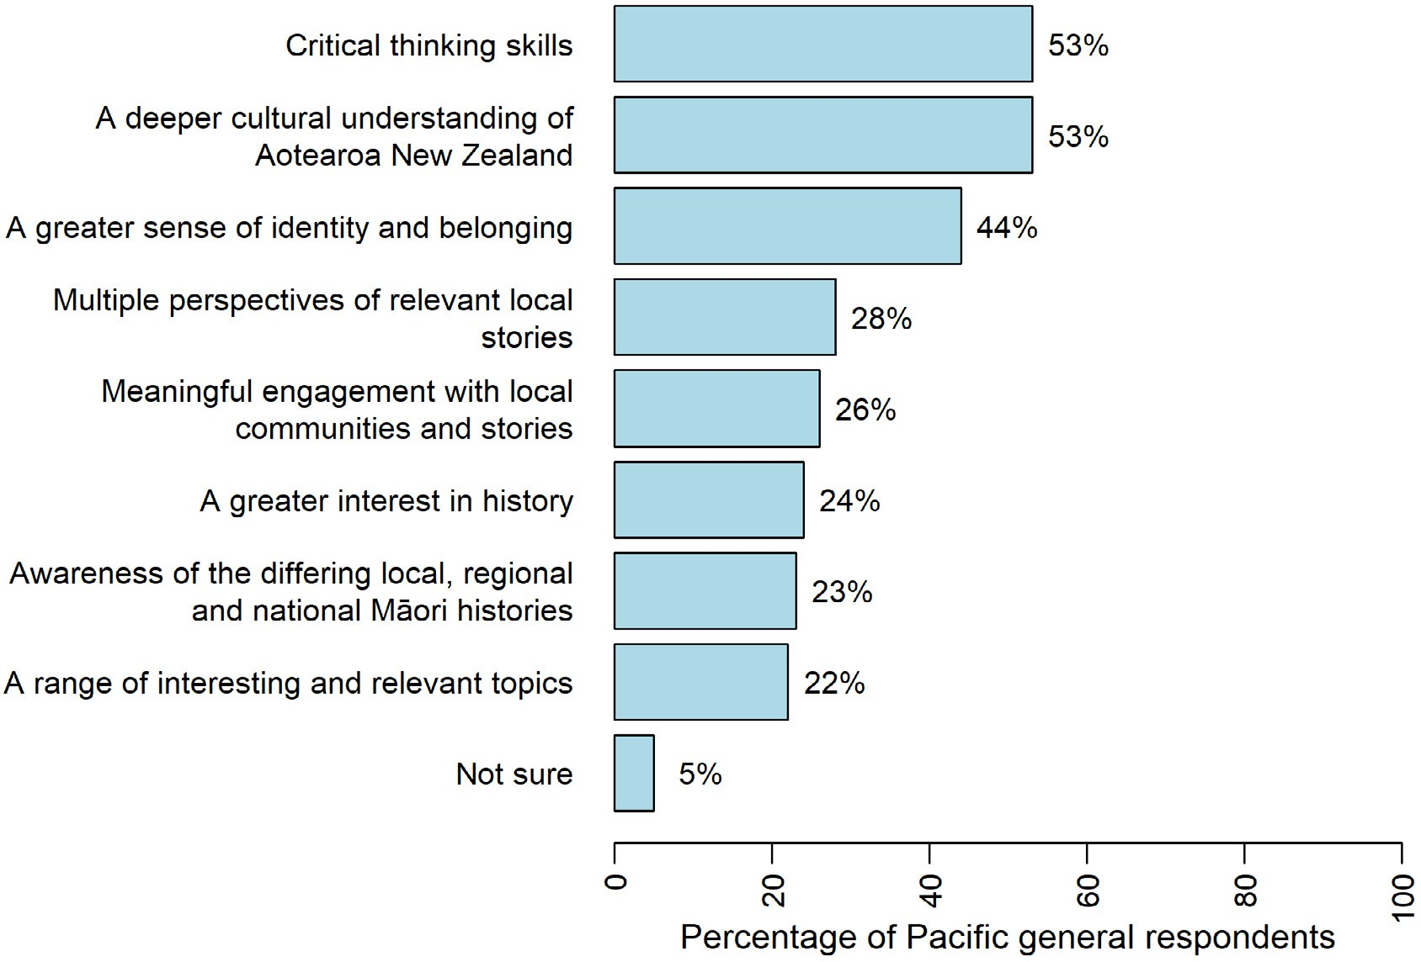

Aotearoa New Zealand’s histories | Findings from the public engagement on the draft curriculum content

In addition, submissions made by Pacific respondents highlighted the importance of national, regional, local, and iwi histories, with national history featuring most prominently. These are described next.

National history
Many Pacific respondents wanted topics such as the Dawn Raids, the migration of Pacific peoples to Aotearoa, and links with the Pacific included in the curriculum content.
I would like to know more about the stories—attitudes—other things that happened to Pacific people in the 1960’s but also to learn how much has been added to NZ because of Pacific peoples. (Survey, ākonga/learner)
Learn about the relationship between Pacific and Māori—how it was back then and how it is now. Why? Etc. (Survey, ākonga/learner)
Impact of colonisation on Māori, what was lost by Māori. (Survey, parent/caregiver)
The place and connections of Pacific peoples to New Zealand. (Survey, parent/caregiver)
Pacific students saw this as an opportunity to learn about Māori and Pacific histories when they have not been able to do so previously at school.
But it’ll be nice to learn more about NZ in Pasifika, relationships of Pasifika diaspora and Māori and just more Pacific histories would be good. (Survey, ākonga/learner)
I want to see Pacific as a main thing otherwise all us Pasifika lot down south gonna learn nothing about us . (Survey, ākonga/learner)

Regional history
For this particular area of the curriculum, a number of Pacific respondents wanted to see place names, the meanings behind them, and the associated iwi and waka included.

Local history
Some Pacific respondents wanted local history to reflect the multicultural and diverse communities that they are living in today so that learners can “see themselves” in the content they are learning about.
Local history must not be confined to Māori history or Māori perspective of history. There are many peoples with a great depth of history within New Zealand and their local history must be included! (Survey, community member)
Kids need to see themselves and how local historical events relate to them and their lives, shaping who they are and who they may become. (Survey, community member)

Iwi history
A few respondents expressed the hope that iwi histories will be taught in a safe and mana-enhancing way through the curriculum, and that the same will be done for histories of other communities.
Multiple perspectives are essential here, while recognising mana whenua. Caution to protect all of these histories, not just the predominant view of the mana whenua. (Survey, community member)

SECTION 9 | Ngā tirohanga mai i ngā tāngata o te Moana-nui-a-Kiwa | Perspectives from Pacific peoples

What do Pacific peoples see as the challenges in implementing this curriculum change?
Figure 19 shows what Pacific peoples perceived to be the greatest challenges in implementing the draft content, according to the online survey. The most frequently selected option was managing teacher bias, followed by lack of kaiako and teacher in-depth knowledge, and making the topics engaging.
FIGURE 19 Greatest challenges in implementing the draft content—Pacific respondents
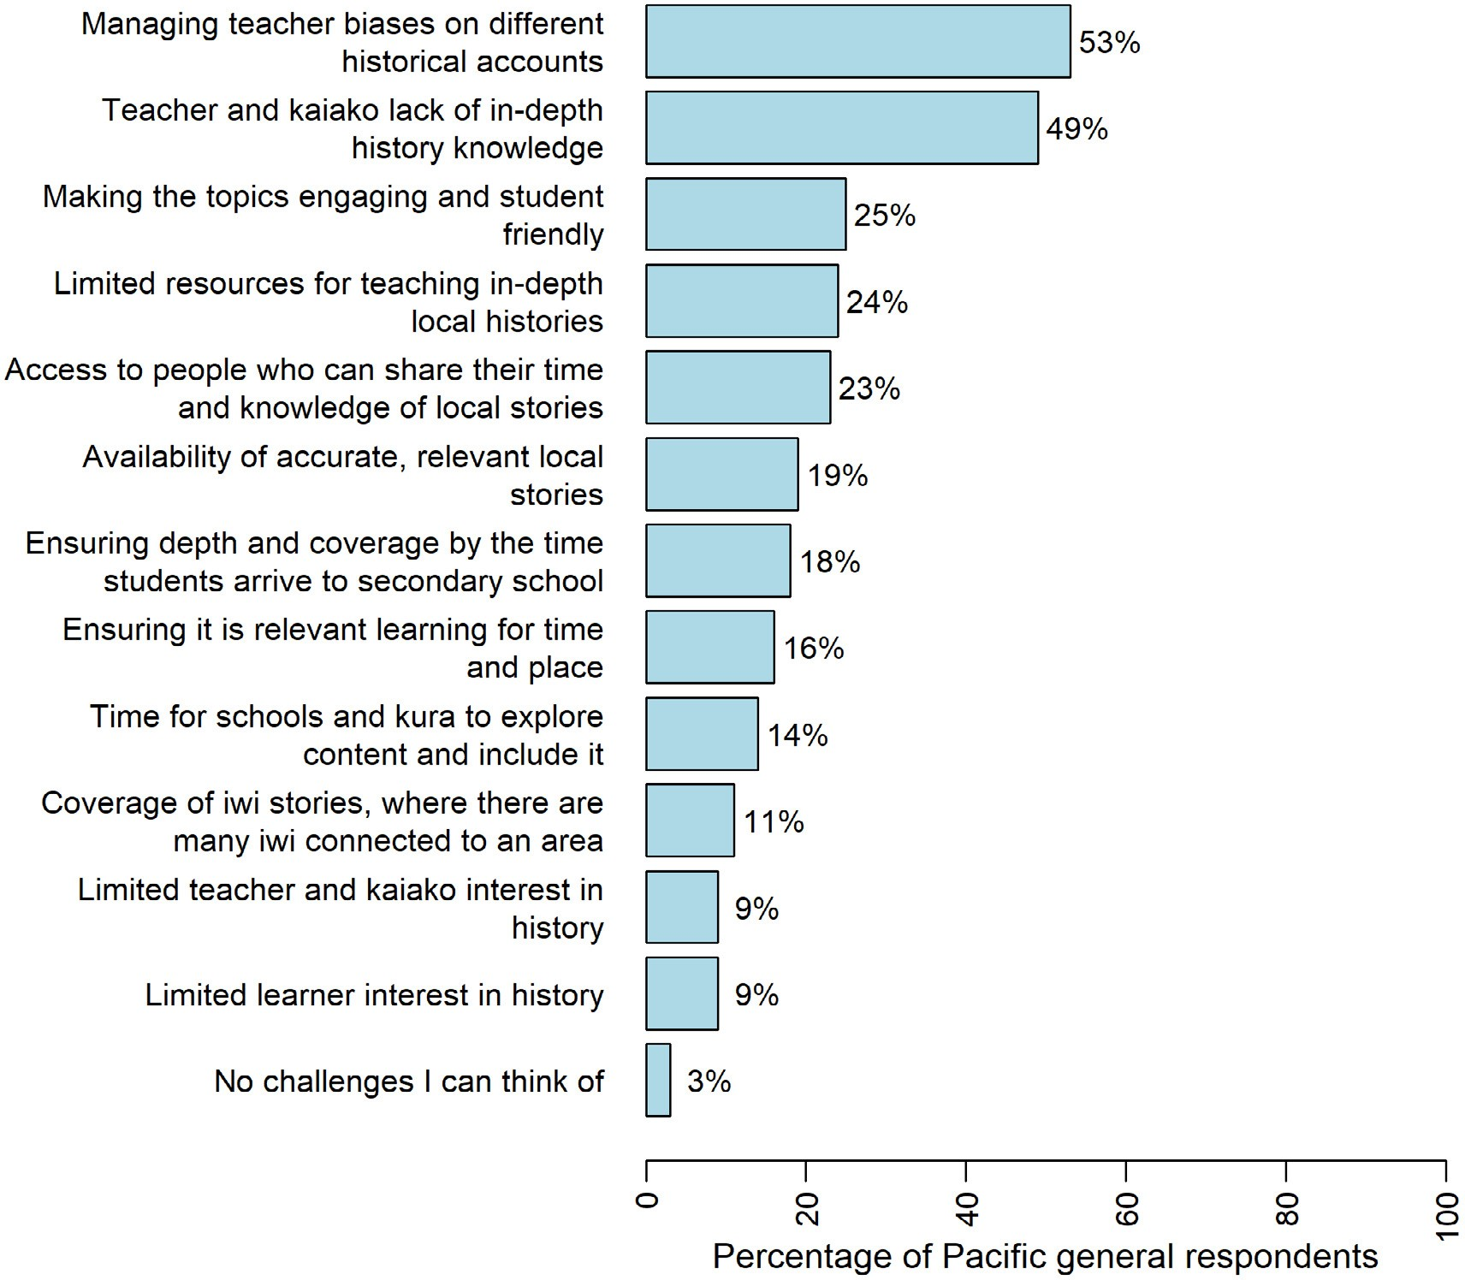

Student and family engagement
The issue of whether students will engage with the content was a concern for a few respondents. This will be new territory for families who themselves may have faced the effects of systemic racism, and may introduce uncomfortable or unfamiliar conversations at home.
It is important that in order for Aotearoa histories to be taught in school it must be made engaging, so for young people to get out of the classroom and take trips to sites. Localise the knowledge and also to help young people appreciate Aotearoa, Māori histories and also Pacific Histories. (Community member)

Aotearoa New Zealand’s histories | Findings from the public engagement on the draft curriculum content

Parents that have already been through the education system in Aotearoa that were not taught this particularly Māori, Polynesian, Asian and immigrants who faced systemic racism. How do they have these conversations on home when their children come home asking questions ... (Parent/ caregiver)

He whakarāpopototanga | In summary
The Pacific respondents covered a wide range of topics that were related to both Aotearoa and the Pacific. Even with a small number of responses, the prominent themes that emerged were positivity towards the content and to the inclusion of Pacific history in, and connections with, Aotearoa New Zealand.

SECTION 10

Ngā tirohanga mai i ngā tāngata o Āhia
Perspectives from Asian peoples

Survey responses from Asian peoples
This section highlights views from respondents who identified as Asian. There were 11 submissions and 237 survey responses from individuals and groups who indicated that their feedback represented an Asian perspective.

Respondent roles
As Figure 20 shows, most of these respondents were community members or parents/caregivers. Compared to other responding groups, fewer Asian respondents were teachers in either primary or secondary schools.
FIGURE 20 Breakdown of Asian respondents by role
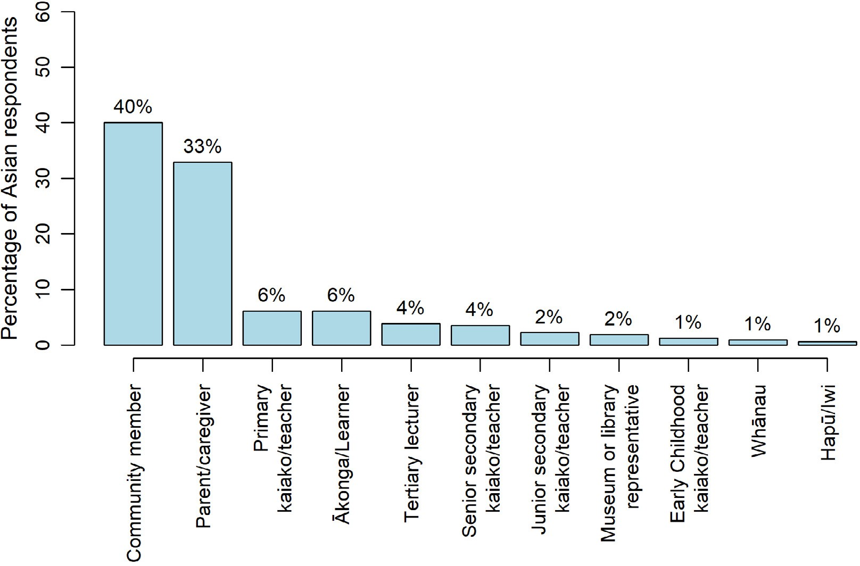

Aotearoa New Zealand’s histories | Findings from the public engagement on the draft curriculum content

Region
Figure 21 shows that more than half of responses to the general survey were from Auckland – Tāmaki Makaurau.
FIGURE 21 Breakdown of Asian respondents to the general survey by region
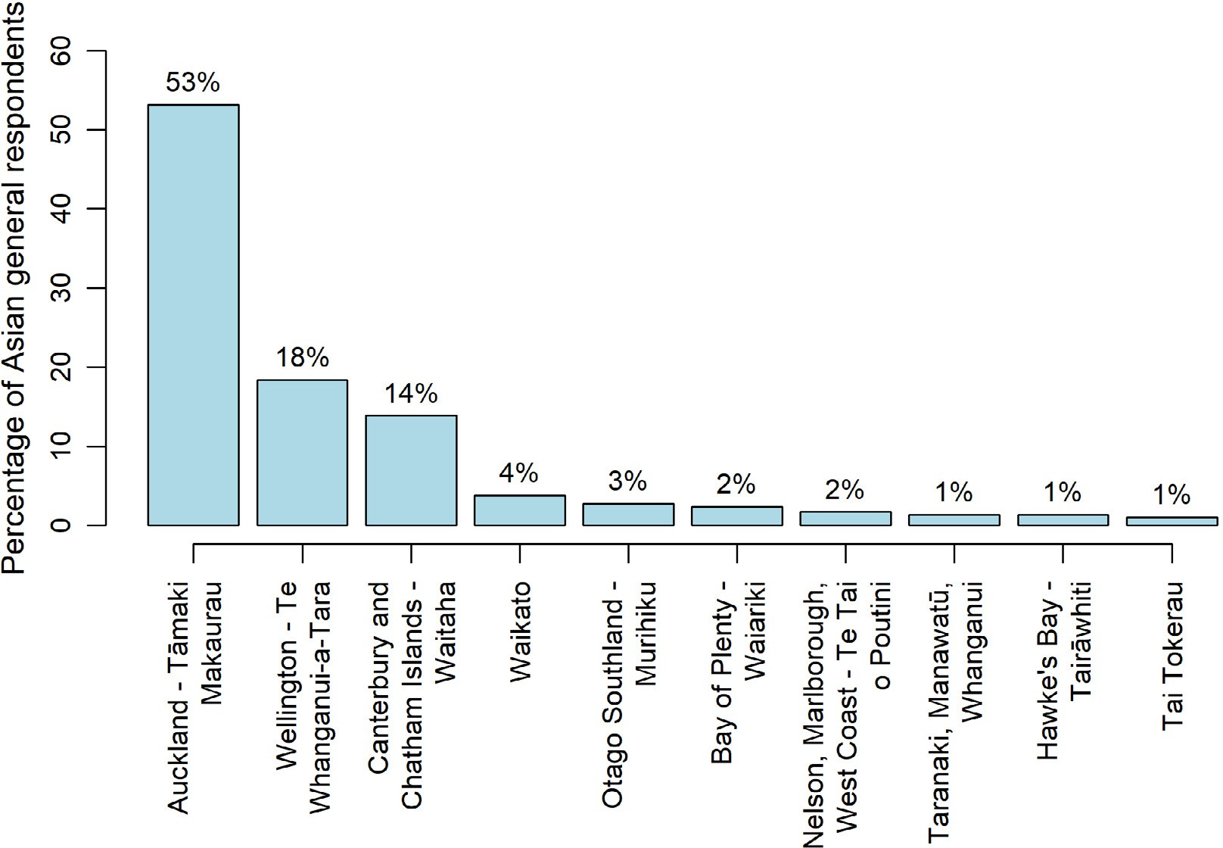

Do Asian peoples think the content reflects us as a nation?
Overall, the submissions and survey responses from Asian respondents showed a positive and near- identical pattern to those reported by Māori and Pacific respondents. As Figure 22 below shows, 55–60% of Asian respondents agreed or strongly agreed with the three statements about the draft curriculum content:
- 55% agreed or strongly agreed that the content reflects stories young people need to know
- 57% agreed or strongly agreed that the content reflects Aotearoa New Zealand’s bicultural history as a nation
- 60% agreed or strongly agreed that the content will encourage more diverse local stories to be acknowledged and learn by young people in school and kura.

SECTION 10 | Ngā tirohanga mai i ngā tāngata o Āhia | Perspectives from Asian peoples

FIGURE 22 Asian responses to the three items about the draft curriculum content
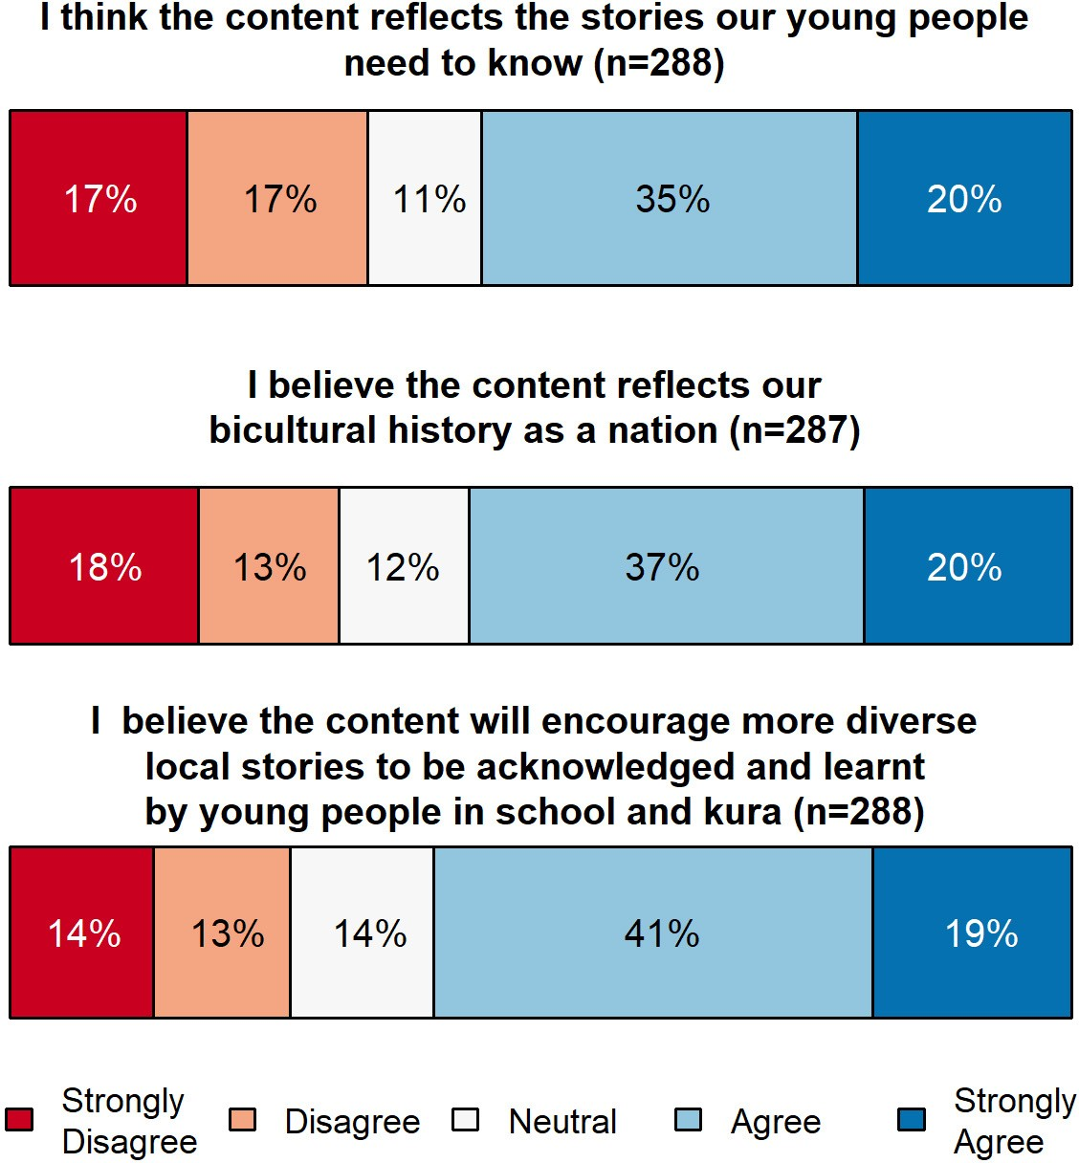

Moreover, Asian respondents recognised the need to rebalance the curriculum by including Māori histories, but they did not want this bicultural focus to come at the expense of a focus on the rich multicultural nature of contemporary New Zealand society. This is described next.

Include diverse Asian cultures
The need to reflect a wider diversity of cultures in the draft content was the most frequently made comment in response to this question.
While more local stories are good, it should include not only Māori stories but all races who make up this wonderful country too, i.e. migrants like Asians who have been contributing to NZ. (Survey, parent/caregiver)
As a mixed Māori identifying individual I am still astounded that my other heritages are bunched together as just the other half of bi in bicultural. Bicultural does not represent me, my whanau, iwi our other ancestors. (Survey, whānau)
As the following comments illustrate, some respondents had strong feelings about the lack of inclusion of Asian peoples’ histories, and the impact this might have on their children’s sense of belonging:

Aotearoa New Zealand’s histories | Findings from the public engagement on the draft curriculum content

I want the teaching of New Zealand history to include everyone so that every child can feel just as kiwi as the next. Unfortunately, growing up, I never felt like a true kiwi nor that I was a true New Zealander because of my Asian origins and the teaching of New Zealand’s history had a part to play in this … my parents had arrived very recently in the grand scheme of things, but I wonder how the Chinese New Zealanders who have been here since the gold rush would feel about learning that New Zealand is a bicultural country? (Submission, community member)
What about the other cultures that have contributed to NZ’s history of which they should be considered and taught more about. A few sentences here and there is not enough to make my children feel welcome. (Survey, parent/caregiver)

Include an overview of histories of Asian nations
As well as ensuring that the history of Asian migration to Aotearoa New Zealand is visible in the curriculum, one group of submitters argued for inclusion of the histories of the wider Asian region as an antidote to the traditional Eurocentric curriculum offered in schools:
We welcome the Curriculum’s emphasis on telling local histories, but we feel it is imperative that local histories need to be contextualised within broader world histories—which are indeed correctly recognised to have been for too long European-centred and in need of including other experiences. The Asian regions and their histories are arguably among the most relevant to New Zealand. Their histories and experiences offer a corrective to Euro-centric histories and present opportunities to compare experiences of colonisation in Aotearoa New Zealand with those elsewhere. (Group submission)

What is most important to Asian respondents?

Acknowledging the diversity of Asian groups
Strong feelings about the lack of focus on Asian histories have already been mentioned. In addition, the importance of addressing the diversity of Asian New Zealanders’ experiences was a clear theme in the feedback:
While we are pleased that the draft curriculum covers New Zealand’s history of discriminatory migration practices, migration is not the sum total of Chinese New Zealand experience. And
it should not be the only place where our community can see its history reflected. (Group submission)

Acknowledging the contribution of Asian peoples to New Zealand society
There was a sense of a need to right past wrongs in a number of comments about the contribution of Asian people to New Zealand society.
The contribution of the Chinese communities in New Zealand has long been ignored as part of Aotearoa New Zealand history, and it’s time that the New Zealand curriculum reflect this, as part of the commitment made in the Poll Tax “Apology”. (Survey, community member)
This is an opportunity for the curriculum to actively reverse some of the ways New Zealand history was presented in the past and emphasise the role smaller and overlooked communities have played in Aotearoa New Zealand. (Survey, community member)

SECTION 10 | Ngā tirohanga mai i ngā tāngata o Āhia | Perspectives from Asian peoples

What do Asian peoples see as the challenges in implementing this curriculum change?

Managing diversity
Managing the diversity of Māori histories is discussed in the Māori perspectives sections of this report. In the same way, respondents noted that Asian histories are diverse and said they should not be conflated into one over-arching narrative.
Asian experiences are highly diverse and even categories such as ‘Chinese’, ‘Indian’ already include myriad communities which are culturally and linguistically distinct from one another. This must
be taken into account and respected in the process of including Asian stories in the curriculum. (Group submission)
The lack of naming different migration groups, periods and ethnicities in relation to the events that brought them to NZ and what was occurring in NZ at the time, does a disservice to the numerous peoples whose stories make up the “migrants” since 1840. It risks glossing over some major pieces of history or concatenating migrants into a single homogeneous (and inaccurately portrayed) group. “Pākēha” alone is a grouping with stories from the Cornish, Irish, Scots, Dalmatians, Germans, etc., whose background and trajectory may differ markedly from the English settlers. The Chinese, for whom the governments of the day introduced more than 60 legislative bills from 1871 in order to control our migration, suffered an intensely different experience (Y4–6,
p. 5) to other Asian migrant groups. Also, the “Chinese” are not a single type of migrant/settler with a uniform back story, language or philosophy, yet there seems no obvious way that these different layers are reflected in what kids may learn or in how they may see their own stories reflected back to them in the curriculum. (Survey, community member)

Resources
One group of Asian academics worried about how well teachers are resourced to manage difficult conversations about the histories of Asian New Zealand settlers, especially given a certain level of anti-Asian sentiment recently seen in the media:
We note on p. 4 there is an intention to address the fact that “different stereotypes of a ‘New Zealand’ identity have been purposely constructed at different times to define who is included and who is excluded.” However, at the moment, there are a number of risks around this, including that the specific use of anti-Asian discourses in the construction of New Zealand identity will not be discussed and that this conversation will not be resourced appropriately, resulting in teachers singling out only racialised identities without providing this fuller context. (Group submission)
Some submitters offered to help develop resources based on their personal experiences, so that these could be shared more widely.

He whakarāpopototanga | In summary
Overall, the submissions and survey responses from Asian peoples were positive towards the draft curriculum. Respondents recognised the need to rebalance the curriculum by including Māori histories, but also wanted to see more acknowledgement of diverse Asian peoples’ histories in Aotearoa New Zealand, and contributions to New Zealand society. Some Asian academics expressed concerns about how well-resourced teachers will be to manage difficult conversations about the histories of Asian New Zealand settlers, against the wider contexts of racism experienced by Asian peoples.

Āpitihanga Appendices

Appendix A | Who responded to the online survey?
By the end of the consultation period there were 4,491 responses to the online survey. Of these, 4,303 were in the English language and 188 responses were in languages other than English: 19 in te reo Māori, 18 in Samoan, one in Tokelauan, one in Tongan, 85 in Korean, 55 in Simplified Chinese, one in Hindi, and eight in Punjabi.

Respondent roles and identities
Respondents to the survey were asked to select one role or identity. Figure A1 shows that the majority of responses to the survey were from community members and parents or caregivers.

FIGURE A1 Breakdown of respondents by role or identity

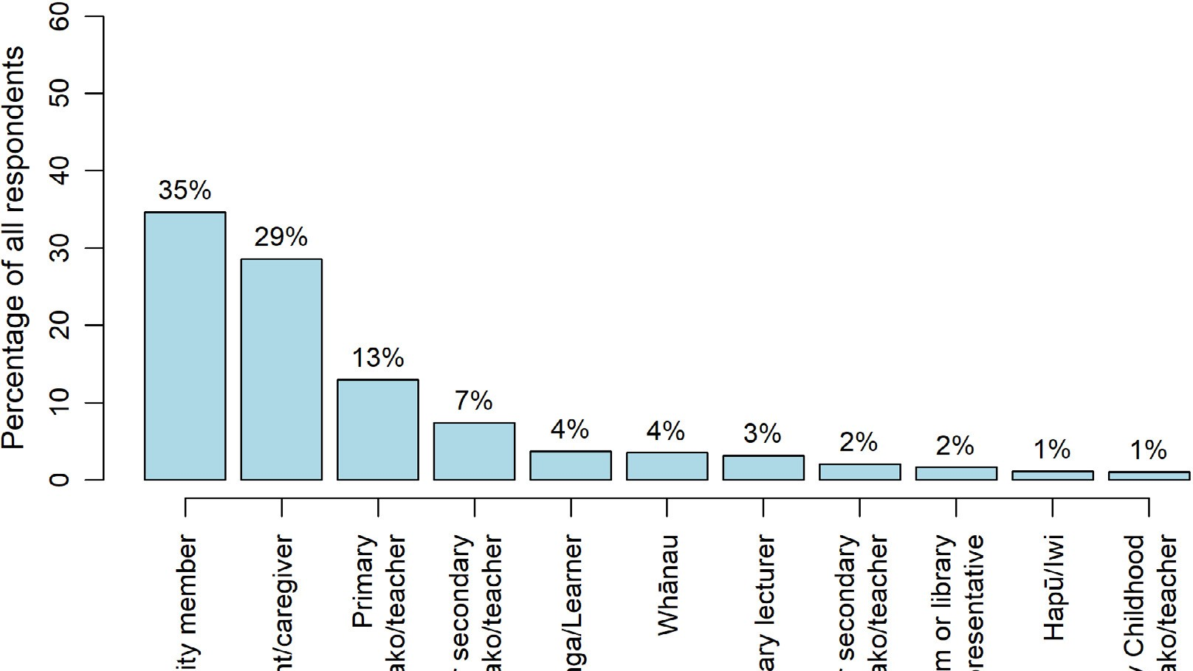

All respondents completed the same set of general survey questions, except for ākonga/learners who responded to a separate (but parallel) set of questions. Overall, there were 168 responses from ākonga/learners and 4,323 from other people.

Āpitihanga | Appendices

To make sure that the voices of educators can be heard, we have collated the responses from kaiako/ teachers at all levels of the education system and provided additional reporting for this group in the report. The combined kaiako/teacher group makes up just over a quarter of the respondents to the general survey question set.

Curriculum
The online survey asked respondents which curriculum document their answers related to. Table A1 shows that the majority of responses related only to The New Zealand Curriculum, with just 58
responses, in total, relating only to Te Marautanga o Aotearoa. Of the 49 general respondents whose responses related only to Te Marautanga o Aotearoa, 30 identified themselves as Māori. A sizable minority indicated their responses were in relation to both curriculum documents.
With a relatively small number of responses pertaining solely to Māori medium and a relatively large number of responses pertaining to both curricula, most of the reporting of survey results combines these responses. However, there is a discussion in the report where the views of Māori respondents on Te Marautanga o Aotearoa are considered in more depth.

TABLE A1 Breakdown of which curriculum content survey respondents chose to respond in relation to

General respondents n %

Te Marautanga o Aotearoa (Māori medium) 49 1%
The New Zealand Curriculum (English medium) 2798 65%
Both 1274 29%
Not sure 200 5%
Total 4321 100%

Ākonga/Learner respondents

Te Marautanga o Aotearoa (Māori medium) 9 5%
The New Zealand Curriculum (English medium) 114 68%
Both 30 18%
Not sure 15 9%
Total 168 100%
Note: These data were not available for two respondents.

Ethnicity
Figures A2 and A3 shows which ethnicity categories respondents selected. Because they were able to select multiple ethnicities, some respondents appear in multiple categories. The most frequently
selected ethnicity category for both general survey respondents and ākonga/learner respondents was NZ European/European, and the least was MELAA (Middle Eastern / Latin American / African). Māori, Pacific, and Asian voices are explored in separate sections in the report.
Among the general survey respondents, the proportion of respondents identifying as Māori approximately reflects the proportion of Māori among the New Zealand population, whereas Pacific and Asian peoples are under-represented.

Aotearoa New Zealand’s histories | Findings from the public engagement on the draft curriculum content

FIGURE A2 Ethnicity of general survey respondents
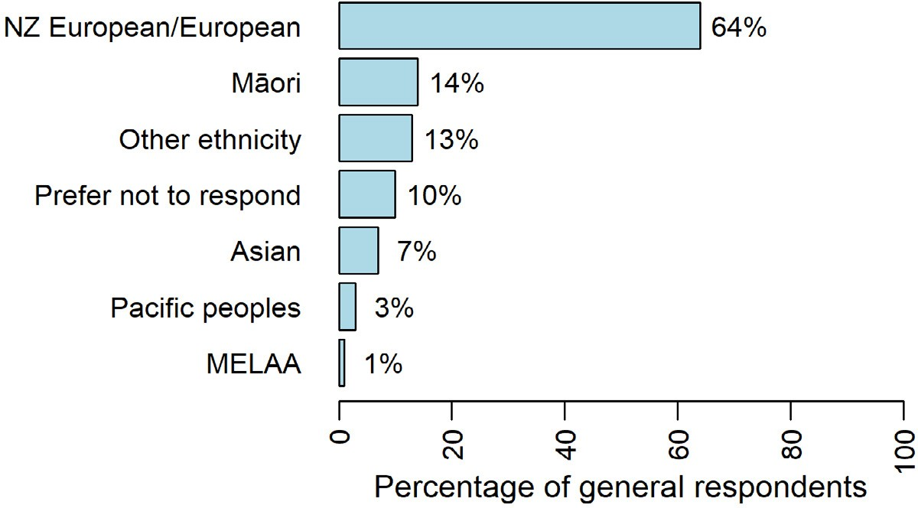

For ākonga/learner respondents, Māori and Pacific peoples are over-represented compared with national demographic data, and Asian peoples are under-represented.
FIGURE A3 Ethnicity of ākonga/learner survey respondents
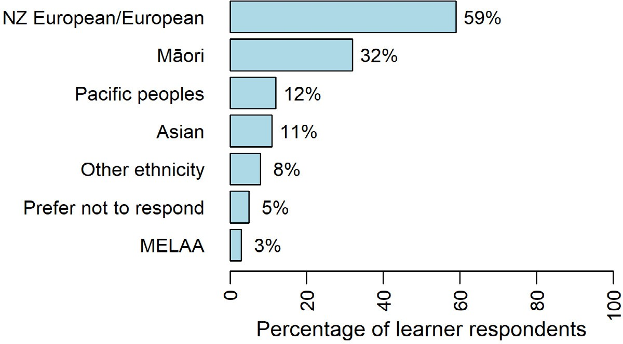

Issues with survey design and ethnicity misclassification
A relatively large number of those represented in Figures A2 and A3 selected “Prefer not to respond”. This is likely due to an oversight whereby no NZ European (or similar) ethnicity option was provided when the survey was first released. Respondents were required to select at least one ethnicity category, and while there was a text field for “Other”, there was no option to select it as a category.
After approximately 850 survey responses had been collected (23 of which were from ākonga/learners), this was addressed with the category “European” being changed to “NZ European/European”. There were up to 63 survey responses (only one from an ākonga/learner) for which a “European” ethnicity category selection may have been lost as a result of this change, due to the data extraction process.
During the period when it was not possible for respondents to select the “Other” category for a time, respondents were identifying themselves via the “Other” text field. “Other” responses were

Āpitihanga | Appendices

largely made up of “New Zealander”, “Kiwi”, “Pākehā”, or similar. Some of these respondents provided additional information about ancestry, or mixed ethnicity, whereas others did not elaborate.
A number of the “Other” respondents expressed dissatisfaction over the ethnicity category selection provided, and some expressed dissatisfaction with being asked to provide information about ethnicity, because they felt it was “irrelevant”, or “racist”. Given the complexity of meaning, the varying level of detail or opacity, and the somewhat different response patterns of the “Other” group, it was decided not to do any back-coding of these responses to the specified ethnicity categories.

Region
Figure A4 shows that the greatest number of responses were from respondents in Auckland – Tāmaki Makaurau and Wellington – Te Whanganui-a-Tara. The lowest number of responses were from Nelson, Marlborough, West Coast – Te Tai o Poutini and Hawke’s Bay – Tairāwhiti.
Table A2 shows how the main respondent types were spread across the regions. Here, kaiako/teachers from all levels have been grouped together, and parents/caregivers have been grouped with whānau. The patterns are fairly similar across the three groups.
Compared to the general survey responses, there were greater proportions of ākonga/learner survey respondents from Wellington – Te Whanganui-a-Tara and Tai Tokerau, and a lesser proportion from Auckland – Tāmaki Makaurau.
FIGURE A4 General survey respondents, by region
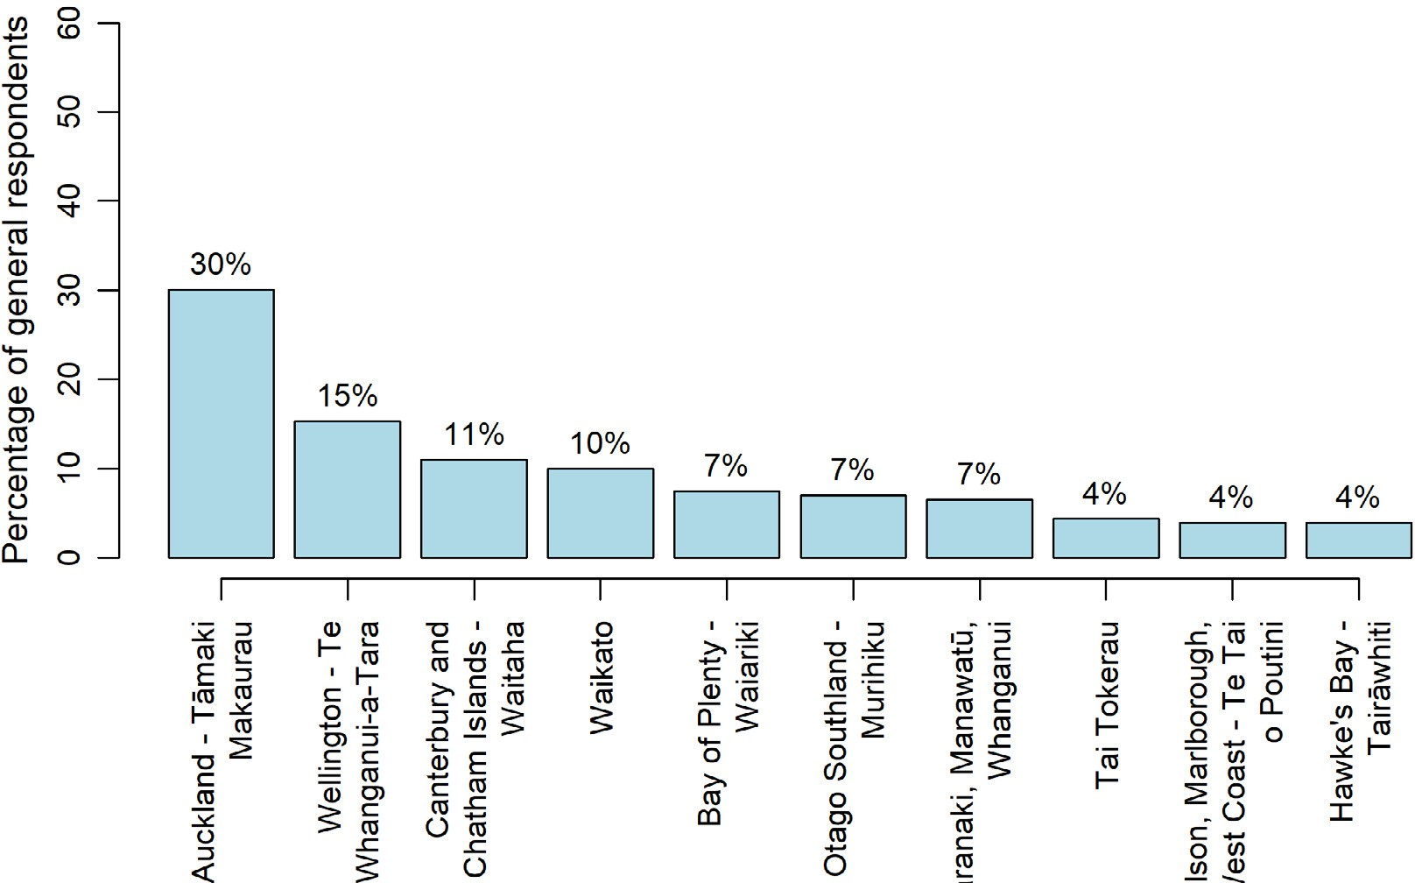

Aotearoa New Zealand’s histories | Findings from the public engagement on the draft curriculum content

TABLE A2 Main respondent role type by region

Kaiako/Teacher (n=1199)  Auckland 33%  Bay of Plenty 9%  Canterbury and Chatham Islands 13%  Hawke’s Bay 4%  Nelson, Marlborough, West Coast 3%  Otago Southland 6%  Tai Tokerau 4%  Taranaki, Manawatū, Whanganui 6%  Waikato 11%  Wellington 11% | Whānau/ Family (n=1,444)  Auckland 30%  Bay of Plenty 7%  Canterbury and Chatham Islands 23%  Hawke’s Bay 4%  Nelson, Marlborough, West Coast 4%  Otago Southland 7%  Tai Tokerau 4%  Taranaki, Manawatū, Whanganui 7%  Waikato 10%  Wellington 14% | Community member (n=1,555)  Auckland 29%  Bay of Plenty 7%  Canterbury and Chatham Islands 9%  Hawke’s Bay 4%  Nelson, Marlborough, West Coast 4%  Otago Southland 8%  Tai Tokerau 4%  Taranaki, Manawatū, Whanganui 6%  Waikato 9%  Wellington 20% | Ākonga/ Learners (n=168)  Auckland 18%  Bay of Plenty 10%  Canterbury and Chatham Islands 9%  Hawke’s Bay 1%  Nelson, Marlborough, West Coast 3%  Otago Southland 7%  Tai Tokerau 12%  Taranaki, Manawatū, Whanganui 7%  Waikato 10%  Wellington 24%

Note: Columns do not add up to 100 due to rounding.

Āpitihanga | Appendices

Appendix B | Content questions by role
Figures B1–B3 below show the survey responses to the three questions about the draft curriculum content by roles. There were some noticeable differences in teacher/kaiako responses when compared with those from other groups such as family/whānau and community members. Overall, teachers and kaiako appear to be more positive than those from other groups.

FIGURE B1 Survey responses to the item “I think the content reflects the stories our young people need to know”
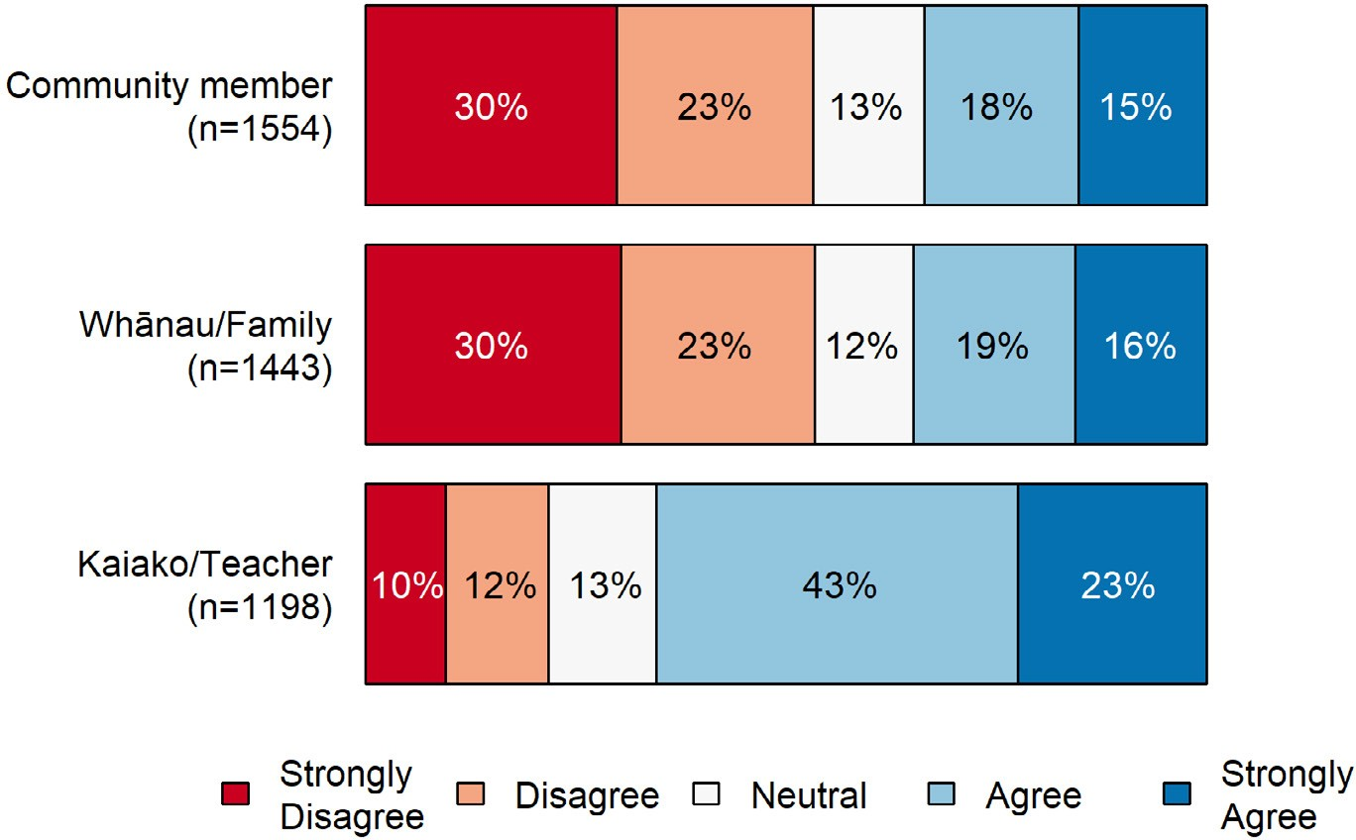

FIGURE B2 Survey responses to the item “I believe the content reflects our bicultural history as a nation”
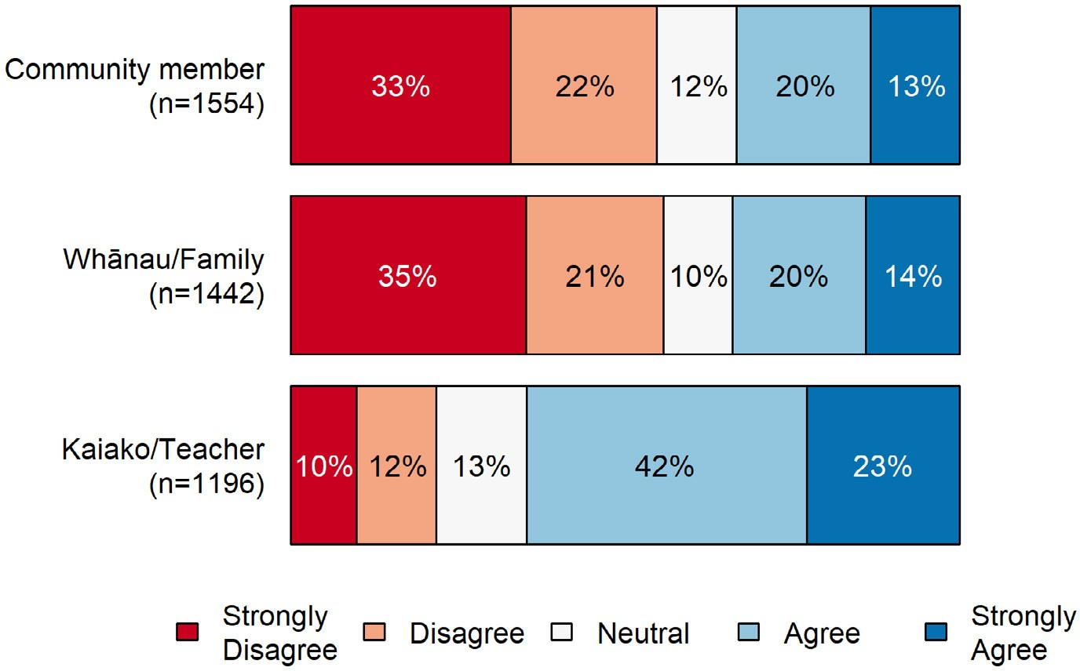

Aotearoa New Zealand’s histories | Findings from the public engagement on the draft curriculum content

FIGURE B3 Survey responses to the item “I believe the content will encourage more diverse local stories to be acknowledged and learnt by young people in school and kura”
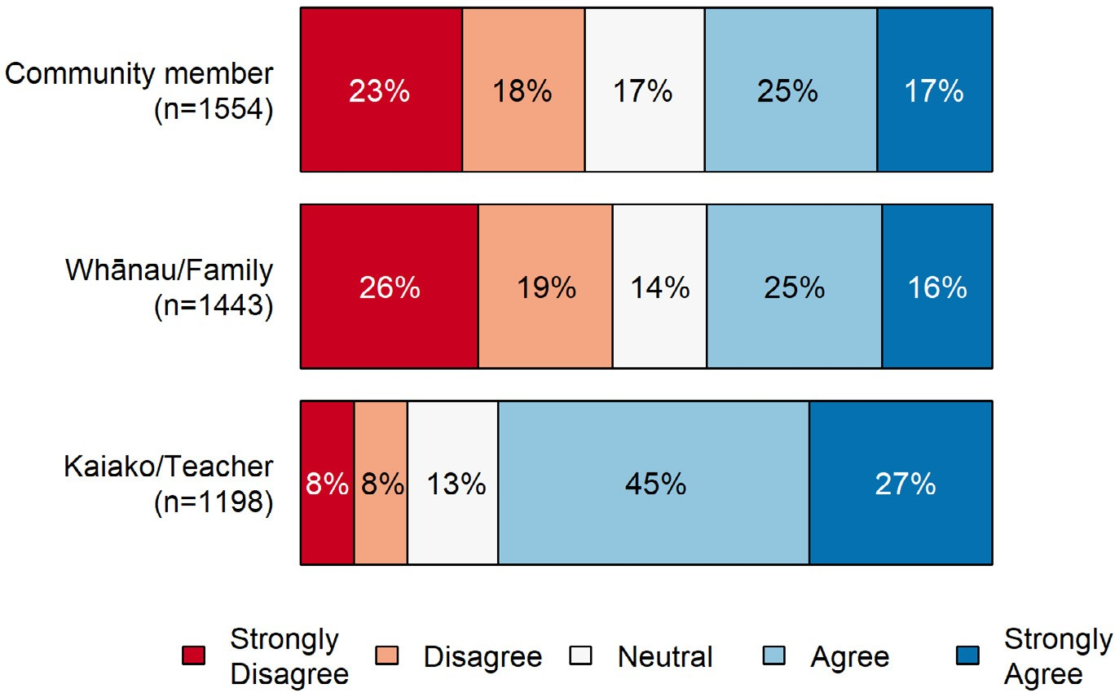

Āpitihanga | Appendices

Appendix C | Content questions by ethnicity
Figures C1–C3 below show the survey responses to the three questions about the draft curriculum content by ethnicity. Overall, respondents from Other ethnicities or ones who preferred not to respond appear to be the least positive about the draft curriculum content.

FIGURE C1 Survey responses to the item “I think the content reflects the stories our young people need to know”
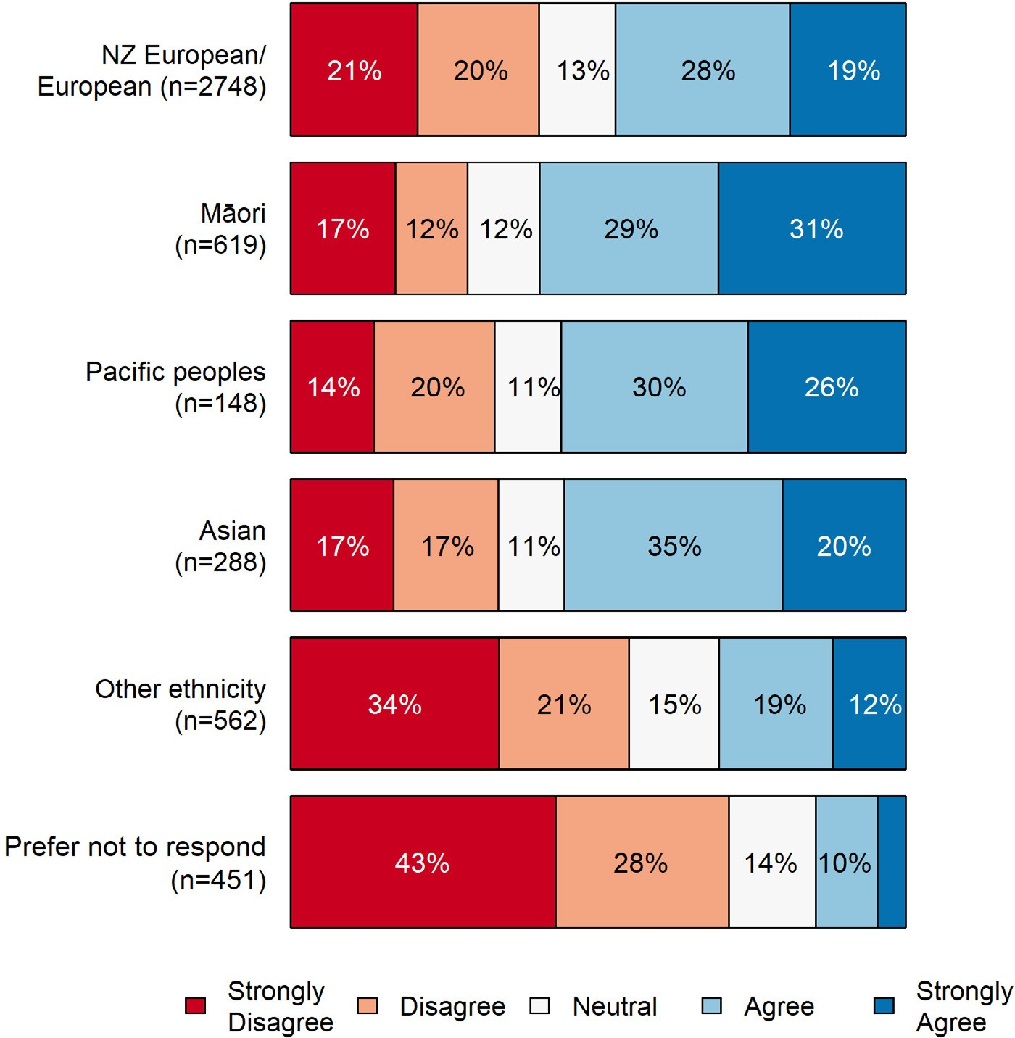

Aotearoa New Zealand’s histories | Findings from the public engagement on the draft curriculum content

FIGURE C2 Survey responses to the item “I believe the content reflects our bicultural history as a nation”
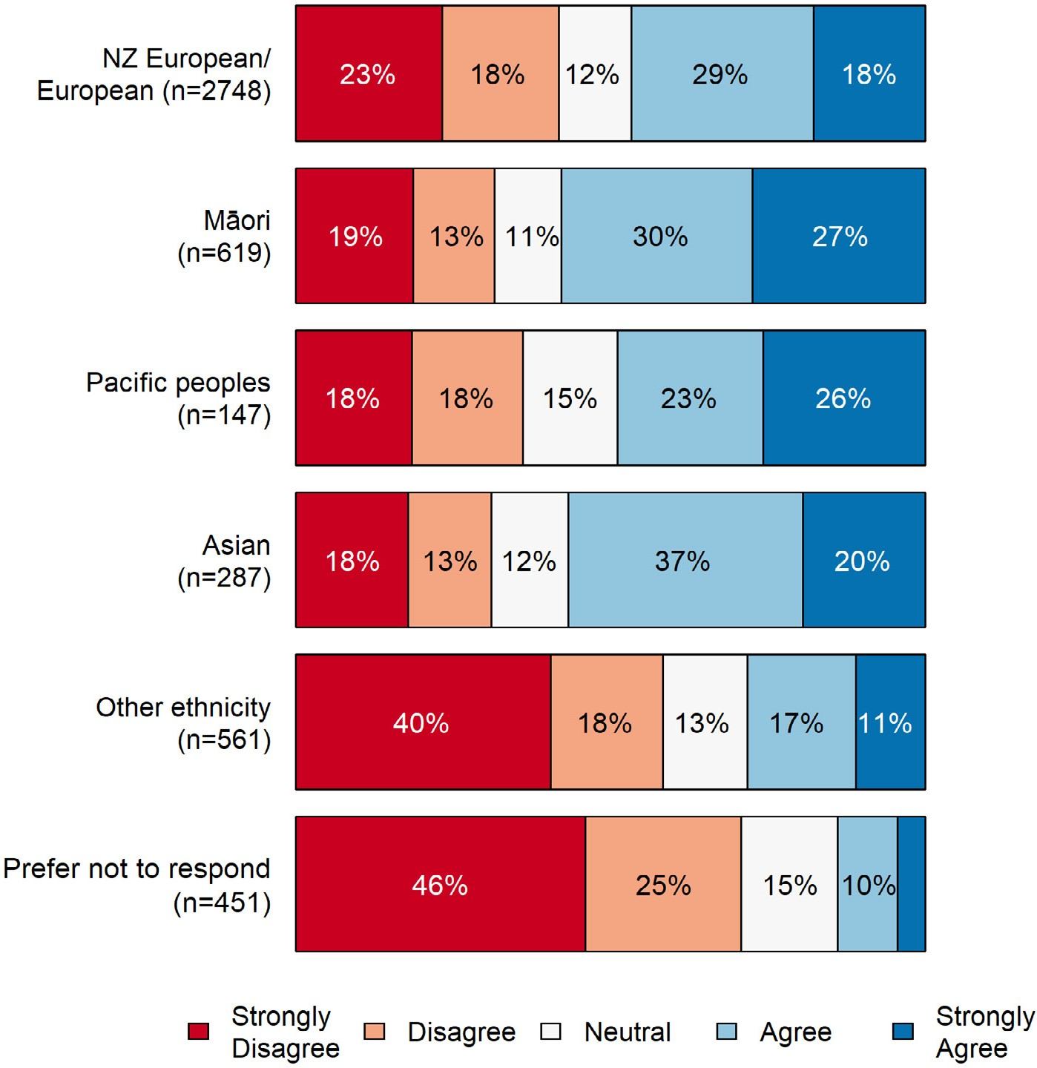

Āpitihanga | Appendices

FIGURE C3 Survey responses to the item “I believe the content will encourage more diverse local stories to be acknowledged and learnt by young people in school and kura”
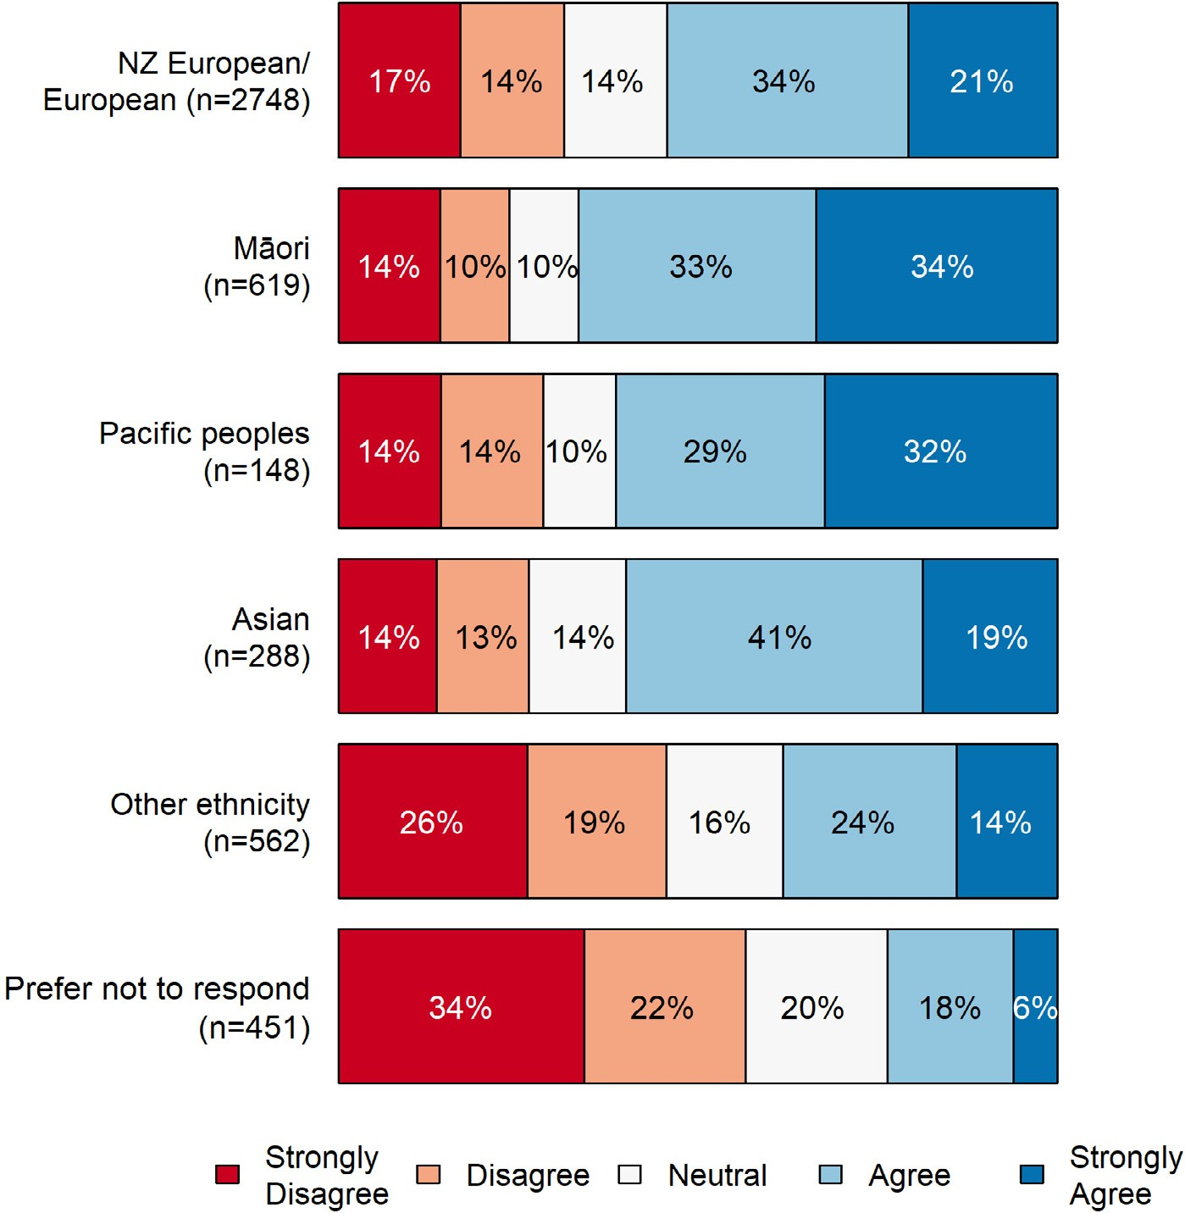

New Zealand Council for Educational Research
facebook.com/nzcer @NZCER
www.linkedin.com/company/new-zealand- council-for-educational-research

